1
Inspire the trust of your clients - the students and parents. Create a good first impression from day one of the academic year.
2
Dress like a professional. It is important for teachers to dress in clean clothes with no stains or odor whether they teach in the gym, the shop, or the math classroom. This also means no denim or t-shirts. Revealing clothes are the number one "no-no" for female teachers. Male teachers should remember that a tie and jacket worn to work, can easily be removed, should the need arise. Teachers should arrive at work, looking the part, not dressed looking like their students.
- 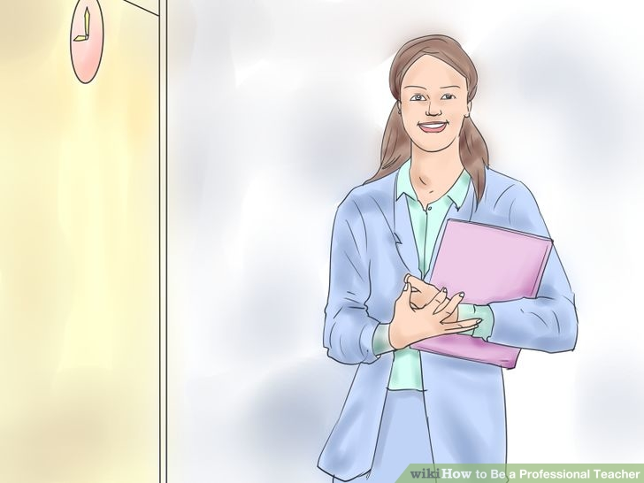
3
Always be on time for work. A professional teacher understands the need to start the day well, every day. Truly professional teachers will make sure that they arrive at least ten minutes before the first bell rings, so as to prepare themselves mentally for the day ahead.
- 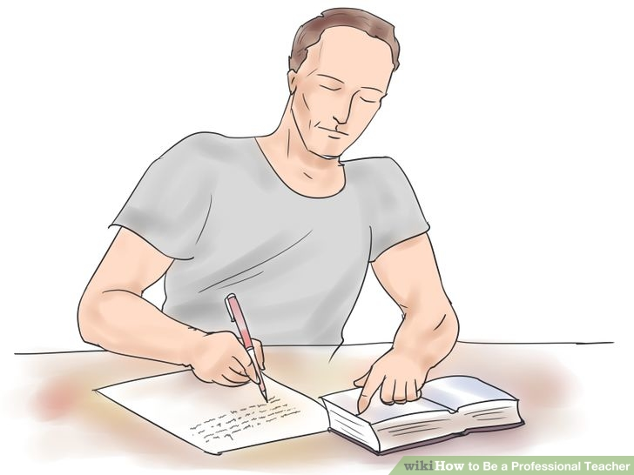
4
Be prepared. Check your diary the night before and plan the day ahead. Professional teachers plan thoroughly too for every lesson and class. They stick to their work programme and assessment schedule, to ensure that not only syllabus content is covered, but also the necessary skills for their students' longer-term success in their specific subject or learning area.
5
Follow procedures and the protocol expected at your school. Professionals embrace the corporate identity and values and model these for the clients - in this case, the children they teach.
- 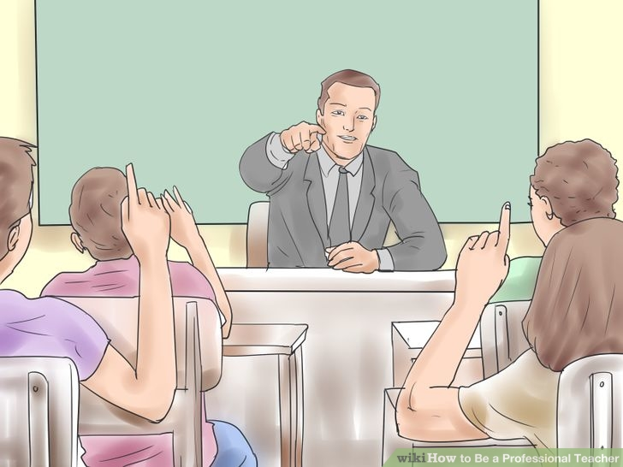
6
Take charge of your classroom. Manage your students' behaviour. A professional teacher will not keep running to school management for assistance with classroom discipline, for example.
- 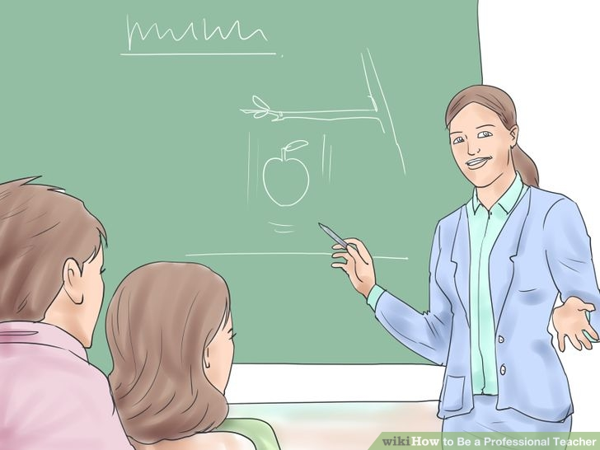
7
Take pride in the process and product. Make sure your notes and handouts are professionally presented. Professional teachers should never have to be asked to re-do a piece of work because its presentation is shoddy.
- 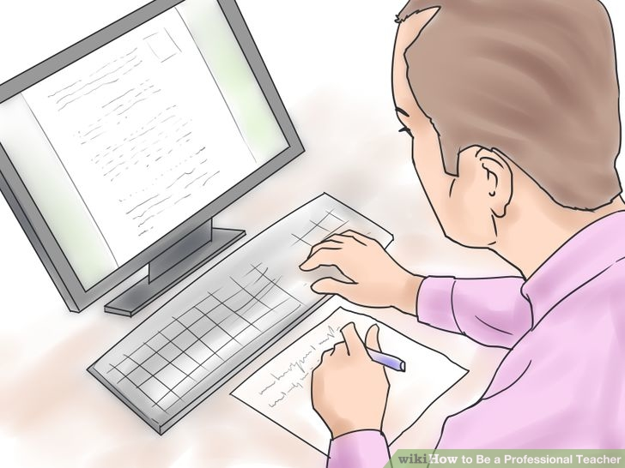
8
Never miss a deadline. Professionals keep their work up to date and plan ahead. Amateurs leave work until the last minute.
- 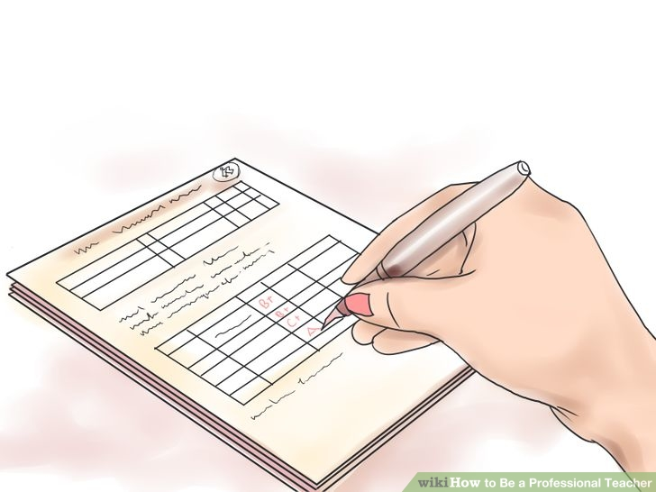
9
Keep up to date with your marking and grading of students' tasks. A three day rule of thumb should apply. If you take too long to hand back class tests and so on, the students will have lost interest in the task and their results by the time you return their work.
10
Treat your colleagues and supervisors with respect. Model respect for authority for your students and gaining their respect will be much easier for you.
11
Be passionate, positive, and enthusiastic about your work. A professional teacher will not create negativity in a staff room or engage in mindless gossip and the spreading of dissent.
- 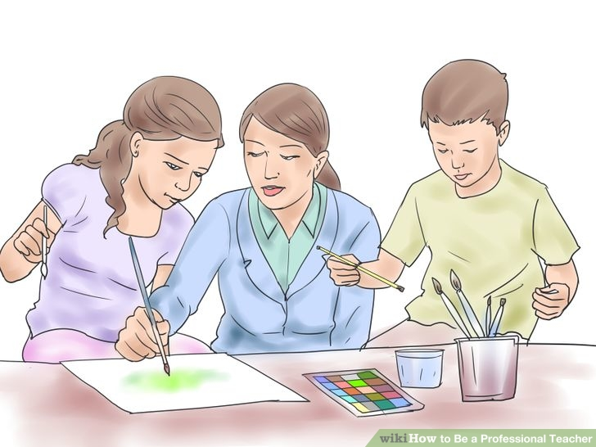
12
Embrace change. A professional teacher will not be a doomsayer and throw cold water on new ideas or suggestions for positive change. A professional will not vocalise negative thoughts like "That will never work at this school."
13
Take an interest in every child. The better you get to know your students, the more influence you will have on their attitude towards your subject and on their lives in general. Remember the adage: "Teachers touch eternity; they never know where their influence may end."
- 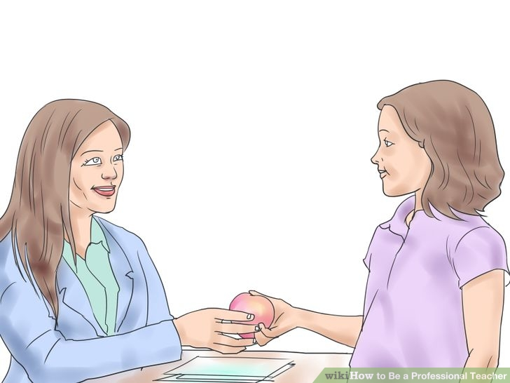
14
Treat your students with respect. Follow the maxim "Do unto others." Never publicly humiliate or belittle your students. Do not discuss their results or grades in front of other students. Don't personalise issues with students. Leave their family, background, religion, behaviour, and personal circumstances out of public disciplinary processes and discussions.
15
Be a mentor not a friend. Model responsible adult values, exhibit self-control, choose your words carefully and consider the impact they may have on a particular student or group of students.
- 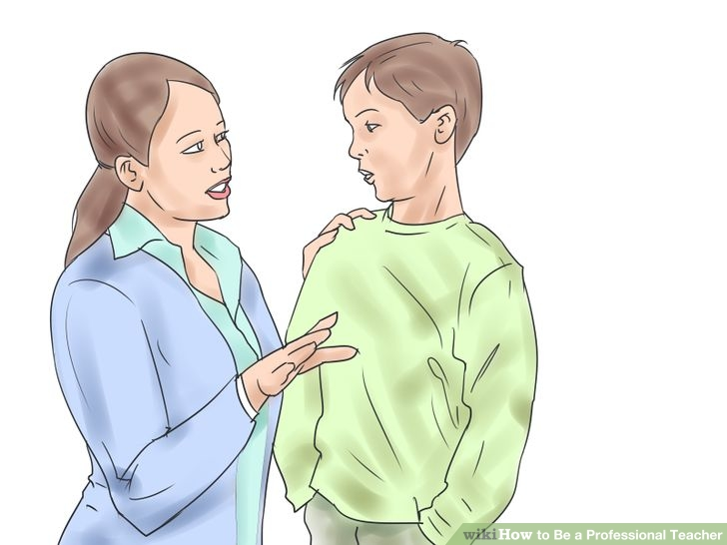
16
Maintain confidentiality. A professional teacher will use students' personal information to assist in helping a child to reach his or her potential. Confidential information will not be disclosed over tea during recess, or used as a weapon against a student. Confidential information such as the content of staff meetings too will be treated in the strictest of confidence.
- 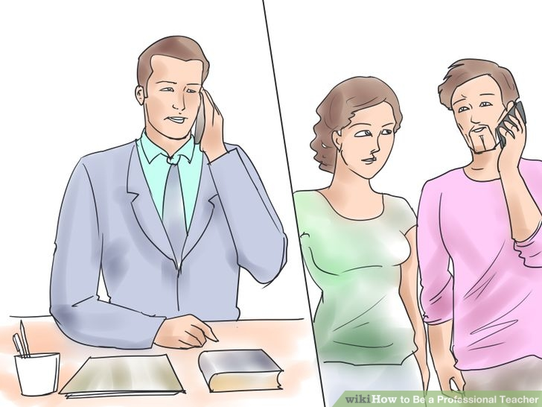
17
Consult parents. Try to include parents in the educational process and encourage their support of the school's disciplinary processes and procedures. Be polite and calm when dealing with parents. Keep reminding them that every discussion about the child needs to be undertaken with the child's best interests at heart.
18
Put safety first. Remember that as a professional teacher you are offering a service to the students and the school community. You are duty-bound to take your "in loco parentis" role seriously. Explain why certain rules are in place and follow all institutional risk management procedures.
19
Support your colleagues and school management. Walk the talk. Put the needs of the institution above your own. Remember you are one person in a group of professionals who share a common goal and vision.
- 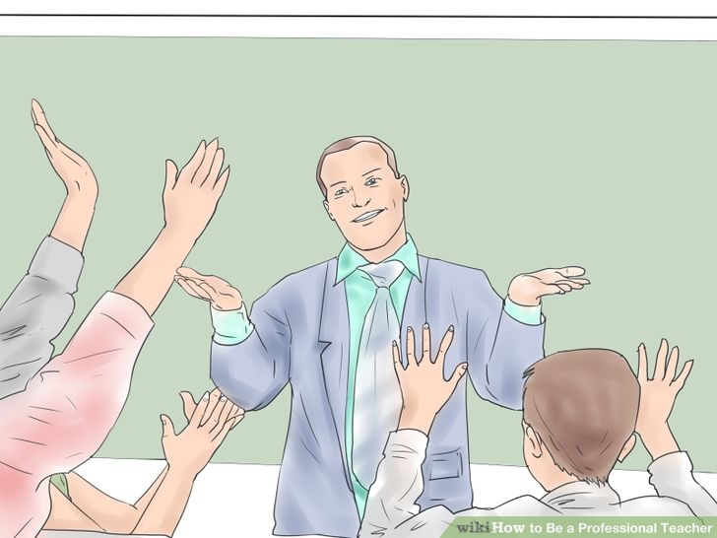
20
Let excellence be your aim. Constantly provide benchmarks for improvement for your students. Give praise when it is due, lots of it. Draw gently alongside those who are in need of help and find creative ways to assist them to improve their grades.
- 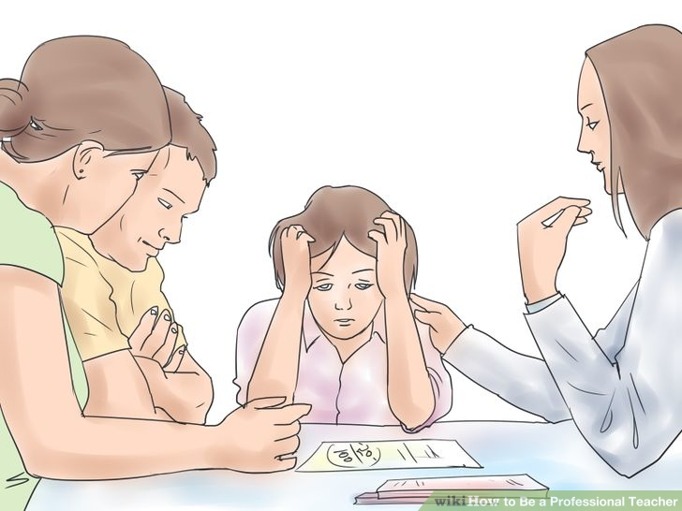
21
Take responsibility for your student's results. As a professional teacher, the grades your students achieve are a reflection on you. Bear this in mind, in all you do.
22
Behave professionally in public. Always support your school if negative people are bad-mouthing the institution. Swearing and being drunk in public will cause community members to lose respect not only for you, but for the profession at large.
- 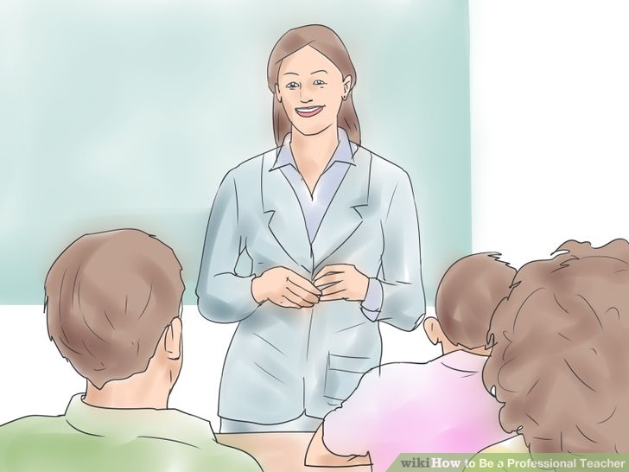
23
Keep abreast of education policy and legislation.
- 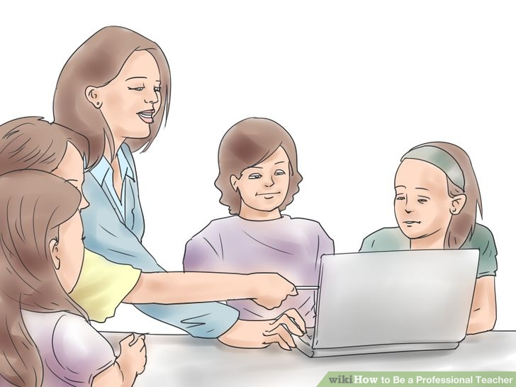
24
Constantly seek new subject knowledge and share this with your students. Take short courses to keep yourself mentally stimulated. Your renewed enthusiasm for your subject will be rewarded by increased student interest and enthusiasm for the subject itself.
25
Simplify your lessons: Good teachers make it easy to understand complicated things. Use examples, models and coloured pictures and Photographs. Teach in illustrations that your students can relate to.
- 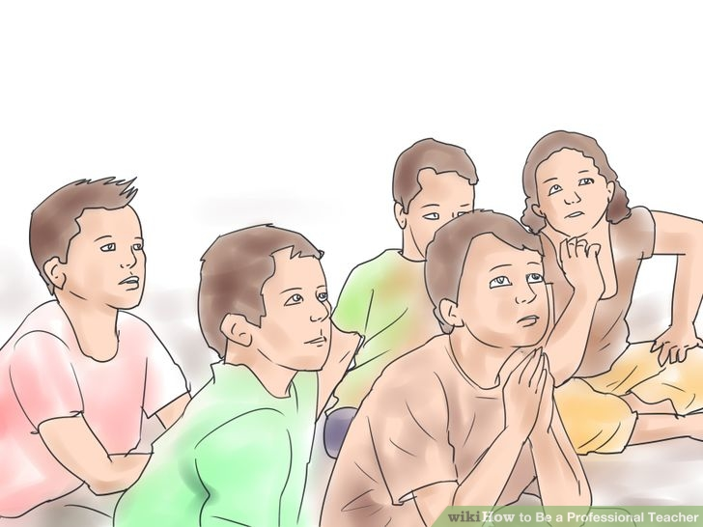
26
Keep your students attention. Teach your students why the knowledge you convey is important and how they can apply what they learn in their daily lives. Then they are more likely to remember what you teach.

