**RESEARCH DESIGN**

**John W. Creswell**

**University of Nebraska**

**2003**

**RESEARCH DESIGN**

Qualitative, Quantitative and Mixed Methods Approaches

SECOND EDITION

**John W. Creswell**

University of Nebraska, Lincoln

**SAGE** Publications

International Educational and Professional Publisher

Thousand Oaks London New Delhi

Copyright O 2003 by Sage Publications, Inc.

All rights reserved. No part of this book may be reproduced or utilized in any form or by any means, electronic or mechanical, including photocopying, recording, or by any information storage and retrieval system, without permission in writing from the publisher.

Cover image copyright O Sheldan CollinsICorbis; used by permission.

**CHAPTER ONE: A Framework for Design**

In the past two decades, research approaches have multiplied to a point at which investigators or inquirers have many choices. For those designing a proposal or plan, I recommend that a general framework be adopted to provide guidance about all facets of the study, from assessing the general philosophical ideas behind the inquiry to the detailed data collection and analysis procedures. Using an extant framework also allows researchers to lodge their plans in ideas well grounded in the literature and recognized by audiences (e.g., faculty committees) that read and support proposals for research.

What frameworks exist for designing a proposal? Although different types and terms abound in **the** literature, I will focus on three: quantitative, qualitative, and mixed methods approaches. 'The first has been available to the social and human scientist for years, the second has emerged primarily during the last three or four decades, and the last is new and still developing in form and substance.

This chapter introduces the reader to the three approaches to research. I suggest that to understand them, the proposal developer needs to consider three framework **elements:** philosophical assumptions about what constitutes ***knowledge*** *claims;* general procedures of research called *strategies of inquiry* and detailed procedures of data collection, analysis, and **writing** called *methods.* Qualitative, quantitative, and mixed methods approaches frame each of these elements differently, and these differences are identified and discussed in this chapter. 'Then typical scenarios that combine the three elements are advanced, followed **by** the reasons why one would choose one approach over another in designing a study. 'This discussion will not be a philosophical **treatise** on the nature of knowledge, but it will provide a practical grounding in some of the philosophical ideas behind research.

**THREE ELEMENTS OF INQUIRY**

In the first edition of this book, I used two approaches-qualitative and quantitative. I described each in terms of different philosophical assumptions about the nature of reality, epistemology, values, the rhetoric of research, and methodology (Creswell, 1994). Several developments in the last decade have caused a reexamination of this stance.

* Mixed methods research has come of age. To include only quantitative and qualitative methods falls short of the major approaches being used today in the social and human sciences.
* Other philosophical assumptions beyond those advanced in 1994 have been widely discussed in the literature. Most notably, critical perspectives, advocacy/participatory perspectives, and pragmatic ideas are being extensively discussed. Although philosophical ideas remain largely "hidden" in research (Slife & Williams, 1995***),*** they still influence the practice of research and need to be identified.
* The situation today is less quantitative versus qualitative and more how research practices lie somewhere on a continuum between the two (e.g., Newrnan & Benz, 1998). The best that can be said is that studies tend to be more quantitative or qualitative in nature. Thus, later in the chapter I introduce typical scenarios of quantitative, qualitative, and mixed methods research.
* Finally, the practice of research (such as writing a proposal) involves much more than philosophical assumptions. Philosophical ideas must be combined with broad approaches to research (strategies) and implemented with specific procedures (methods). Thus, a framework is needed that combines the elements of philosophical ideas, strategies, and methods into the three approaches to research. Crotty's (1998) ideas established the groundwork for this framework. He suggested that in designing a research proposal, we consider four questions:

1. What epistemology-theory of knowledge embedded in the theoretical perspective--informs the research (e.g., objectivism, subjectivism, etc.)?
2. What theoretical perspective-philosophical stance-lies behind the methodology in questions (e.g., positivism and postpositivm, interpretivism, critical theory, etc.)?

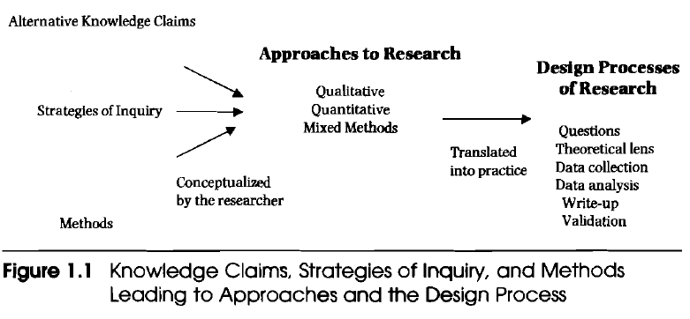

1. What methodology-strategy or plan of action that links methods to outcomes-governs our choice and use of methods (e.g., experimental research, survey research, ethnography, etc.)?
2. What methods-techniques and procedures40 we propose to use (e.g., questionnaire, interview. focus group, etc.)?

These four questions show the interrelated levels of decisions that go into the process of designing research. Moreover, these are aspects that inform a choice of approach, ranging fromthe broad assumptions that are brought to a project to the more practical decisions made about how to collect and analyze data. With these ideas in mind, I conceptualized Crotty's model to address three questions central to the design of research:

1. What knowledge claims are being made by the researcher (including a theoretical perspective)?
2. What strategies of inquiry will inform the procedures?
3. What methods of data collection and analysis will be used?

Next, I drew a picture, as shown in Figure 1.1. This displays how three elements of inquiry (i.e., knowledge claims, strategies, and methods) combine to form different approaches to research. These approaches, in turn, are translated into processes in the design of research. Preliminary steps in designing a research proposal, then, are to assess the knowledge claims brought to the study, to consider the strategy of inquiry that will be used, and to identify specific methods. Using these three elements, a researcher can then identify either the quantitative, qualitative, or mixed methods approach to inquiry.

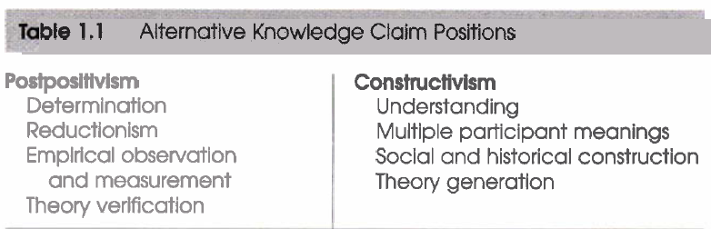



**Alternative Knowledge Claims**

Stating a ***knowledge claim*** means that researchers start a project with certain assumptions about how they will learn and what they will learn during their inquiry. These claims might be called paradigms (Lincoln & Guba, 2000; Mertens, 1998); philosophical assumptions, epistemologies, and ontologies (Crotty, 19 9 8); or broadly conceived research methodologies (Neuman, 2000). Philosophically, researchers make claims about what is knowledge (ontology), how we know it (epistemology), what values go into it (axiology), how we write about it (rhetoric), and the processes for studying it (methodology) (Creswell, 1994). Four schools of thought about knowledge claims will be discussed: postpositivism, constructivism, advocacy/participatory, and pragmatism. The major elements of each position are presented in Table 1.1. In discussions to follow, I will attempt to translate the broad philosophical ideas of these positions into practice.

1. **Postpositive Knowledge Claims**

Traditionally, the postpositivist assumptions have governed claims about what warrants knowledge. This position is sometimes called the **scientific method** or doing **science research**. It is also called **quantitative research**, **positivist/postpositivist research**, **empirical science**, and **postpostivism**. The last term, "postpositivism," refers to the thinking after positivism, challenging the traditional notion of the *absolute truth of knowledge* (Phillips & Burbules, 2000) and recognizing that we cannot be *positive* about our claims of knowledge when studying the behavior and actions of humans. The postpositivist tradition comes from 19th-century writers such as Comte, Mill, Durkheim, Newton, and Locke (Smith, 1983), and it has been most recently articulated by writers such as Phillips and Burbules (2000).

Postpositivism reflects a deterministic philosophy in which causes probably determine effects or outcomes. Thus, the problems studied by postpositivists reflect a need to *examine causes that influence outcomes*, such as *issues examined in experiments*. It is also **reductionistic** in that the intent is to reduce the ideas into *a small, discrete set of ideas to test,* such as the variables that constitute hypotheses and research questions.

The knowledge that develops through a postpositivist lens is based on careful **observation** and **measurement** of the objective reality that exists "**out there**" in the world. Thus, developing **numeric measures** of observations and studying the behavior of individuals become paramount for a postpositivist. Finally, there are laws or theories that govern the world, and these need to be tested or verified and refined so that we can understand the world. Thus, in the scientific method-the accepted approach to research by postpostivists:

* an individual begins with a theory
* collects data that either supports or refutes the theory,
* and then makes necessary revisions before additional *tests*are conducted

In reading Phillips and Burbules (2000), one can gain a sense of the key assumptions of this position, such as the following:

1. That knowledge is conjectural (and anti-foundationa1)- absolute truth can never be found. Thus, evidence established in research is always **imperfect** and fallible. It is for this reason that researchers do not prove hypotheses and instead indicate a failure to reject.
2. Research is the process of making claims and then refining or abandoning some of them for other claims more strongly warranted. Most quantitative research. for example, starts with the test of a theory.
3. Data, evidence, and rational considerations shape knowledge. In practice, the researcher collects information on instruments based on measures completed by the participants or by observations recorded by the researcher.
4. Research seeks to develop relevant true statements, ones that can serve to explain the situation that is of concern or that describes the causal relationships of interest. In quantitative studies, researchers advance the relationship among variables and pose this in terms of questions or hypotheses.
5. Being objective is an essential aspect of competent inquiry, and for this reason researchers must examine methods and conclusions for bias. For example, standards of validity and reliability are important in quantitative research.
6. **Socially Constructed Knowledge Claims**

Others claim knowledge through an alternative process and set of assumptions. Social constructivism (often combined with interpretivism; see Mertens, 1998) is such a perspective. The ideas came from Mannheim and from works such as Berger and Luckmann's ***The Social*** ***Construction of Reality*** (1 9 6 7) and Lincoln and Guba's ***Naturalistic*** ***Inquiry*** (1985). More recent writers who have summarized this position are Lincoln and Guba (2000), Schwandt (2000), Neuman (2000), and Crotty (1 998), among others. Assumptions identified in these works hold that individuals seek understanding of the world in which they live and work. They develop subjective meanings of their experiences-meanings directed toward certain objects or things. These meanings are varied and multiple, leading the researcher to look for the complexity of views rather than narrowing meanings into a few categories or ideas. The goal of research, then, is to rely as much as possible on the participants' views of the situation being studied. The questions become broad and general so that the participants can construct the meaning of a situation, a meaning typically forged in discussions or interactions with other persons. The more open-ended the questioning, the better, as the researcher listens carefully to what people say or do in their life setting. Often these subjective meanings are negotiated socially and historically. **In** other words, they are not simply imprinted on individuals but are formed through interaction with others (hence social constructivism) **and** through historical and cultural norms that operate in individuals' lives**.** Thus, constructivist researchers often address the "processes" of interaction among individuals. They also focus on the specific contexts in which people live and work in order to understand the historical **and** cultural settings of the participants.

Researchers recognize that their own background shapes their interpretation, and they "position themselves" in the research to acknowledge how their interpretation flows from their own personal, cultural, and historical experiences. The researcher's intent, then, is to make sense of (or interpret) the meanings others have about the world. Rather than starting with a theory (as in postpostivism), inquirers generate or inductively develop a theory or pattern of meaning. For example, in discussing constructivism, Crotty (1998) identified several assumptions:

1. Meanings are constructed by human beings as they engage with the world they are interpreting. Qualitative researchers tend to use open-ended questions so that participants can express their views. Humans engage with their world and make sense of it based on their historical and social perspective. We are all born into a world of meaning bestowed upon us by our culture. Thus, qualitative researchers seek to understand the context or setting of the participants through visiting this context and gathering information personally. They also make an interpretation of what they find, an interpretation shaped by the researchers' own experiences and backgrounds.
2. The basic generation of meaning is always social, arising in and out of interaction with a human community. The process of qualitative research is largely inductive, with the inquirer generating meaning from the data collected in the field.
3. **Advocacy/Participatory Knowledge Claims**

Another group of researchers claims knowledge through an advocacy/participatory approach. This position arose during the 1980s and 1990s from individuals who felt that the postpostivist assumptions imposed structural laws and theories that did not fit marginalized individuals or groups or did not adequately address issues of social justice.

Historically, some of the advocacy/participatory (or emancipatory) writers have drawn on the works of **Marx,** Adorno, Marcuse, Habermas, and Freire (Neuman, 2000). More recently, works by Fay (1987), Heron and Reason (199 7), and Kemmis and WWson (1998) can be read for this perspective. In the main, these inquirers felt that the constructivist stance did not go far enough in advocating for an action agenda to help marginalized peoples. These researchers believe that inquiry needs to be intertwined with politics and a political agenda. Thus, the research should contain an action agenda for reform that may change the lives of the participants, the institutions in which individuals work or live, and the researcher's life. Moreover, specific issues needed to be addressed that speak to important social issues of the day, issues such as empowerment, inequality, oppression, domination, suppression, and alienation.

The advocacy researcher often begins with one of these issues as the focal point of research. This research also assumes that the inquirer will proceed collaboratively so as to not further marginalize the participants as a result of the inquiry. In this sense, the participants may help design questions, collect data, analyze information, or receive rewards for participating in the research. The "voice" for the participants becomes a united voice for reform and change. This advocacy may mean providing a voice for these participants, raising their consciousness, or advancing an agenda for change to improve the lives of the participants.

Within these knowledge claims are stances for groups and individuals in society that may be marginalized or disenfranchised. Therefore, theoretical perspectives may be integrated with the philosophical assumptions that construct a picture of the issues being examined, the people to be studied, and the changes that are needed. Some of these theoretical perspectives are listed below.

***Feminist perspectives*** center and make problematic women's diverse situations and the institutions that frame those situations. Research topics may include policy issues related to realizing social justice for women in specific contexts or knowledge about oppressive situations for women (Olesen, 2000).

***Racialized discourses*** raise important questions about the control and production of knowledge, particularly knowledge about people and communities of color (Ladson-Billings, 2000).

***Critical theory*** perspectives are concerned with empowering human beings to transcend the constraints placed on them by race, class, and gender (Fay, 19 8 7).

***Queer theory*** focuses on individuals calling themselves lesbians, gay, bisexuals, or transgendered people. The research can be less objectifying, can be more concerned with cultural and political means, and can convey the voices and experiences of individuals who have been suppressed (Gamson, 2000).

***Disability inquiry*** addresses the meaning of inclusion in schools and encompasses administrators, teachers, and parents who have children with disabilities (Mertens, 1998). These are diverse groups and topics, and my summaries here are inadequate generalizations. It is helpful to view the summary by Kemrnis and Wilkinson (1998) of key features of the advocacy or participatory forms of inquiry:

1. Participatory action is recursive or dialectical and is focused on bringing about change in practices. Thus, at the end of advocacy/participatory studies, researchers advance an action agenda for change.
2. It is focused on helping individuals free themselves from constraints found in the media, in language, in work procedures, and in the relationships of power in educational settings. Advocacy/ participatory studies often begin with an important issue or stance about the problems in society, such as the need for empowerment.
3. It is emancipatory in that it helps unshackle people from the constraints of irrational and unjust structures that limit self development and self-determination. The aim of advocacy/participatory studies is to create a political debate and discussion so that change will occur.
4. It is practical and collaborative because it is inquiry completed "with" others rather than "on" or "to" others. In this spirit, advocacy/participatory authors engage the participants as active collaborators in their inquiries.
5. **Pragmatic Knowledge Claims**

Another position about claims on knowledge comes from the pragmatists. Pragmatism derives from the work of Peirce, James, Mead, and Dewey (Cherryholmes, 1992). Recent writers include Rorty (1990), Murphy (1990), Patton (1990), and Cherryholmes (1992). There are many forms of pragmatism. For many of them, knowledge claims arise out of **actions**, **situations**, and **consequences** rather than antecedent conditions (as in postpositivism). There is a concern with applications-" what works”-and solutions to problems (Patton, 1990). Instead of methods being important, **the problem is most important**, and **researchers use all approaches to understand the problem** (see Rossman & Wilson, 1985). As a philosophical underpinning for mixed methods studies, Tashakkori and Teddlie (1998) and Patton (1990) convey the importance for focusing attention on the research problem in social science research and then using pluralistic approaches **to derive knowledge about the problem**. According to Cherryholmes (1992; Murphy, 1990) and my own interpretations of these writers, pragmatism provides a basis for the following knowledge claims:

1. Pragmatism is not committed to any one system of philosophy and reality. This applies to **mixed methods** **research** in that inquirers draw liberally from both quantitative and qualitative assumptions when they engage in their research.
2. Individual researchers have a **freedom of choice**. They are "free" to choose the methods, techniques, and procedures of research that best meet their needs and purposes.
3. Pragmatists do not see the world asan absolute unity. In a similar way, mixed methods researchers **look to many approaches** to collecting and analyzing data rather than subscribing to only one way (e.g., quantitative or qualitative).
4. **Truth is what works at the time;** it is not based in a strict dualism between the mind and a reality completely independent of the mind. Thus, in mixed methods research, investigators use both quantitative and qualitative data because they work to provide the best understanding of a research problem.
5. Pragmatist researchers look to the **'what"** and **"how**" to research based on its intended consequence-where they want to go with it. Mixed methods researchers needto establish a purpose for their "mixing," a rationale for the reasonswhy quantitative and qualitative data need to be mixed in the firstplace.
6. Pragmatists agree that research **always occurs** in social, historical, political, and other contexts. In **this way,** mixed methods studies may include a postmodern turn, a theoretical lens that is **reflexive of social justice** and **political aims**.
7. Pragmatists believe (Cherryholmes, 1992) that we need to stop asking questions about *reality and the laws of nature*. "They would simply like to change the subject" (Rorty, 1983, p. xiv). Thus, for the mixed methods researcher, pragmatism opens the door to *multiple methods*, *different* *worldviews, and different assumptions, as well as to different forms of data collection and analysis in the mixed methods study.*

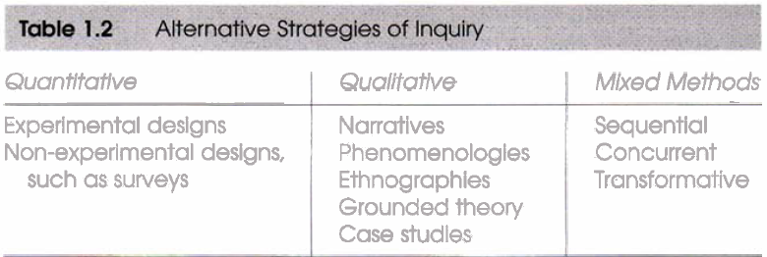

**Strategies of Inquiry**

The researcher brings to the choice of a research design assumptions about knowledge claims. In addition, operating at a more applied level are strategies of inquiry (or traditions of inquiry, Creswell, 1998; or methodologies, Mertens, 1998) that provide specific direction for procedures in a research design. Like knowledge claims, strategies have multiplied over the years as computer technology has pushed forward data analysis and the ability to analyze complex models, and as individuals have articulated new procedures for conducting social science research.

These strategies of inquiry contribute to our overall research approach. The major strategies employed in the social sciences are discussed in Chapters 9, 10, and 11 of this book. Rather than cover all or a large number of strategies, these chapters focus on those frequently used in the social sciences. Here I will introduce those that will be discussed later and that are cited in examples of research throughout the book. An overview of these strategies is shown in Table 1.2.

1. Strategies Associated With the Quantitative Approach

During the late 19th century and throughout the 20th, strategies of inquiry associated with quantitative research were those that invoked the postpositivist perspectives. These include the true experiments and the less rigorous **experiments** called **quasi-experiments** and **correlational** **studies** (Campbell & Stanley, 1963), and specific **single-subject experiments** (Cooper, Heron, & Heward, 1987; Neuman & McCorrnick, 1995). More recently, quantitative strategies involved complex experiments with **many variables** and treatments (e.g., *factorial designs* and *repeated measure designs*). They also included elaborate structural equation models that incorporated causal paths and the identification of the collective strength of *multiple variables*. In this book, we will focus on two strategies of inquiry: **experiments** and **surveys**.

* ***Experiments*** include true experiments, with the random assignment of subjects to treatment conditions, as well as quasi-experiments that use nonrandomized designs (Keppel, 19 9 1). Included within quasi-experiments are *single-subject designs*.
* ***Surveys*** include cross-sectional and longitudinal studies using questionnaires or structured interviews for data collection, with the intent of generalizing from a sample to a population (Babbie, 1990).

1. Strategies Associated With the Qualitative Approach

In qualitative research, the numbers and types of approaches also became more clearly visible during the 1990s. Books have summarized the various types (such as the 19 strategies identified by Wolcott, 2001), and complete procedures are now available on specific qualitative inquiry approaches. For example, Clandinin and Connelly (2000) have constructed a picture of what "**narrative researchers do,**" Moustakas (1994) discussed the philosophical tenets and the procedures of the **phenomenological method**, and Strauss and Corbin (1990, 1998) have explicated the procedures of **grounded theory**. Wolcott (1999) has summarized **ethnographic procedures**, and Stake (1995) has identified the processes of **case study research**. In this **book,** illustrations will be drawn from the following strategies:

1. ***Ethnographies,*** in which the researcher studies an intact cultural group in a natural setting over a prolonged period of time by collecting, primarily, observational data (Creswell, 1998). The research process is flexible and typically evolves contextually in response to the lived realities encountered in the field setting (LeCompte & Schensul, 1999).
2. ***Grounded theory,*** in which the researcher attempts to derive a general, abstract theory of a process, action, or interaction grounded in the views of participants in a study. This process involves using multiple stages of data collection and the refinement and interrelationship of categories of information (Strauss & Corbin, 1990,199 8). Two primary characteristics of this design are the constant comparison of data with emerging categories and theoretical sampling of different groups to maximize the similarities and the differences of information.
3. ***Case studies,*** in which the researcher explores in depth a program, an event, an activity, a process, or one or more individuals. The case(s) are bounded by time and activity, and researchers collect detailed information using a variety of data collection procedures over a sustained period of time (Stake, 1995).
4. ***Phenomenological research,*** in which the researcher identifies the "essence" of human experiences concerning a phenomenon, as described by participants in a study. Understanding the "lived experiences" marks phenomenology as a philosophy as well as a method, and the procedure involves studying a small number of subjects through extensive and prolonged engagement to develop patterns and relationships of meaning (Moustakas, 1994). In this process, the researcher "brackets" his or her own experiences in order to understand those of the participants in the study (Nieswiadomy, 1993).
5. ***Narrative research,*** a form of inquiry in which the researcher studies the lives of individuals and asks one or more individuals to provide stories about their lives. This information is then retold or restored by the researcher into a narrative chronology. In the end, the narrative combines views from the participant's life with those of the researcher's life in a collaborative narrative (Clandinin & Connelly, 2000).
6. Strategies Associated With the Mixed Methods Approach

Less well known than either the quantitative or qualitative strategies are those that involve collecting and analyzing both forms of data in a single study. The concept of mixing different methods probably originated in 1959, when Campbell and **Fiske** used multiple methods to study validity of psychological traits. They encouraged others to employ their "multi-method matrix to examine multiple approaches to data collection in a study. This prompted others to mix methods, and soon approaches associated with field methods such as observations and interviews (qualitative data) were combined with traditional surveys (quantitative data) (S. D. Sieber, 1973). Recognizing that all methods have limitations, researchers felt that biases inherent in any single method could neutralize or cancel the biases of other methods. Triangulating data sources-a means for seeking convergence across qualitative and quantitative methods-were born (Jick, 1979). From the original concept of triangulation emerged additional reasons for mixing different types of data. For example, the results from one method can help develop or inform the other method (Greene, Caracelli, & Graham, **1989).** Alternatively, one method can be nested within another method to provide insight into different levels or units of analysis (Tashakkori & Teddlie, **1998).** Or the methods can serve a larger, transformative purpose to change and advocate for marginalized groups, such as women, ethnicIracia1 minorities, members of gay and lesbian communities, people with disabilities, and those who are poor (Mertens, **2003).**

These reasons for mixing methods have led writers from around the world to develop procedures for mixed methods strategies of inquiry and to take the numerous terms found in the literature, such as multimethod, convergence, integrated, and combined (Creswell, **1994)** and shape procedures for research (Tashakkori & Teddlie, **2003).** In particular, three general strategies and several variations within them will be illustrated in this book:

* Sequential procedures, in which the researcher seeks to elaborate on or expand the findings of one method with another method. This may involve beginning with a qualitative method for exploratory purposes and following up with a quantitative method with a large sample so that the researcher can generalize results to a population. Alternatively, the study may begin with a quantitative method in which theories or concepts are tested, to be followed by a qualitative method involving detailed exploration with a few cases or individuals.
* Concurrent procedures, in which the researcher converges quantitative and qualitative data in order to provide a comprehensive analysis of the research problem. In this design, the investigator collects both forms of data at the same time during the study and then integrates the information in the interpretation of the overall results. Also, in this design, the researcher nests one form of data within another, larger data collection procedure in order to analyze different questions or levels of units in an organization.
* Transformative procedures, in which the researcher uses a theoretical lens (see Chapter 7) as an overarching perspective within a design that contains both quantitative and qualitative data. This lens provides a framework for topics of interest, methods for collecting data, and outcomes or changes anticipated by the study. Within this lens could be a data collection method that involves a sequential or a concurrent approach.

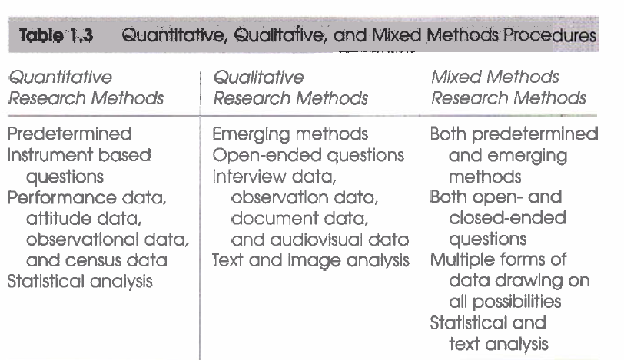

**Research Methods**

The third major element that goes into a research approach is the specific methods of data collection and analysis. As shown in Table **1.3,** it is useful to consider the full range of possibilities for data collection in any study, and to organize these methods by their degree of predetermined nature, their use of closed-ended versus open-ended questioning, and their focus for numeric versus non-numeric data analysis. These methods will be developed further in Chapters 9 through 11 as quantitative, qualitative, and mixed methods.

Researchers collect data on an instrument or test (e.g., a set of questions about attitudes toward self-esteem) or gather information on a behavioral checklist (e.g., where researchers observe a worker engaged in using a complex skill). On the other end of the continuum, it might involve visiting a research site and observing the behavior of individuals without predetermined questions or conducting an interview in which the individual is allowed to talk openly about a topic largely without the use of specific questions. The choice of methods by a researcher turns on whether the intent is to specify the type of information to be collected in advance of the study or to allow it to emerge from participants in the project. Also, the type of data may be numeric information gathered on scales of instruments or more text information, recording and reporting the voice of the participants. In some forms of data collection, both quantitative and qualitative data are collected. Instrument data may be augmented with open-ended observations, or census data may be followed by in-depth exploratory interviews.

**THREE APPROACHES TO RESEARCH**

The knowledge claims, the strategies, and the method all contribute to a research approach that ***tends*** to be more quantitative, qualitative, or mixed. Table 1.4 creates distinctions that may be useful in choosing an approach for a proposal. This table also includes practices of all three approaches that will be emphasized in the remaining chapters of this book.

Definitions can help further clarify the three approaches: A ***quantitative*** approach is one in which the investigator primarily uses **postpositivist claims** for developing knowledge (i.e., cause and effect thinking, reduction to specific variables and hypotheses and questions, use of measurement and observation, and the test of theories), employs strategies of inquiry such as experiments and surveys, and collects data on predetermined instruments that yield statistical data.

Alternatively, a ***qualitative*** approach is one in which the inquirer often makes knowledge claims based primarily on constructivist perspectives (i.e., the multiple meanings of individual experiences, meanings socially and historically constructed. with an intent of developing a theory or pattern) or advocacy/participatory perspectives (i.e., political, issue-oriented, collaborative. or change oriented) or both. It also uses strategies of inquiry such as narratives, phenomenologies, ethnographies, grounded theory studies, or case studies. The researcher collects open-ended, emerging data with the primary intent of developing themes from the data.

Finally, a ***mixed methods*** approach is one in which the researcher tends to base knowledge claims on pragmatic grounds (e.g., consequence- oriented, problem-centered, and pluralistic). It employs strategies of inquiry that involve collecting data either simultaneously or sequentially to best understand research problems.

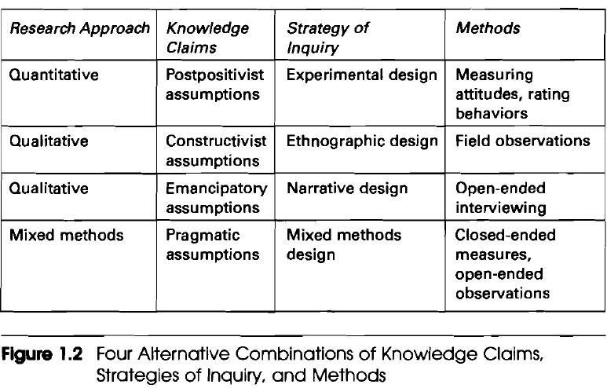

The data collection also involves gathering both numeric information (e.g., on instruments) as well as text information (e.g., on interviews) so that the final database represents both quantitative and qualitative information. To see how these three elements (knowledge claims, strategies, and methods) combine in practice, I have drafted several typical scenarios of research, as shown in Figure 1.2.

**Quantitative approach:** postpositivist knowledge claims, experimental strategy of inquiry, and pre- and posttest measures of attitudes In this scenario, the researcher tests a theory by specifying narrow hypotheses and the collection of data to support or refute the hypotheses. An experimental design is used in which attitudes are assessed both before and after an experimental treatment. The data are collected on an instrument that measures attitudes, and the information collected is analyzed using statistical procedures and hypothesis testing.

**Qualitative approach:** constructivist knowledge claims, ethnographic design, and observation of behavior.

**Pragmatic assumptions**

In this situation the researcher seeks to establish the meaning of a phenomenon from the views of participants. This means identifying a culture-sharing group and studying how it developed shared patterns of behavior over time (i.e., ethnography). One of the key elements of collecting data is to observe participants' behaviors by participating in their activities.

***Qualitative*** approach: participatory knowledge claims, narrative design, and open-ended interviewing. For this study, the inquirer seeks to examine an issue related to oppression of individuals. To study this, the approach is taken of collecting stories of individual oppression using a narrative approach. Individuals are interviewed at some length to determine how they have personally experienced oppression.

***Mixed methods*** approach: pragmatic knowledge claims, collection of both quantitative and qualitative data sequentially. The researcher bases the inquiry on the assumption that collecting diverse types of data best provides an understanding of a research problem. The study begins with a broad survey in order to generalize results to a population and then focuses, in a second phase, on detailed qualitative, open-ended interviews to collect detailed views from participants.

**CRITERIA FOR SELECTING AN APPROACH**

Given these three approaches, what factors affect a choice of one approach over another for the design of a proposal? Three considerations play into this decision:

* the research problem
* the personal experiences of the researcher and
* the audience(s) for whom the report will be written

**Match Between Problem and Approach**

Certain types of social research problems call for specific approaches. A research problem, as discussed in Chapter 4, is an issue or concern that needs to be addressed (e.g., whether one type of intervention works better than another type of intervention). For example, if the problem is identifying factors that influence an outcome, the utility of an intervention, or understanding the best predictors of outcomes, then a quantitative approach is best. It is also the best approach to use to test a theory or explanation. On the other hand, if a concept or phenomenon needs to be understood because little research has been done on it, then it merits a qualitative approach. Qualitative research is exploratory and is useful when the researcher does not know the important variables to examine. This type of approach may be needed because the topic is new, the topic has never been addressed with a certain sample or group of people, or existing theories do not apply with the particular sample or group under study (Morse, 199 1).

A mixed methods design is useful to capture the best of both quantitative and qualitative approaches. For example, a researcher may want to both generalize the findings to a population and develop a detailed view of the meaning of a phenomenon or concept for individuals. In this research, the inquirer first explores generally to learn about what variables to study and then studies those variables with a large sample of individuals. Alternatively, researchers may first survey a large number of individuals, then, follow up with a few of them to obtain their specific language and voices about the topic. In these situations, the advantages of collecting both close ended quantitative data and open-ended qualitative data prove advantageous to best understand a research problem.

**Personal Experiences**

Into this mix of choice also comes the researcher's own personal training and experiences. An individual trained in technical, scientific writing, statistics, and computer statistical programs, who is also familiar with quantitative journals in the library, would most likely choose the quantitative design. The qualitative approach incorporates much more of a literary form of writing, computer text analysis programs, and experience in conducting open-ended interviews and observations.

The mixed methods researcher needs to be familiar with both quantitative and qualitative research. This person also needs an understanding of the **rationales** for combining both forms of data so that they can be **articulated** in a proposal. The mixed methods approach also requires knowledge about the different mixed methods designs that help organize procedures for a study.

Because quantitative studies are the traditional mode of research, carefully worked out procedures and rules exist for the research. This means that researchers may be more comfortable with the highly systematic procedures of quantitative research. Also, for some individuals, it can be uncomfortable to challenge accepted approaches among some faculty by using qualitative and advocacy/participatory approaches to inquiry. On the other hand, qualitative approaches allow room to be innovative and to work more within researcher-designed frameworks. They allow more creative, literary-style writing, a form that individuals may like to use. For advocacy/participatory writers, there is undoubtedly a strong personal stimulus to pursue topics that are of personal interest-issues that relate to marginalized people and an interest in creating a better society for them and everyone. For the mixed methods researcher, a project will take extra time because of the need to collect and analyze both quantitative and qualitative data. It fits a person who enjoys both the structure of quantitative research and the flexibility of qualitative inquiry.

**Audience**

Finally, researchers are sensitive to audiences to whom they report their research. These audiences may be journal editors, journal readers, graduate committees, conference attendees, or colleagues in the field. Students should consider the approaches typically supported and used by their advisers. The experiences of these audiences with quantitative, qualitative, or mixed methods studies will shape the decision made about this choice.



One preliminary consideration before designing a proposal is to identify a framework for the study. Three approaches to research are discussed in this chapter: quantitative, qualitative, and mixed methods research. They contain philosophical assumptions about knowledge claims, strategies of inquiry, and specific research methods. When philosophy, strategies, and methods are combined, they provide different frameworks for conducting research. The choice of which approach to use is based on the research problem, personal experiences, and the audiences for whom one seeks to write.



**Additional readings**

**Cherryholmes, C. H. (1992). Notes on pragmatism and scientific realism. Educational Researcher,l 4, August-September, 13-1 7.**

Cleo Cherryholmes contrasts pragmatism with traditional scientific research. The strengths of this article are the numerous citations to writers about pragmatism and a clarification of the alternative versions of pragmatism. Cherryholmes clarifies his own stance by indicating that pragmatism is driven by anticipated consequences, a reluctance to tell a true story, and the idea that there is an external world independent of our minds.

**Crotty, M. (1998). The foundations of *social* march: Meaning and perspective in the research process. London: Sage.**

Michael Crotty offers a useful framework for tying together the many epistemological issues, theoretical perspectives, methodology, and methods of social research. He interrelates the four components of the research process and shows in Table 1 a representative sampling of topics of each component. He then goes on to discuss nine different theoretical orientations in social research, such as postmodernism, feminism, critical inquiry, interpretivism, constructionism, and positivism.

**Kemmis, S.,** & **Wilkinson, M. (1998). Participatory action research and the study of practice. In B. Atweh, S. Kemmis,** & **l? Weeks (Eds.), *Action research in practice: Partnerships for* *social justice in education* (pp. 2 1-36). New York: Routledge.**

Stephen Kemmis and Mervyn Wilkinson provide an excellent overview of participatory research. In particular, they note the six major features of this inquiry approach and then discuss how action research is practiced at the individual, the social, or both levels.

**Lincoln, Y. S.,** & **Guba, E. G. (2000). Paradigmatic controversies, contradictions, and emerging confluences. In N. K. Denzin, Y. S. Lincoln,** & **E. G. Guba (Eds.), *Handbook of qualitative research* (2nd ed., pp. 163-188). Thousand Oaks, CA: Sage.**

Yvonna Lincoln and Egon Guba have provided the basic beliefs of five alternative inquiry paradigms in social science research. These extend the earlier analysis provided in the first edition of the Handbook and include positivism, postpositivism, critical theory, constructivism, and participatory paradigms. Each is presented in terms of ontology (i.e., nature of reality), epistemology (i.e., how we know what we know), and methodology (i.e., the process of research). The participatory paradigm adds another alternative paradigm to those originally advanced in the first edition. After briefly presenting these five approaches, the authors contrast them in terms of seven issues, such as the nature of knowledge and how knowledge accumulates.

**Neuman, W. L. (2000). *Social research methods: Qualitative and quantitative aproaches* (4th ed.). Boston: Allyn and Bacon.**

Lawrence Neuman provides a comprehensive research methods text as an introduction to social science research. Especially helpful in understanding the alternative meaning of methodology is Chapter 4, titled "The Meanings of Methodology," in which he contrasts three methodologies-positivist social science, interpretive social science, and critical social science-in terms of eight questions (e.g., What constitutes an explanation or theory of social reality? What does good evidence or factual information look like?)

**Phillips, D. C.,** & **Burbules, N. C. (2000). Postpositivism and educationd research. Lanham, MD: Rowman** & **Littlefield.**

D. C. Phillips and Nicholas Burbules summarize the major ideas of postpositivist thinking. Through two chapters, "What Is Postpositivism?" and "Philosophical Commitments of Postpositivist Researchers," the authors advance major ideas about postpositivism, especially those that differentiate it from positivism. These include knowing that human knowledge is conjectural rather than unchallengeable, and that our warrants for knowledge can be withdrawn in light of further investigations.

ssssssssssssssssssssssss April 2020 sssssssssssssssssssssss