FACULTY OF SOCIAL SCIENCES AND HUMANITIES
DEPARTMENT OF ENGLISH LANGUAGE AND LITERATURE
Module for the course Seminar on Selected Topics (Enla 3112)
Credit hours: 2

Content Page
Chapter One: The Nature and Characteristics of Research
- Types of Research ------------------------------------------------------------------------
- What is a Research Problem? ------------------------------------------------------------
- Selection of Research Problem ----------------------------------------------------------
- Sources of Research Problem ------------------------------------------------------------
- Criteria for a Good Research Topic -----------------------------------------------------
- Defining the Research Problem ----------------------------------------------------------
- Research Process ---------------------------------------------------------------------------
- Data Sources and Methods of Data Collection-----------------------------------------
- Significances of Research ----------------------------------------------------------------
- Objectives of Research ------------------------------------------------------------------
- Motivation in Research---------------------------------------------------------------------
Chapter Two: A Research Proposal ------------------------------------------------------------
- What is A Research Proposal? ------------------------------------------------------------
- Characteristics of Research Proposal -----------------------------------------------------
- Components of A Research Proposal-----------------------------------------------------
Chapter Three: Academic Writing and Presentation --------------------------------------
- Elements of writing ------------------------------------------------------------------------
- Writing Critical Reviews of a Journal Article ------------------------------------------
- Effective Presentation ----------------------------------------------------------------------
- Writing a Research Report -----------------------------------------------------------------

Chapter One: The Nature and Characteristics of Research
1. Types of Research
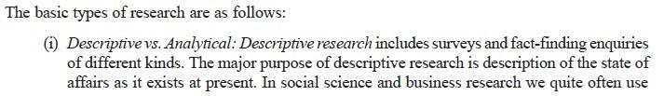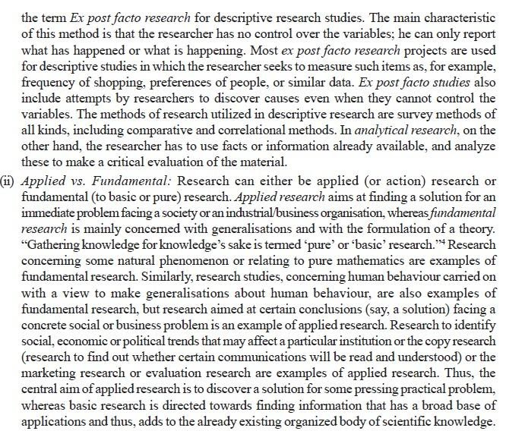
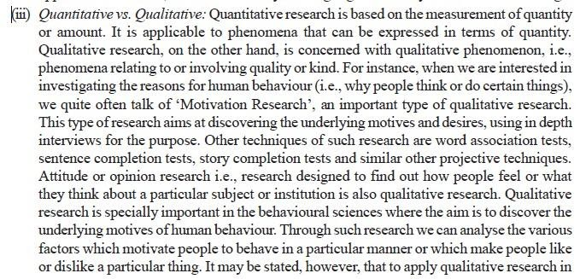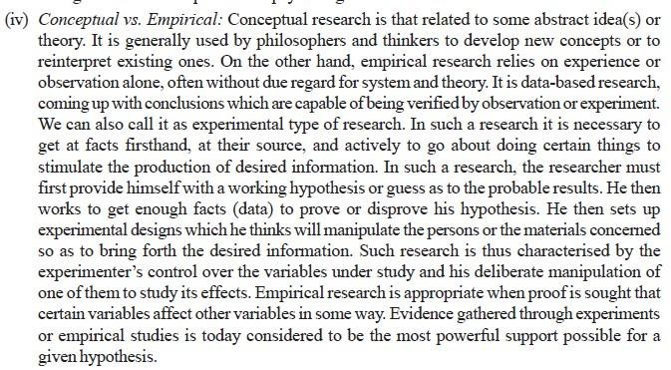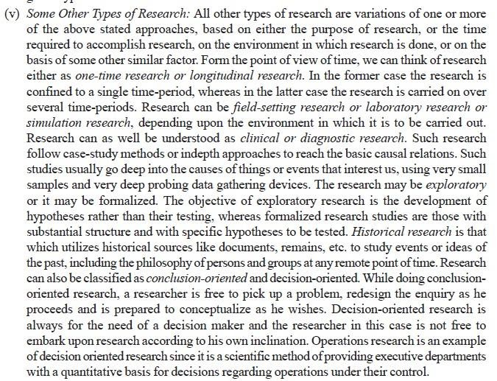
2. What is a Research Problem?
An event or situation that is difficult to fully understand or explain which/whose little is known. Harmful matter that needs to be dealt with and to overcome. Problem is solved by problem solving process, which is intellectual process that is refined and systematized. A research problem refers to some difficulty/problem which a researcher experiences/faces in the context of either a theoretical or practical situation which needs a solution. Thus, a research problem is one which requires a researcher to find out the best solution for the given problem, i.e., to find out by which course of action the objective can be attained optimally in the context of a given environment.
There are different components of research problem. The following are the components of a research problem as under:
- There must be an individual or a group which has some difficulty or the problem.
- There must be some objective(s) to be attained at. If one wants nothing, one cannot have a problem.
- There must be alternative means (or the courses of action) for obtaining the objective(s) one wishes to attain. This means that there must be at least two means available to a researcher, if he has no choice of means, he cannot have a problem.
- There must remain some doubt in the mind of a researcher with regard to the selection of alternatives. This means that research must answer the question concerning the relative efficiency of the possible alternatives.
- There must be some environment(s) to which the difficulty pertains.
3. Selection of Research Problem
The research problem undertaken for study must be carefully selected. The task is a difficult one, although it may not appear to be so. Help may be taken from a research guide in this connection. Nevertheless, every researcher must find out his own salvation for research problems cannot be borrowed. A problem must spring from the researcher’s mind like a plant springing from its own seed. Thus, a research guide can at the most only help a researcher choose a subject. However, the following points may be observed by a researcher in selecting a research problem or a subject for research:
Do all problems be researched?
As you are amidst innumerable social, economic, environmental, educational, etc problems, it is difficult to conduct a thorough investigation on a verity of problems that claim your attention. It is therefore essential to set priority areas in order to identify those problems, which are too grave/severe to require your immediate attention. Also, ask yourself: where does my interest, ability, experience fit in order to make a worthy investigation?
4. Sources of Research Problem
There are important sources out of which you may select a problem for investigation. Some of these are the following:
- Your professional experience: one of the most productive sources of research problem for you is your professional experience as a scholar. In a classroom, you may feel that something has gone wrong. This could be dissatisfaction with student discipline, teaching method, test results, etc. in your locality, you may be inspired by societal and environmental problems such as pollution, environmental degradation, poverty, unemployment, etc. out of classroom situation the experiences of pupils, their attitudes, home environments, peer influence, socio-economic status etc. provide rich source of problem.
- Contact and discussion with people: as a researcher, you may have several venues to share your ideas with research-oriented people in conferences, seminars or public lectures.
- Influence from theory: As a scholar, you may come across various theories in your specific field of study. The application of the theories into practical situation sometimes becomes a serious problem. Probing into how this theory practice gap can be bridged could be one important source of a research problem.
- Professional literature: investigating in to professional literature in your field of study can serve as source of pressing societal and environmental problems. Research reports, abstracts, yearbooks, dictionaries, research guides, etc. suggest areas that need to be researched.
- Contemporary social and technological changes: social and technological changes usually influence how different institutions function. As a result, changes may take place in the policies, which may in turn bring change of socio-economic and other components of society. The new development brings forth new problems for research.
5. Criteria for a Good Research Topic
While considering a topic for research, you should keep in mind the criteria below.
- Is the topic important? One criteria test of applied research is whether the result of research could help to improve the existing problems or not. As a researcher, you should worry about the practical implementations the topic has.
- Does the topic build on previous research? : It would be pointless to say that your topic is the first of its kind. This is not a merit topic. Ass well designed study that answers an important question raised by recent findings usually makes a better contribution to knowledge than a creative approach that come from out of blue. Subject which is overdone should not be normally chosen, for it will be a difficult task to throw any new light in such a case.
- Is the topic timely? : A good topic should build on previous research but it shouldn’t be duplicate of it. If much of what you are doing is worked before, ask if it is possible to extend the problem beyond its present limit. Besides, it is important to do research on currently “live” issues. For example, the issue of “labor education” was a “live” around 1980s in Ethiopian schools. Now a study of this sort would have little relevance.
- Is the topic feasible to you? : The research problem may be worthwhile in light of the criteria set above. It, however, could be inappropriate in terms of your personal aspects. What are these personal aspects?
- Research competence: - the problem should be in the field in which you are qualified and competent. You need to be well conversant with existing theories, concepts, techniques and laws, to make a thorough investigation on the issue.
- Interest and enthusiasm: - make sure that you have a genuine interest in the topic. Unless you are enthusiastic about the topic, it is doubtful that you will put time and energy to bring the study into completion.
- Financial considerations: - you should ascertain whether you have the required financial resource to carry on the investigation at hand. You must have an estimate of the expenditure involved at the various stages of the possibility of getting financial assistance from other sources.
- Time: - it is essential to plan for manageable research project that can be done within the limited span of time. If the problem is a big one, then it is essential to explore the possibilities of seeking cooperation from others and to consider it as a team research.
- Administrative considerations: - you need to pay attention to all administrative matters necessary to bring your study to its full completion. For instance, you should check whether the administrative bodies in different levels allow you to contact different groups of people, administer questionnaires, conduct experiments, interview the target groups, or have access to vital statistics and documents.
6. Defining the Research Problem
Having selected the research problem and ascertained its validity, the next logical step is properly defining your problem. Defining a research problem properly and clearly is a crucial part of a research study and must in no case be accomplished hurriedly. However, in practice this is frequently overlooked which causes a lot of problems later on. Hence, the research problem should be defined in a systematic manner, giving due weightage to all relating points. The technique for the purpose involves the undertaking of the following steps generally one after the other: (i) statement of the problem in a general way; (ii) understanding the nature of the problem; (iii) surveying the available literature (iv) developing the ideas through discussions; and (v) rephrasing the research problem into a working proposition.
Advantage of defining your research problem
- Helps you to stick on your research objective
- Reduce unnecessary and vague concepts
- Discriminate relevant data from the irrelevant one
- Specifies the techniques and research methods to be pursued
7. Research Process
Before embarking on the details of research methodology and techniques, it seems appropriate to present a brief overview of the research process. Research process consists of series of actions or steps necessary to effectively carry out research and the desired sequencing of these steps. The chart shown in Figure 1 well illustrates a research process.

Figure 1: Research Process
- Steps of A Research Work
In conducting research, there are steps that researchers are to follow. The research process consists of series of actions or steps. The steps of research are not mutually exclusive; nor are they separate and distinct. The exact formulation of steps varies from author to author but the major, typical steps outlined hereunder, provide useful procedural guidelines regarding the research process. These steps are:
- Problem Identification and Definition: researchers start with a question or a problem for which the answer is not available.
- Survey of the Related Literature: this is the stage, at which the researcher presents what is known so far about the problem under consideration.
- Formulation of the Hypotheses or Basic Questions: the third step is to formulate hypothesis or basic questions that indicate the future directions of the research activity.
- Defining the Research Methodology: this is the step, at which the researcher decides the general philosophy or principle, which will guide his/her research activity.
- Validating the Data Gathering Techniques/Tools: at this stage, the researcher decides the type of tools, instruments, etc. that are to be used in the data gathering or experimentation process.
- Collection, Analysis and Interpretation of Data: once the data collection tool designed and tested, the next logical step is to collect data in the field through observation, survey, testing and experimentation with the aim of accepting/rejecting the hypothesis or answering the basic questions raised.
- Summarizing the Findings: this is the stage at which findings are identified, summarized, and conformation or rejection of the hypothesis is made.
- Drawing Conclusions and Suggesting Possible Solutions to the Problem: at these step generalizations or at the highest level, theories are made.
- Taking Actions: this is a task of either to apply the recommendations, or look for a forum or an opportunity to disseminate the research results
8. Data Sources and Methods of Data Collection
8.1. Data Sources
In research both primary and secondary data are used. Primary data are obtained from primary sources and secondary data are obtained from secondary data sources. Data can be collected from their sources by different methods and techniques. In deciding about the method of data collection to be used for the study, the researcher should keep in mind two types of data. These are primary and secondary data. The primary data are those which are collected afresh and for the first time, and thus happen to be original in character. The secondary data, on the other hand, are those which have already been collected by someone else and which have already been passed through the statistical process.
8.2. Methods of Data Collection
The methods of collecting primary and secondary data differ since primary data are to be originally collected, while in case of secondary data the nature of data collection work is merely that of compilation. We describe the different methods of data collection, with their merits and demerits.
8.2.1 Collection of Primary Data
There are several methods of collecting primary data, particularly in surveys and descriptive researches. Important ones are:
- observation method
- interview method
- through questionnaires
- focus group discussion

- Observation Method
In a way we all observe things around us, but this observation is not scientific observation. Observation becomes a scientific tool and the method of data collection for the researcher, when
- It serves a formulated research purpose,
- It is systematically planned and recorded and
- It is subjected to checks and controls on validity and reliability.
Under the observation method, the information is sought by way of investigator’s own direct observation without asking from the respondent.
The main advantage of observation method are:
- Subjective bias is eliminated, if observation is done accurately.
- The information obtained under this method relates to what is currently happening;
- It is not complicated by either the past behavior or future intentions or attitudes.
- It is independent of respondents’ willingness to respond and as such is relatively less demanding of active cooperation on the part of respondents as happens to be the case in the interview or the questionnaire method.
- It is particularly suitable in studies which deal with subjects (i.e., respondents) who are not capable of giving verbal reports of their feelings for one reason or the other.
Limitations/drawbacks of Observation Methods are:
- It is an expensive method.
- The information provided by this method is very limited.
- Sometimes unforeseen factors may interfere with the observational task.
- The fact that some people are rarely accessible to direct observation creates obstacle for this method to collect data effectively.
While using this method, the researcher should keep in mind things like:
- What should be observed?
- How the observations should be recorded?
- Or how the accuracy of observation can be ensured?
- Interview Method
The interview method of collecting data involves presentation of oral-verbal stimuli and reply in terms of oral-verbal responses. This method can be used through personal interviews and, if possible, through telephone interviews.
(a) Personal interviews: Personal interview method requires a person known as the interviewer asking questions generally in a face-to-face contact to the other person or persons. This sort of interview may be in the form of direct personal investigation or it may be indirect oral investigation. In the case of direct personal investigation the interviewer has to collect the information personally from the sources/persons/ concerned. He has to be on the spot and has to meet people from whom data have to be collected. This method is particularly suitable for intensive investigations. But in certain cases it may not be possible or worthwhile to contact directly the persons concerned or on account of the extensive scope of enquiry, the direct personal investigation technique may not be used. In such cases an indirect oral examination can be conducted under which the interviewer has to cross-examine other persons who are supposed to have knowledge about the problem under investigation and the information, obtained is recorded.
The method of collecting information through personal interviews is usually carried out in a structured way. As such we call the interviews as structured interviews. Such interviews involve the use of a set of predetermined questions and of highly standardized techniques of recording. Thus, the interviewer in a structured interview follows a rigid procedure laid down, asking questions in a form and order prescribed.
Unstructured interviews are characterized by a flexibility of approach to questioning. Unstructured interviews do not follow a system of pre-determined questions and standardized techniques of recording information. In a non-structured interview, the interviewer is allowed much greater freedom to ask, in case of need, supplementary questions or at times he may omit certain questions if the situation so requires. He may even change the sequence of questions. He has relatively greater freedom while recording the responses to include some aspects and exclude others.
The Chief Merits of the Interview Method are:
- More and greater depth information can be obtained.
- Interviewer by his own skill can overcome the resistance
- There is greater flexibility under this method as the opportunity to restructure questions is always there, especially in case of unstructured interviews.
- Observation method can as well be applied to recording verbal answers to various questions.
- Personal information can as well be obtained easily under this method.
- Samples can be controlled more effectively as there arises no difficulty of the missing returns; non-response generally remains very low.
- The interviewer can usually control which person(s) will answer the questions.
- The language of the interview can be adopted to the ability or educational level of the person interviewed and as such misinterpretations concerning questions can be avoided.
- The interviewer can collect supplementary information about the respondent’s personal characteristics and environment which is often of great value in interpreting results.
Weaknesses of the interview method
- It is a very expensive method, especially when large and widely spread geographical sample is taken.
- There remains the possibility of the bias of interviewer as well as that of the respondent; there also remains the headache of supervision and control of interviewers.
- Certain types of respondents such as important officials or executives or people in high income groups may not be easily approachable under this method and to that extent the data may prove inadequate.
- This method is relatively more-time-consuming, especially when the sample is large and recalls upon the respondents are necessary.
- The presence of the interviewer on the spot may over-stimulate the respondent, sometimes even to the extent that he may give imaginary information just to make the interview interesting.
- Under the interview method the organization required for selecting, training and supervising the field-staff is more complex with formidable problems.
- Interviewing at times may also introduce systematic errors.
- Effective interview presupposes proper rapport with respondents that would facilitate free and frank responses. This is often a very difficult requirement.
- Questionnaires
A questionnaire is a type of survey where respondents write answers to questions posed by the researcher on a question form. A number of respondents are asked identical questions, in order to gain information that can be analyzed, patterns found and comparisons made. This method of data collection is quite popular, particularly in case of big enquiries. It is being adopted by private individuals, research workers, private and public organizations and even by governments.
The merits claimed on behalf of this method are as follows:
1. There is low cost even when the universe is large and is widely spread geographically.
2. It is free from the bias of the interviewer; answers are in respondents’ own words.
3. Respondents have adequate time to give well thought out answers.
4. Respondents, who are not easily approachable, can also be reached conveniently.
5 Large samples can be made use of and thus the results can be made more dependable and reliable.
The main demerits of this system can also be listed hereunder:
1. Low rate of return of the duly filled in questionnaires; bias due to no-response is often indeterminate.
2. It can be used only when respondents are educated and cooperating.
3. The control over questionnaire may be lost once it is sent.
4. There is inbuilt inflexibility because of the difficulty of amending the approach once questionnaires have been dispatched.
5. There is also the possibility of ambiguous replies or omission of replies altogether to certain questions; interpretation of omissions is difficult.
6. It is difficult to know whether willing respondents are truly representative.
7. This method is likely to be the slowest of all.
The form of the question may be either closed (i.e., of the type ‘yes’ or ‘no’) or open (i.e., inviting free response) but should be stated in advance and not constructed during questioning.
- Focus Group
The focus group is a type of interview that involves carefully selected individuals who usually do not know each other. They generally consist of 7-10 members alongside the researcher. These individuals are selected as they hold particular characteristics which the researcher believes are necessary to the topic of focus. A group discussion is held in a permissive environment in order to extract opinions and share ideas and perceptions through group interaction. It is not necessary to reach a consensus.
Focus groups are extremely useful in providing qualitative data which gives an insight into attitudes and perceptions difficult to obtain using other procedures. The researcher acts as a moderator and listener posing predetermined open ended questions which the respondents answer in any way they choose.
8.2.2. Collection of Secondary Data
When the researcher utilizes secondary data, then he has to look into various sources from where he can obtain them. In this case he is certainly not confronted with the problems that are usually associated with the collection of original data. Secondary data may either be published data or unpublished data. Usually published data are available in: (a) various publications of the central, state are local governments; (b) various publications of foreign governments or of international bodies and their subsidiary organizations; (c) technical and trade journals; (d) books, magazines and newspapers; (e) reports and publications of various associations connected with business and industry, banks, stock exchanges, etc.; (f) reports prepared by research scholars, universities, economists, etc. in different fields; and (g) public records and statistics, historical documents, and other sources of published information. The sources of unpublished data are many; they may be found in diaries, letters, unpublished biographies and autobiographies and also may be available with scholars and research workers, trade associations, labor bureaus and other public/ private individuals and organizations.
- Document Analysis
This refers to the process of using any kind of document, films, television programs and photographs as well as written sources, such as books, papers and letters, for analysis in relation to a particular research question. It can be used as the singular method of research or as a supplementary form of inquiry.
Document analysis, also referred to as content analysis, differs from the majority of research methods in two major ways.
- It is an indirect form of research; it is something that has been produced, so the investigator is not generating original data.
- It is an 'unobtrusive', or 'non-reactive' method. This refers to the fact that the document will not be affected in any way by your research; it cannot react as a human can.
In general, documents have been written from the perspective of those from official sources but a different perspective can be gained from using personal accounts and oral testaments such as letters, diaries, and autobiographies.

By way of caution, the researcher, before using secondary data, must see that they possess following characteristics:
1. Reliability of data: The reliability can be tested by finding out such things about the said data:
(a) Who collected the data? (b) What were the sources of data? (c) Were they collected by using proper methods? (d) At what time were they collected? (e) Was there any bias of the compiler?
(f) What level of accuracy was desired? Was it achieved?
2. Suitability of data: The data that are suitable for one enquiry may not necessarily be found suitable in another enquiry. Hence, if the available data are found to be unsuitable, they should not be used by the researcher. In this context, the researcher must very carefully scrutinize the definition of various terms and units of collection used at the time of collecting the data from the primary source originally. Similarly, the object, scope and nature of the original enquiry must also be studied. If the researcher finds differences in these, the data will remain unsuitable for the present enquiry and should not be used.
3. Adequacy of data: If the level of accuracy achieved in data is found inadequate for the purpose of the present enquiry, they will be considered as inadequate and should not be used by the researcher.
The data will also be considered inadequate, if they are related to an area which may be either narrower or wider than the area of the present enquiry.
Selection of Appropriate Method for Data Collection
Thus, there are various methods of data collection. As such the researcher must judiciously select the method/methods for his own study, keeping in view the following factors:
1. Nature, scope and object of enquiry: This constitutes the most important factor affecting the choice of a particular method. The method selected should be such that it suits the type of enquiry that is to be conducted by the researcher. This factor is also important in deciding whether the data already available (secondary data) are to be used or the data not yet available (primary data) are to be collected.
2. Availability of funds: Availability of funds for the research project determines to a large extent the method to be used for the collection of data. When funds at the disposal of the researcher are very limited, he will have to select a comparatively cheaper method which may not be as efficient and effective as some other costly method. Finance, in fact, is a big constraint in practice and the researcher has to act within this limitation.
3. Time factor: Availability of time has also to be taken into account in deciding a particular method of data collection. Some methods take relatively more time, whereas with others the data can be collected in a comparatively shorter duration. The time at the disposal of the researcher, thus, affects the selection of the method by which the data are to be collected.
4. Precision required: Precision required is yet another important factor to be considered at the time of selecting the method of collection of data.
9. Significances of Research
- To Gather Necessary Information
Research provides you with all necessary information in field of your work, study or operation before you begin working on it. For example, most companies do research before beginning a project in order to get a basic idea about the things they will need to do for the project. Research also helps them get acquainted with the processes and resources involved and reception from the market. This information helps in the successful outcome of the project.
- To Make Changes
Sometimes, there are in-built problems in a process or a project that is hard to discover. Research helps us find the root cause and associated elements of a process. The end result of such a research invokes a demand for change and sometimes is successful in producing changes as well. For example, many U.N researches have paved way for changes in environmental policies.
- Improving Standard of Living
Only through research can new inventions and discoveries come into life. It was C.V Raman’s research that prompted invention of radio communication. Imagine how you would have communicated had Graham Bell not come out with the first ever practical telephone! Forget telephones, what would have happened if Martin Cooper did not present the world the concept of mobile phones! Addicted as we are to mobile phones, we need to understand that all the luxuries and the amenities that are now available to us are the result of research done by someone. And with the world facing more and crisis each day, we need researchers to find new solutions to tackle them.
- For A Safer Life
Research has made ground breaking discoveries and development in the field of health, nutrition, food technology and medicine. These things have improved the life expectancy and health conditions of human race in all parts of the world and helped eradicate diseases like polio, smallpox completely. Diseases that were untreatable are now history, as new and new inventions and research in the field of medicine have led to the advent of drugs that not only treat the once-incurable diseases, but also prevent them from recurring.
- To Know the Truth
It has been proved time and again that many of established facts and known truths are just cover ups or blatant lies or rumors. Research is needed to investigate and expose these and bring out the truth.
- Explore Our History
Research about our planets history and human history has enabled us to learn and understand more about our forefathers and helped us learn from their mistakes and absorb good things from their life. Research about the planet’s history and existence has told us a lot about how things will shape up in years to come and how we need to respect our planet and work closely together to stop global warming and other scenarios of destruction.
- Understanding Arts
This helps us in understanding the work of artists in literature, paintings, sculptures and everything that can be attributed with artistic touch. If no research is conducted into any of these, we will never be able to understand any of these as per the artist’s imagination. Also, a lot of great artistic work is hidden in the shadows of history, which needs to be drawn out.

10. Objectives of Research
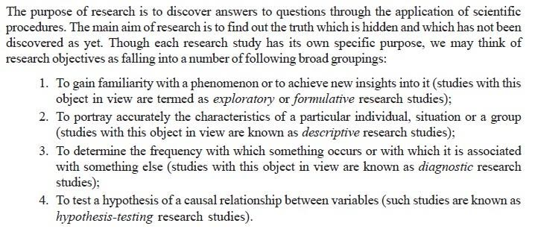
11. Motivation in Research
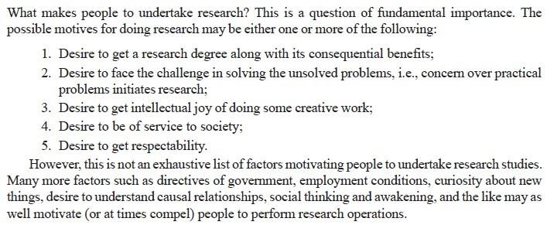
Chapter Two: A Research Proposal
1. What is A Research Proposal?
The research proposal is the detailed plan of study. The term ‘research proposal’ indicates that a specific course of action will be followed. It is a document which sets out your ideas in an easily accessible way. The intent of the written research proposal is to present a focused and scholarly presentation of a research problem and plan. The objective in writing a proposal is to describe what you will do, why it should be done, how you will do it and what you expect will result. Being clear about these things from the beginning will help you complete your research in a timely fashion. A vague, weak or ambiguous proposal can lead to a long, painful, and often unsuccessful research writing exercise. A clear, well thought-out, proposal forms the backbone for the research itself. A good research proposal centers on a good idea. Getting a good idea hinges on familiarity with the topic. This assumes a longer preparatory period of reading, observation, discussion, and incubation. Read everything that you can in your area of interest. Figure out what are the important and missing parts of our understanding. Figure out how to build/discover those pieces. Live and breathe the topic. Talk about it with anyone who is interested. Then just write the important parts as the proposal.
2. Characteristics of Research Proposal
A good and qualified research proposal may contain the following characteristics:
• Informative title; • Clear research question;
• Convincing abstract; • Scientific background and rationale;
• Good selection of research methods; • Ethical considerations, and realistic budget and time table.
- The proposed activity is clearly established, and preferable with data.
- The most important ideas are highlighted and repeated in several places.
- The objectives of the project are given in detail.
- There is a detailed schedule of activities for the project, or at least sample portions of such a complete project schedule.
- Collaboration with all interested groups in planning of the proposed project is evident in the proposal.
- All of the major matters indicated in the proposal guidelines are clearly addressed in the proposal.
- Appropriate detail is provided in all portions of the proposal.
- All of the directions given in the proposal guidelines have been followed carefully.
- Appendices have been used appropriately for detailed and lengthy materials which the reviewers may not want to read but are useful as evidence of careful planning, previous experience, etc.
- The qualifications of project personnel are clearly communicated and the writing style is also clear and concise. It speaks to the reader, helping the reader understand the problems and proposal. Summarizing statements and headings are used to lead the reader.
3. Components of A Research Proposal
The basic components of a research proposal are the same in many fields. However, how they are expressed and staged may vary by discipline. The following components can be regarded as steps in the writing of the research proposal. They are important and should be followed for the actual composition of the proposal. The organization of the contents of a proposal may vary somewhat with the nature of the activity proposed.
- The Title
Naming the research is an important part of the research proposal. A title must be well studied, and to give, so far as its limits permit, a definite and concise indication of what is to come. The title of a research proposal should state your topic exactly in the smallest possible number of words. All words in the title should be chosen with great care, and association with one another must be carefully managed. The title page identifies the proposal and provides the endorsement of appropriate body (advisor). A good title is defined as the fewest possible words that adequately describe the contents of the study. Title is a label (it is not a sentence). Titles should almost never contain abbreviations. The title page has no page number and it is not counted in any page numbering. Besides, the title should not be too broad or too specific, but relatively specific.
- Summary/Abstract
The abstract is a concise summary of the material presented in the proposal. The abstract is a one page brief summary of the thesis proposal. It needs to show a reasonably informed reader why a particular topic is important to address and how you will do it. To that end, it needs to show how your work fits into what is already known about the topic and what new contribution your work will make. Specify the question that your research will answer, establish why it is a significant question; show how you are going to answer the question. Do not put information in the abstract that is not in the main text of your research proposal. Do not put references, figures, or tables in the abstract.
Your research proposal in its entirety should not be too long. So it is important that you give a summary of the entire document. This summary is known as the abstract, and should demonstrate to the reader the most important parts of each of the sections of the research proposal in around 200 words. It is often useful to write the abstract last, after the rest of the research proposal has been written and fully thought out.
- Introduction/Background
The introduction is the part of the proposal that provides readers with the background information for the research proposal. Its purpose is to establish a framework for the research, so that readers can understand how it is related to other research. The researcher has to make sure to include a hook at the beginning of the introduction. This is a statement of something sufficiently interesting to motivate your reader to read the rest of the proposal, it is an important/interesting scientific problem that your study either solves or addresses. The introduction should cite those who had the idea or ideas first, and should also cite those who have done the most recent and relevant work. You should then go on to explain why more work is necessary.
The introduction/background section should contain a rationale for your research. Why are you undertaking the project? Why is the research needed? This rationale should be placed within the context of existing research or within your own experience or observation. You need to demonstrate that you know what you’re talking about and that you have knowledge of the literature surrounding this topic. If you’re unable to find any other research that deals specifically with your proposed project, you need to say so, illustrating how your proposed research will fill this gap. If there is other work that has covered this area, you need to show how your work will build on and add to the existing knowledge. Basically, you have to convince people that you know what you’re talking about and that the research is important.
- Statement of the Problem
Giving a clear and concise description of the research problem or question denote exactly what the researcher intends to do and what he or she wants to achieve with the research. This description will later serve as the point of departure for the wording of the title of the research paper, dissertation or thesis. Most research proposal, whether designed for master’s thesis or doctoral dissertation, may be considered as responses to a problem. A problem might be defined as the issue that exists in the literature, theory, or practice that leads to a need for the study. The prospective researcher should think on what caused the need to do the research problem identification. The question that he/she should ask him/herself is: Are there questions about this problem to which answers have not been found up to the present? The research problem should be stated in such a way that it would lead to analytical thinking on the part of the researcher with the aim of possibly concluding solutions to the stated problem. The problem statement describes the context for the study and it also identifies the general analysis approach. It is important in a proposal that the problem stand out—that the reader can easily recognize it. Effective problem statements answer the question “Why does this research need to be conducted.” If a researcher is unable to answer this question clearly and succinctly, and without resorting to hyper-speak, then the statement of the problem will come off as ambiguous and diffuse. The most frequent dilemma among graduate students is their seemingly aimless search for a problem significant enough to pursue and discrete enough to handle. A well-articulated statement of the problem establishes the foundation for everything to follow in the proposal and will render less problematic most of the conceptual, rhetorical and methodological obstacles typically encountered during the process of proposal development.
- Objectives/Aims of the Study
Most of the research proposal formats will ask for only one or two aims and may not require objectives. However, for some research these will need to be broken down in more depth to also include the objectives. The aim is the overall driving force of the research and the objectives are the means by which you intend to achieve the aims. These must be and succinct. On the other hand, the objective might be general and specific objective. The objectives of a research describe the ends or aim which the inquirer seeks to bring about as a result of completing the research undertaken. An objective may be thought of as either a solution to a problem or a step along the way toward achieving a solution; an end state to be achieved in relation to the problem. The objectives of a research project summarized what is to be achieved by the study. Objectives should be closely related to the statement of the problem. After statement of the primary objective, secondary objectives may be mentioned. In this section you should expand on the title of your research project to articulate in full detail the aims and objectives of your research. You should be able to provide a detailed description of the research question, the purpose of the research, and a description of your approach (methodology and method) to the research.
Objectives should be characterized as follows:
• Simple (not complex),
• Specific (not vague),
• Stated in advance (not after the research is done), and
• Stated using “action verbs” that are specific enough to be measured.
Commonly, research objectives are classified into general objective and specific objectives. The general and specific objectives are logically connected to each other and the specific objectives are commonly considered as smaller portions of the general objectives. It is important to ascertain that the general objective is closely related to the statement of the problem.
- General Objective
- What exactly will be studied?
- General statements specifying the desired outcomes of the proposed project.
- Specific Objectives
- Specific statements summarizing the proposed activities and including description of the outcomes and their assessment in measurable terms.
- It identifies a greater detail of the specific aims of the research project, often breaking down what is to be accomplished into smaller logical components.
- Specific objectives should systematically address the various aspects of the problem as defined under ‘Statement of the Problem’ and the key factors that are assumed to influence or cause the problem. They should specify what you will do in your study, where and for what purpose.
- Hypotheses/ Question
Hypotheses are projections of the possible outcomes of the research and are not biased restatements of conclusions. They present the frame work for the analysis of the problem in relation to the plan of attack and indicate how the projected research must lead to one or another set of conclusion. Formulate a hypothesis which will form part of the research proposal. Indicate whether the hypothesis is inductive or deductive. Also indicate which variables apply.
- Significance of the Study
The researcher has to set the overall importance of the research. This means that someone has to benefit from the actual research in solving the problem.

- Review of Related Literature
To conduct research regarding a topic, by implication, means that the researcher has obtained sound knowledge with regard to the research topic. It is therefore imperative that the researcher, at the time of the submission of the research proposal, clearly indicates what theoretical knowledge he possesses about the prospective research.
Literature review is not a compilation of every work written about a topic. It is not simply a list of sources reviewed separately for their own merit. A literature review is a description of the literature relevant to a particular field or topic. It gives an overview of what has been said, who the key writers are, what are the prevailing theories and hypotheses, what questions are being asked, and what methods and methodologies are appropriate and useful. As such, it is not in itself primary research, but rather it reports on other findings.
- Methods, Design and Procedures
The methods or procedures section is really the heart of the research proposal. The researcher must decide exactly how he/she is going to achieve his/her stated objectives: i.e., what new data he/she needs in order to shed light on the problem he/she has selected and how you are going to collect and process this data. The activities should be described with as much detail as possible, and the continuity between them should be apparent. The researcher is expected to indicate the methodological steps he/she will take to answer every question, to test every hypothesis illustrated in the questions/hypotheses section or address the objectives he/she set. Methods/procedures show how the researcher will achieve the objectives and answer the questions.
This section of the proposal needs to demonstrate how the researcher intends to go about investigating the research question. The methodology generally refers to the theory to be used to justify the use of the particular research methods that the researcher is choosing to use. It is possible to use more than one methodology to inform research method. The method describes the way you intend to investigate the question, such as a questionnaire, in-depth, individual interviews, focus group interviews, a survey and so forth. If you are using more than one methodology then you will need to demonstrate why you have chosen to use another methodology alongside and how it is relevant to the aims and objectives of your research.
You should also discuss the different methods you intend to use in full detail, and provide justification as to why you have chosen to use these methods. It is also helpful to discuss how many participants you intend to involve in your research, how you intend to find or approach participants, and how they will be used in your study.
In nut shell, the methodology of the research encompasses the following elements in it.
- Description of study area
- Description of study design
- Description of study participants
- Eligibility criteria (if any)
- Determination of sample size (if any)
- Description of selection process (sampling method)
- Methods of data collection
- Work Plan
Work plan is a schedule, chart or graph that summarizes the different components of a research proposal and how they will be implemented in a coherent way within a specific time-span. The researcher needs to be able to demonstrate that his/her research is possible within a given time frame. He/she may be able to define his/her own timeframe, or the institution for which he/she is writing a proposal may have a set time frame that he/she will need to work within. Either way, it is important that the researcher be able to pilot the intended progress of the project from start to finish. If the researcher intends to produce any outputs, reports, findings then he/she should be inserted into this schedule.
The work plan includes the following major points:
- The tasks to be performed;
- When and where the tasks will be performed;
- Who will perform the tasks and the time each person will spend on them;
- It describes the plan of assessing the ongoing progress toward achieving the research objectives;
- The plan specifies how each project activity is to be measured in terms of completion, the time line for its completion;
A good work time plan enables both the investigators and the advisors to monitor project progress and provide timely feedback for research modification or adjustments.
- Budget and Funding
Most often than not, you will require to secure funds from a funding organization to cover the cost of conducting a research project. The items to consider when drawing up a budget requirement are outlined below. In addition, it is important to remember that the funding agency will invariably also read through the whole proposal (not just the budget requirement). Therefore, it is critical that the entire proposal document is well thought out and written to effectively communicate the aim of the research and how you plan to achieve it. Normally, a proposal budget reflects direct and indirect costs.
- Budget items need to be explicitly stated.
- Cost for every budget item should be quantitatively showed.
- There might be a need for budget justification of certain costs whose requirement is not obvious.
- References
The researcher must give references to all the information that he/she obtains from books, papers in journals, and other sources. References may be made in different styles. You will also need to place a list of references, numbered as in the main text (or alphabetically ordered), at the end of your research proposal. The exact format for depicting references within the body of the text and as well as the end of the proposal varies from one discipline to another. It is best that you consult with someone who is familiar with the format in your particular area of research.
The information you give in the reference list must be enough for readers to find the books and papers in a library or a database. It also demonstrates to those interested in your proposal how well versed you are on the particular area of research.
As a general guideline, there are certain items that must be included from each source reference. As mentioned above, the exact format applicable to your particular area of study will be identified by you.
Reference for A Journal Paper
  - The names of the authors,
  - The year of publication,
  - The title of the paper,
  - The title of the journal,
  - The volume number of the journal,
  - The first and last page numbers of the paper.
Reference for A Book
  - The author,
  - The year of publication,
  - The title, and the edition number if there is one,
  - The name of the publisher,
  - The page numbers for your reference.
Reference for An Internet
  - The author of the web page;
  - The title of the item on the web page;
  - The date the item was posted on the web page;
  - The date the item was accessed from the web page;
  - The complete and exact URL.
Particularly, with references obtained from websites, it is important to establish the reputability and reliability of the website you are making reference to.
Every reference in your main text must appear in the list at the end of your proposal, and every reference in the list must be mentioned in your main text.
- Appendices/Annexes
Include in the appendices of your proposal any additional information you think might be helpful to a proposal reviewer. For example, include:
• Questionnaire & other collection forms;
• Dummy tables;
• Biographical data on the principal investigator;
• The consent forms (if any).
Sources of Review of Related Literature
According to Singh (2006), review of related literature is obtained from following sources.
- Periodicals: are regularly published items that are available in print as well as online such as journals, magazines, newspapers, newsletters, regularly published materials (manuals & proceedings-published records of meeting/conference) and so on.
- Non-periodicals: are items published separately such as books, reports, brochures, monographs (scholarly written article/paper on a single topic) manuals, audiovisual media, theses, dissertations and the like.

Chapter Three: Academic Writing and Presentation
Academic writing is:
- Formal - impersonal, no slang, formal sentence structure
- Reasoned - critical thinking: how and why
- Impartial - gives a balanced point of view, more than one point of view
- Logical - ideas flow logically from one to another: signposts, topic sentences and linked paragraphs
- Structured - keeps to the structure of an essay, report etc
- Introduction usually one paragraph explains what you are writing about and how you plan to do it
- Body A series of paragraphs (80-90%) of the essay. Gives details/ evidence to answer the question
- Conclusion usually one paragraph, briefly summarises main ideas and shows you have answered the question
- References list of sources you used (APA style)
- Supported (evidence and examples, referencing)
- Using sources strengthens your writing / gives credibility to what you are saying
- Shows you’ve done research and have synthesized the findings into your own words
- Shows your participating in the intellectual conversation within your discipline

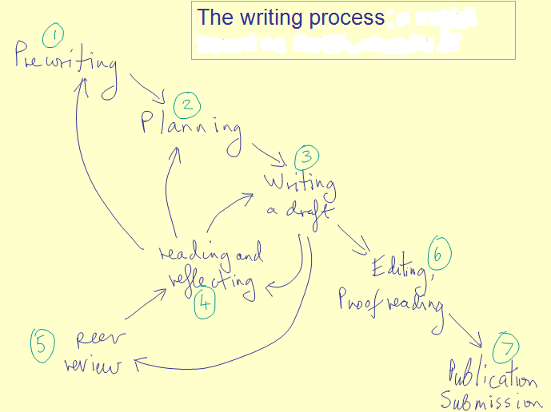
1. Elements of writing
- Summarize
Summarizing is the tool in writing which is used when you need the main idea of the text. It is a condensed form of the written text in your own words with only the highlights of the text. A summary is much shorter than the original text. It excludes the explanation of the text. Only the main idea or the basic information is included. Summarizing is used to refer to work that culminates into the present writing that you are doing. It is sometimes used when you want to draw attention to an important point. It is also applicable when you want to distance yourself from the original text.
- Paraphrase
Paraphrasing - presenting the ideas and information you have read in your own words - is an important academic skill. By translating content from your research into your own words, you demonstrate to your reader that you've understood and are able to convey this content. It is important to be very thorough when you paraphrase. Paraphrasing is not simply taking what someone has written and changing a few words to make it your own. It is about translating another person's ideas into your own words and in reduced form. You must change the words a lot so they are no longer similar to the original.
- Synthesize
A synthesis is a written discussion that draws on one or more sources. It follows that your ability to write syntheses depends on your ability to infer relationships among sources - essays, articles, fiction, and also non-written sources, such as lectures, interviews, observations. In an academic synthesis, you make explicit the relationships that you have inferred among separate sources.
- Analyze
The process of deduction wherein you cut down a bigger concept into smaller ones. As such, analysis breaks down complex ideas into smaller fragmented concepts so as to come up with an improved understanding.
- Evaluate
It is a systematic determination of a subject’s merit, worth and significance, using criteria governed by a set of standards. In simple words it is the assessment or examination to know the vitality of a task, and in this regard there is set of standard, with its accordance we have to evaluate. For example, Scientific method; it is a scientific method, in which the acquired knowledge is tested by observation, hypothesis, experiment, conclusions etc. These steps are the set of standards, and the results will be the evaluation of the hypothesis we guessed.

2. Writing Critical Reviews of a Journal Article
What is a Critical Review of a Journal Article?
A critical review of a journal article evaluates the strengths and weaknesses of an article's ideas and content. It provides description, analysis and interpretation that allow readers to assess the article's value.
Before You Read the Article
- What does the title lead you to expect about the article?
- Study any sub-headings to understand how the author organized the content.
- Read the abstract for a summary of the author's arguments.
- Study the list of references to determine what research contributed to the author's arguments. Are the references recent? Do they represent important work in the field?
- If possible, read about the author to learn what authority he or she has to write about the subject.
- Consult Web of Science to see if other writers have cited the author's work. Has the author made an important contribution to the field of study?
Reading the Article: Points to Consider
Read the article carefully. Record your impressions and note sections suitable for quoting.
- Who is the intended audience?
- What is the author's purpose? To survey and summarize research on a topic? To present an argument that builds on past research? To refute another writer's argument?
- Does the author define important terms?
- Is the information in the article fact or opinion? (Facts can be verified, while opinions arise from interpretations of facts.) Does the information seem well-researched or is it unsupported?
- What are the author's central arguments or conclusions? Are they clearly stated? Are they supported by evidence and analysis?
- If the article reports on an experiment or study, does the author clearly outline methodology and the expected result?
- Is the article lacking information or argumentation that you expected to find?
- Is the article organized logically and easy to follow?
- Does the writer's style suit the intended audience? Is the style stilted or unnecessarily complicated?
- Is the author's language objective or charged with emotion and bias?
- If illustrations or charts are used, are they effective in presenting information?
Prepare an Outline
Read over your notes. Choose a statement that expresses the central purpose or thesis of your review. When thinking of a thesis, consider the author's intentions and whether or not you think those intentions were successfully realized. Eliminate all notes that do not relate to your thesis. Organize your remaining points into separate groups such as points about structure, style, or argument. Devise a logical sequence for presenting these ideas. Remember that all of your ideas must support your central thesis.
Write the First Draft
The review should begin with a complete citation of the article. For example:
Platt, Kevin M.F. "History and Despotism, or: Hayden White vs. Ivan the Terrible and Peter the Great." Rethinking History 3:3 (1999) : 247-269.
NOTE: Use the same bibliographic citation format as you would for any bibliography, works cited or reference list. It will follow a standard documentation style such as MLA or APA.
The first paragraph may contain:
- a statement of your thesis
- the author's purpose in writing the article
- comments on how the article relates to other work on the same subject
- information about the author's reputation or authority in the field
The body of the review should:
- state your arguments in support of your thesis
- follow the logical development of ideas that you mapped out in your outline
- include quotations from the article which illustrate your main ideas
The concluding paragraph may:
- summarize your review
- restate your thesis
Revise the First Draft
Ideally, you should leave your first draft for a day or two before revising. This allows you to gain a more objective perspective on your ideas. Check for the following when revising:
- grammar and punctuation errors
- organization, logical development and solid support of your thesis
- errors in quotations or in references
You may make major revisions in the organization or content of your review during the revision process. Revising can even lead to a radical change in your central thesis.

3. Effective Presentation
- Show your Passion and Connect with your Audience
It’s hard to be relaxed and be yourself when you’re nervous. But time and again, the great presenters say that the most important thing is to connect with your audience, and the best way to do that is to let your passion for the subject shine through. Be honest with the audience about what is important to you and why it matters. Be enthusiastic and honest, and the audience will respond.
- Focus on your Audience’s Needs
Your presentation needs to be built around what your audience is going to get out of the presentation. As you prepare the presentation, you always need to bear in mind what the audience needs and wants to know, not what you can tell them. While you’re giving the presentation, you also need to remain focused on your audience’s response, and react to that. You need to make it easy for your audience to understand and respond.
- Keep it Simple: Concentrate on your Core Message
When planning your presentation, you should always keep in mind the question: What is the key message for my audience to take away? You should be able to communicate that key message very briefly. Some experts recommend a 30-second ‘elevator summary’, others that you can write it on the back of a business card, or say it in no more than 15 words. Whichever rule you choose, the important thing is to keep your core message focused and brief. And if what you are planning to say doesn’t contribute to that core message, don’t say it.
- Smile and Make Eye Contact with your Audience
This sounds very easy, but a surprisingly large number of presenters fail to do it. If you smile and make eye contact, you are building rapport, which helps the audience to connect with you and your subject. It also helps you to feel less nervous, because you are talking to individuals, not to a great mass of unknown people. To help you with this, make sure that you don’t turn down all the lights so that only the slide screen is visible. Your audience needs to see you as well as your slides.
- Start Strongly
The beginning of your presentation is crucial. You need to grab your audience’s attention and hold it. They will give you a few minutes’ grace in which to entertain them, before they start to switch off if you’re dull. So don’t waste that on explaining who you are. Start by entertaining them.

- Prepare Good Slideshows
As a general rule, slides should be the sideshow to you, the presenter. A good set of slides should be no use without the presenter, and they should definitely contain less, rather than more, information, expressed simply. If you need to provide more information, create a bespoke handout and give it out after your presentation.
- Tell Stories
Human beings are programmed to respond to stories. Stories help us to pay attention, and also to remember things. If you can use stories in your presentation, your audience is more likely to engage and to remember your points afterwards. It is a good idea to start with a story, but there is a wider point too: you need your presentation to act like a story. Think about what story you are trying to tell your audience, and create your presentation to tell it.
- Use your Voice Effectively
The spoken word is actually a pretty inefficient means of communication, because it uses only one of your audience’s five senses. That’s why presenters tend to use visual aids, too. But you can help to make the spoken word better by using your voice effectively. Varying the speed at which you talk, and emphasizing changes in pitch and tone all help to make your voice more interesting and hold your audience’s attention.
- Use your Body Too
It has been estimated that more than three quarters of communication is non-verbal. That means as well as your tone of voice, your body language is crucial to getting your message across. Make sure that you are giving the right messages: body language to avoid includes crossed arms, hands held behind your back or in your pockets, and pacing the stage. Make your gestures open and confident, and move naturally around the stage, and among the audience too, if possible.
- Relax, Breathe and Enjoy
If you find presenting difficult, it can be hard to be calm and relaxed about doing it.
One option is to start by concentrating on your breathing. Slow it down, and make sure that you’re breathing fully. Make sure that you continue to pause for breath occasionally during your presentation too. If you can bring yourself to relax, you will almost certainly present better. If you can actually start to enjoy yourself, your audience will respond to that, and engage better. Your presentations will improve exponentially, and so will your confidence. It’s well worth a try.

Consider the following key components of a presentation:
- Context
Ask yourself the following questions to develop a full understanding of the context of the presentation.
- When and where will you deliver your presentation?
There is a world of difference between a small room with natural light and an informal setting, and a huge lecture room, lit with stage lights. The two require quite different presentations, and different techniques.
- Will it be in a setting you are familiar with, or somewhere new?
If somewhere new, it would be worth trying to visit it in advance, or at least arriving early, to familiarize yourself with the room.
- Will the presentation be within a formal or less formal setting?
A work setting will, more or less by definition, be more formal, but there are also various degrees of formality within that.
- Will the presentation be to a small group or a large crowd?
- Are you already familiar with the audience?
With a new audience, you will have to build rapport quickly and effectively, to get them on your side.
- What equipment and technology will be available to you, and what will you be expected to use?
In particular, you will need to ask about microphones and whether you will be expected to stand in one place, or move around.
- What is the audience expecting to learn from you and your presentation?
Check how you will be ‘billed’ to give you clues as to what information needs to be included in your presentation.
- Presenter
The role of the presenter is to communicate with the audience and control the presentation. Remember, though, that this may also include handing over the control to your audience, especially if you want some kind of interaction.
- Audience
The audience receives the presenter’s message(s).
However, this reception will be filtered through and affected by such things as the listener’s own experience, knowledge and personal sense of values.
- Message
The message or messages are delivered by the presenter to the audience. The message is delivered not just by the spoken word (verbal communication) but can be augmented by techniques such as voice projection, body language, gestures, eye contact (non-verbal communication), and visual aids.
The message will also be affected by the audience’s expectations. For example, if you have been billed as speaking on one particular topic, and you choose to speak on another, the audience is unlikely to take your message on board even if you present very well. They will judge your presentation a failure, because you have not met their expectations.
- Reaction
The audience’s reaction and therefore the success of the presentation will largely depend upon whether you, as presenter, effectively communicated your message, and whether it met their expectations. As a presenter, you don’t control the audience’s expectations. What you can do is find out what they have been told about you by the conference organizers, and what they are expecting to hear. Only if you know that can you be confident of delivering something that will meet expectations.
- Method
How will the presentation be delivered?
Presentations are usually delivered direct to an audience. However, there may be occasions where they are delivered from a distance over the Internet using video conferencing systems, such as Skype.
It is also important to remember that if your talk is recorded and posted on the internet, then people may be able to access it for several years. This will mean that your contemporaneous references should be kept to a minimum.
- Impediments
Many factors can influence the effectiveness of how your message is communicated to the audience. For example, background noise or other distractions, an overly warm or cool room, or the time of day and state of audience alertness can all influence your audience’s level of concentration.
As presenter, you have to be prepared to cope with any such problems and try to keep your audience focused on your message.

