Jimma University
College of Natural Sciences
Department of Statistics

Design and Analysis of Experiments Lecture Note (Stat2043)

By Mr Demeke Kifle (MSc)

Chapter One
Strategy of Experimentation
Experiments are performed by investigators in virtually all fields of inquiry, usually to discover something about a particular process or system. Liberally, an experiment is a test. More formally we can define an experiment as a test or series of test in which purposeful changes are made to the input variables of a process or system so that we may observe and identify the reasons for changes that may be observed in the output response.
As an example of an experiment suppose that a person may plan to compare the effect of two different types of fertilizers on the yield of the crop. But when we possess such kind of experiment a number of important questions may be raised. Some of the questions may be:
- Are these two types of fertilizers are the only factors that affect the yield of the crop?
- Are there any other factors that may affect the yield of the crop?
- How many plot of land should need for the experiment?
- How do we allocate the fertilizer to the plot of land?
- What method of data analysis should be applied?
All of these questions, and perhaps many others, will have to be answered satisfactorily before the experiment is performed. Therefore, the general approaches of planning and conducting the experiment is called strategy of experimentation. Now let us define and explain some terms commonly used in this course.
Treatment: it is the different procedure under comparison in an experiment. Example, in an agricultural experiment the different crops, the different manures will be considered as a treatment.
Experimental unit /material/: it is a material to which applied the treatments and on which the variable under study is measured. Example, in an agricultural experiment the plot of land is considered as the experimental unit.
Response variable: a characteristic of an experimental unit measured after the treatment and analyzed to address the objective of the experiment. Example, in an agricultural experiment the yield of the crop is considered as the response variable.
In short design of experiment is a plan used in experimentation. It is mainly used in comparative experiment and it is a complete sequence of steps or it touches the following points:
- The set of treatments selected for comparisons
- The specification of unit on which treatments are to be applied
- The rule by which the treatments are to be allocated to the experimental unit
- The specification of measurements or other records to be made in each unit
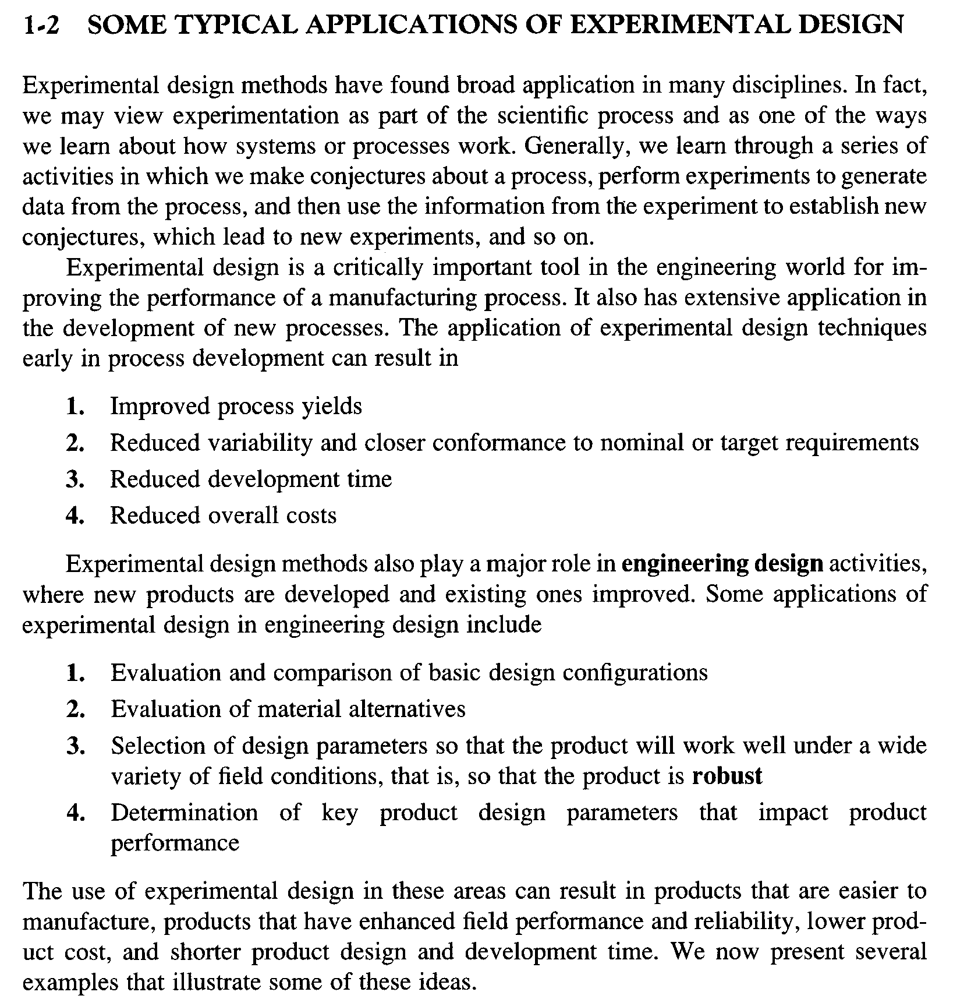
Basic Principles
If an experiment such as the ones described in the above is to be performed most efficiently, a scientific approach to planning the experiment must be employed. Statistical design of experiment refers to the process of planning the experiment so that appropriate data that can be analyzed by statistical methods will be collected, resulting in valid and objective conclusions. The statistical approach of experimental design is necessary if we wish to draw meaningful conclusions from the data. When the problem involves data that are subjected to the experimental error, statistical methodology is the only objective approach to analysis. Thus there are two aspects to any experimental problem: the design of experiment and the statistical analysis of data. These two subjects are closely related because the method of analysis depends directly on the design employed. The three basic principles of experimental design are replication, randomization and blocking.
Replication: we mean a repetition of a basic experiment or it refers to the numbers of experimental units that receive the same treatment. It has two important properties, first it allows the experimenter to obtain an estimate of the experimental error. This estimate or error becomes a basic unit of measurement for determining whether observed differences in the data are really statically different. Second, if the sample mean is used to estimate the effect of a factor in the experiment, replication permits the experimenter to obtain a more precise estimate of this effect.
Randomization: is a cornerstone of underlying the use of statistical methods in experimental design. By randomization we mean that both the allocation of the experimental material and the order in which the individual runs or trails of the experiment are to be performed are randomly determined. Statistical methods require that the observation (or errors) be independently distributed random variables. Randomization usually makes this assumption valid.
Blocking: is a design technique used to improve the precision with which comparison among the factors of interest are made. Often blocking is used to reduce or eliminate the variability transmitted from nuisance factors; that is, factors that may influence the experimental response but in which we are not directly interested.
Guidelines for design designing of experiments
To use the statistical approach in designing and analyzing an experiment, it is necessary for everyone involved in the experiment to have a clear idea in advance of exactly what is to be studied, how the data are to be collected, and at least qualitative understanding of how these data how these data are to be analyzed. In short we can describe as follow:
- Recognition of and statement of the problem
- Choice of factors, levels, and ranges
- Selection of the response variable
- Choice of experimental design
- Performing the experiment
- Statistical analysis of the data
- Conclusion and recommendation
Remark: step 1 and 2 are called pre experimental planning and steps 2 and 3 are often done simultaneously or in reverse order.
Historical Perspective
There have been four eras in the modern development of statistical experimental design. The agricultural era was led by the pioneering work of Sir Ronald A. Fisher in the 1920s and early 1930s. During this time, fisher was responsible for statistics and data analysis at the Rothamsted Agricultural experimental station near London, England. The second or industrial era was categorized by the development of response surface methodology (RSM) by Box and Wilson (1951). They recognized and exploited the fact that many industrial experiments are fundamentally different from their agricultural counterparts in two ways: (1) the response variable can usually be observed (nearly) immediately, and (2) the experimenter can quickly learn crucial information from a small group of run that can be used to plan the next experiment. Box (1999) calls these two features of industrial experiments immediacy and sequentiality.
The increasing interest of western industry in quality improvement that began in the late 1970s ushered in the third era of statistical design. The work of Genichi Taguchi had a significant impact on expanding the interest in and use of designed experiment.

Chapter 2
Simple comparative experiment
Here we consider the experiment to compare two conditions (sometimes called treatments). This are often called simple comparative experiments. Example an experiment performed to determine whether two different formulations of product give equivalent results. The discussion leads to a review of several basic statistical concepts, such as random variables, probability distribution, random samples, sampling distribution and test of hypothesis.
Hypothesis testing: it allows the comparison of the two formulations to be made on objective terms with knowledge of the risk associated with reaching the wrong conclusion. Before presenting procedures for hypothesis testing in simple comparative experiments, we will briefly summarize some elementary statistical concepts.
Basic Statistical Concepts
Each observation in any given observation called a run. Notice that the individuals run differ, so there is fluctuation or noise in the result. This noise is usually called experimental error or simply error. It is a statistical error meaning that it arises from variation that is uncontrolled and generally unavoidable. The presence of error or noise implies that the response variable is a random variable.
Sampling and Sampling Distribution
The objective of statistical inference is to draw conclusions about the population using a sample from that population. Most of the methods that we will study assume that random sample are used. That is if the population contains N elements and samples of n them is to be selected and if each of the possibe sample has an equal probability of being choosen, then the procedure empolyed is called random sampling.
Reading Assignment: Inference about the difference in means (Randomized design and Paired), Comparison design Inferences about the variances of normal distribution.

Chapter 3
Completely randomized design (CRD): Single Factor Analysis of Variance (ANOVA)
In this section we present methods for the design and analysis of single factor experiment with level of factors (or treatments). We will assume that the experiment has been completely randomized.
Example: A product development engineer is interested in investigating the tensile strength of a new synthetic fiber that will be used to make cloth for men’s shirt. The engineer knows from previous experience that the strength is affected by the weight percent of cotton used in the blend of materials for the fiber. Furthermore, he suspects that increasing the cotton contain will increase the strength, at least initially. He also knows that the cotton contain should range between 10 and 40 % if the final product is to have other quality characteristic that are desired (such as the ability to take a permanent – press finishing treatment). The engineer decides to test specimens at five levels of cotton weigh percent: 15, 20, 25, 30 and 35 %. He also decides to test five specimens at each level of cotton contain.
This is an example of a single factor experiment with (levels of the factor) and n=25 replicates. The 25 run should be made in random order. To illustrate how the run order may be randomized, suppose that we number the run as follows:
Cotton weight in percent | Experiment run number
15 | 1 2 3 4 5
20 | 6 7 8 9 10
25 | 11 12 13 14 15
30 | 16 17 18 19 20
35 | 21 22 23 24 25

Now we select a random number between 1 and 25. Suppose this number is 8. Then the number 8 observation (20 % of cotton) is run first. This process could be repeated until all 25 observations have been assigned a position in the test sequence. The only restriction on randomization here is that if the same number (eg. 8) is drawn again, it is discarded. Suppose that the test sequence obtained is:
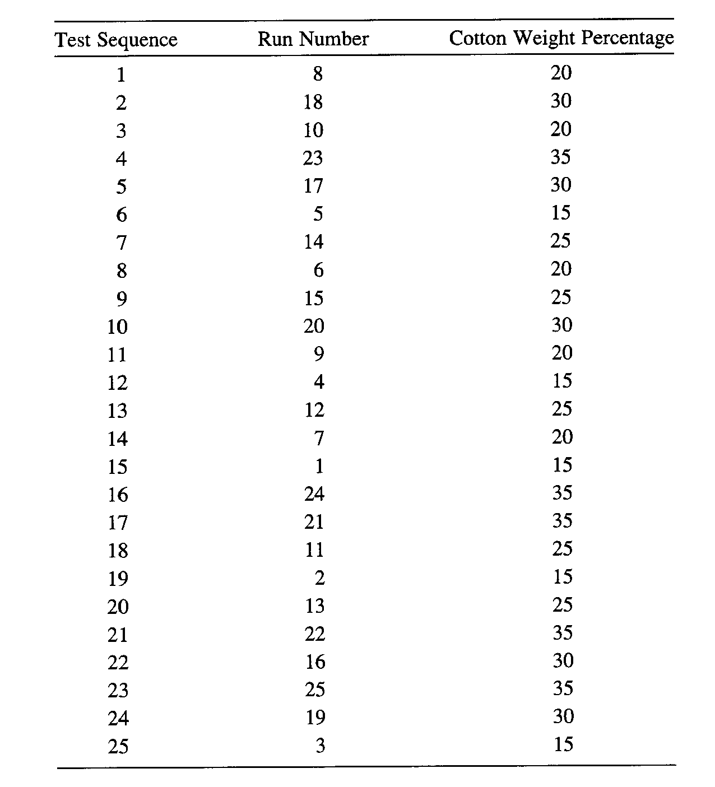
This randomized test sequence is necessary to prevent the effects of unknown nuisance variables, perhaps varying out of control during the experiment, from contaminating the result. To illustrate suppose that we were to run the 25 test specimens in the original nonrandomized order (that is all five 15 percent cotton specimens are tested first, all five 20 percent cotton specimens are tested next and so on). If the tensile strength testing machine exhibits a warm-up effect such that the longer it is on, the lower the observed tensile strength reading will be the warm up effect will potentially contaminate the tensile strength data and destroy the validity of the experiment.
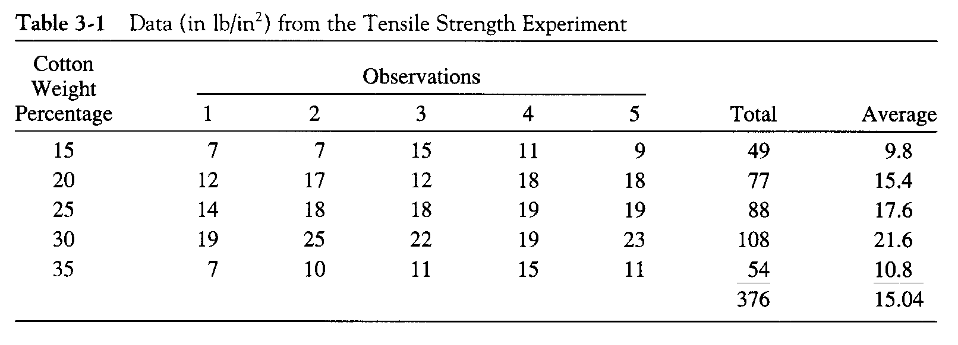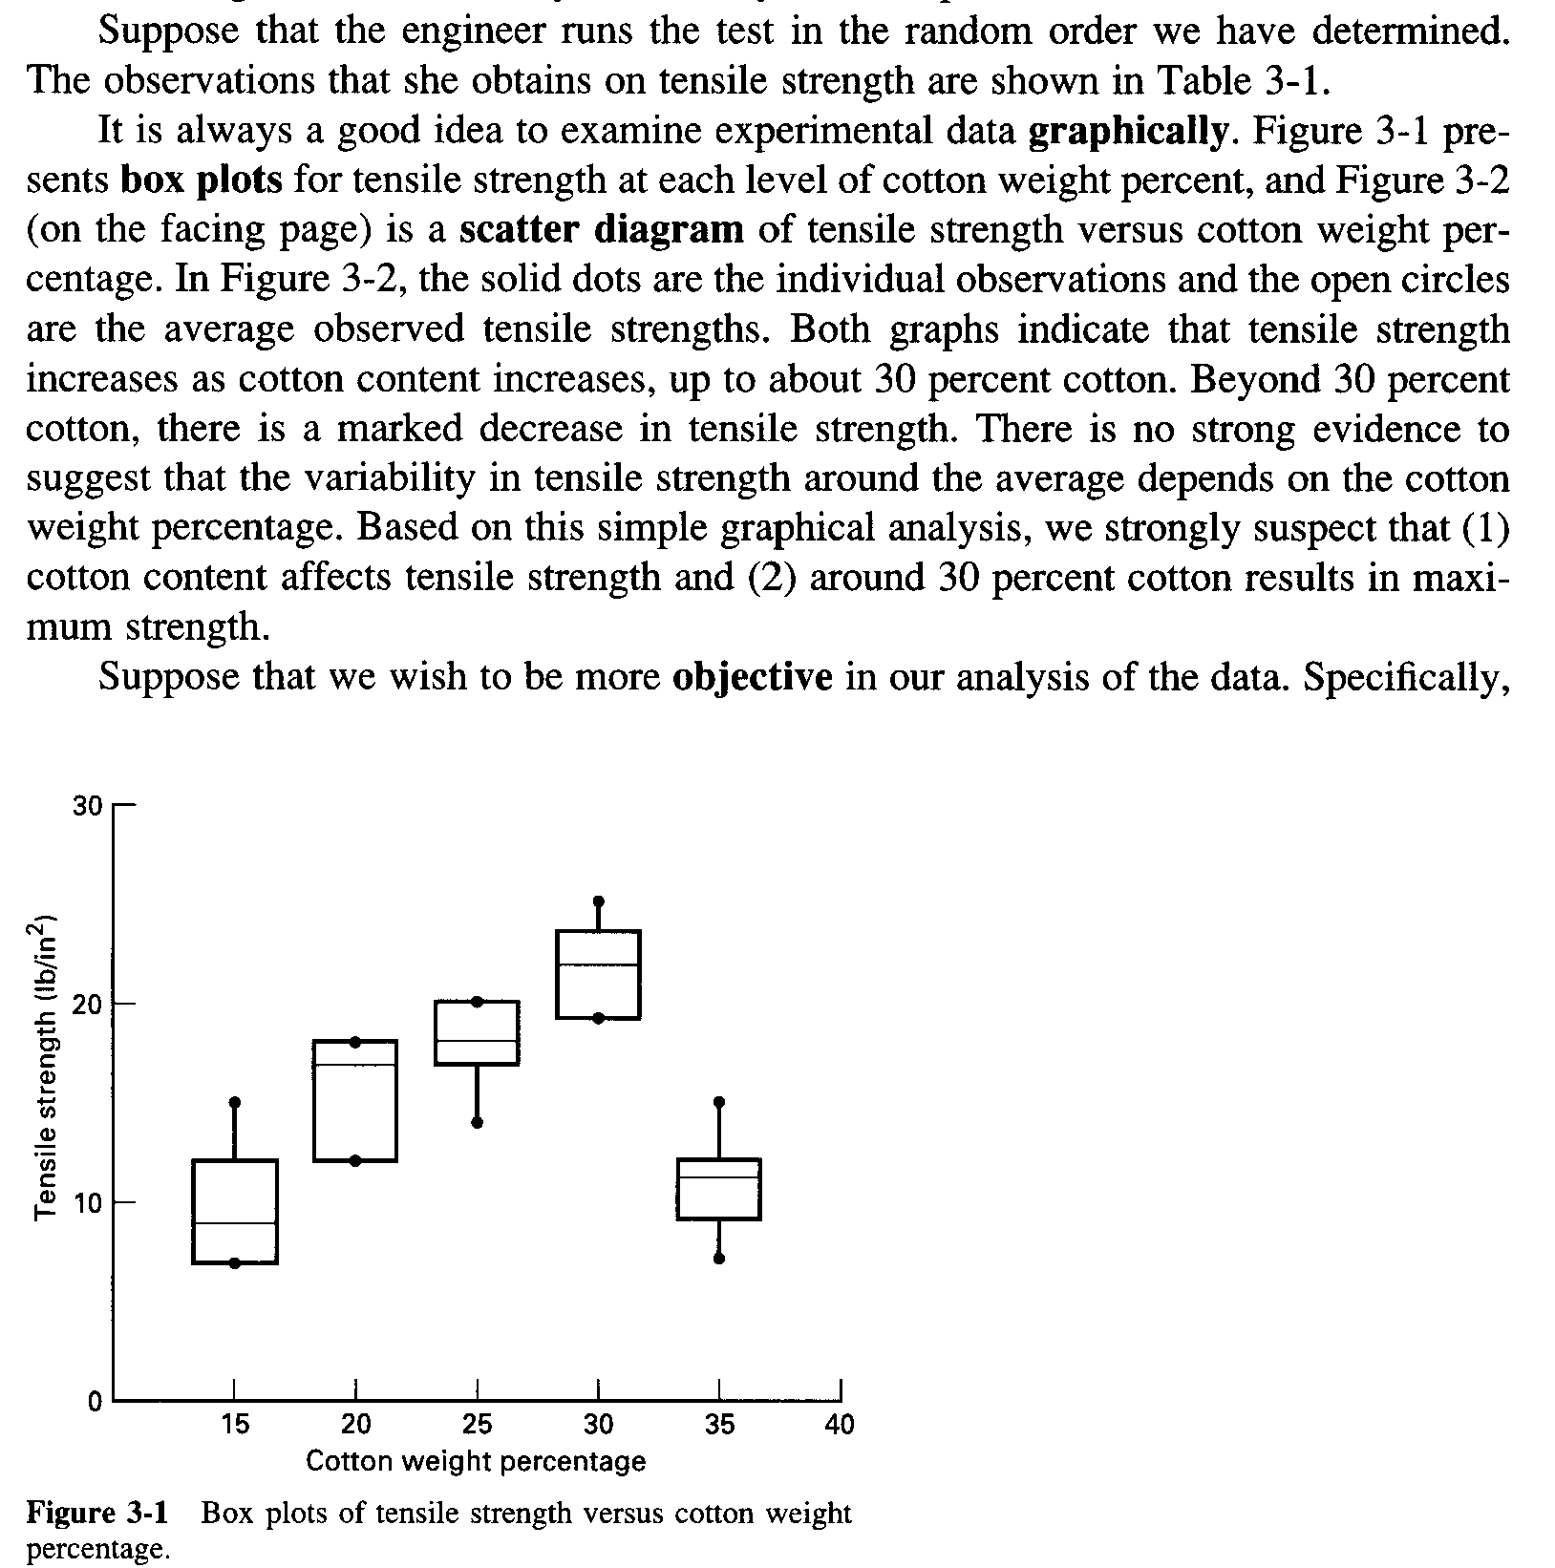

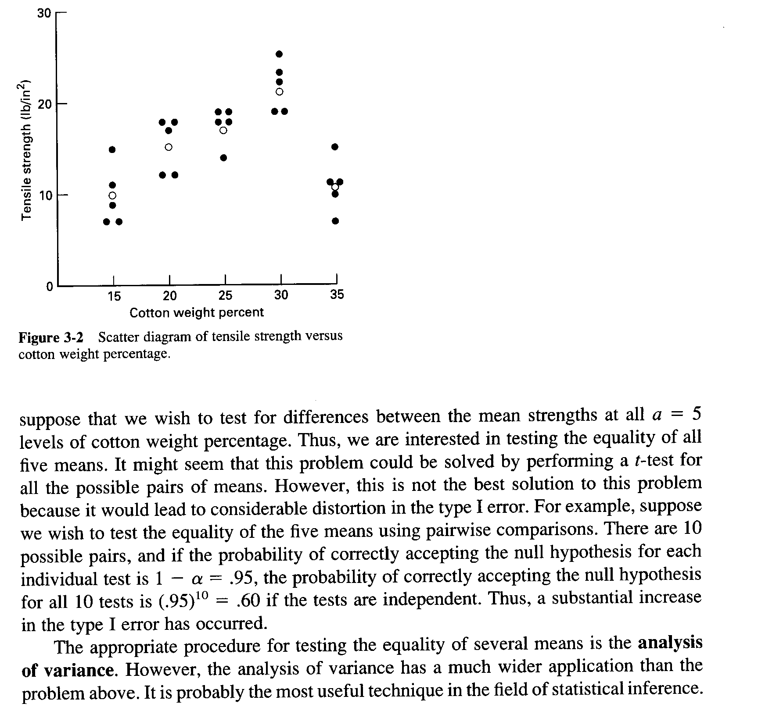Completely Randomized Design (CRD)
The experimenter involves a comparison of a number of treatment say “a” of treatments based on independent random samples of n₁, n₂, ……, n_{a} observation drawn from population associated with treatments 1,2,……a respectively.
Completely Randomized Design (CRD) is the design in which the treatments are assigned completely at random to the experimental unit or vice versa. It improves no restriction on the allocation of treatment on the experimental unit.
Analysis of Variance (ANOVA)
Suppose we have a treatments or different levels of a single factor that we wish to compare. The observed response from each of the treatment is a random variable. The data would appear as in the following table (e.g. y_{ij} represents the j^{th} observation taken under factor level or treatment i). There will be n observation under the i^{th} treatment.
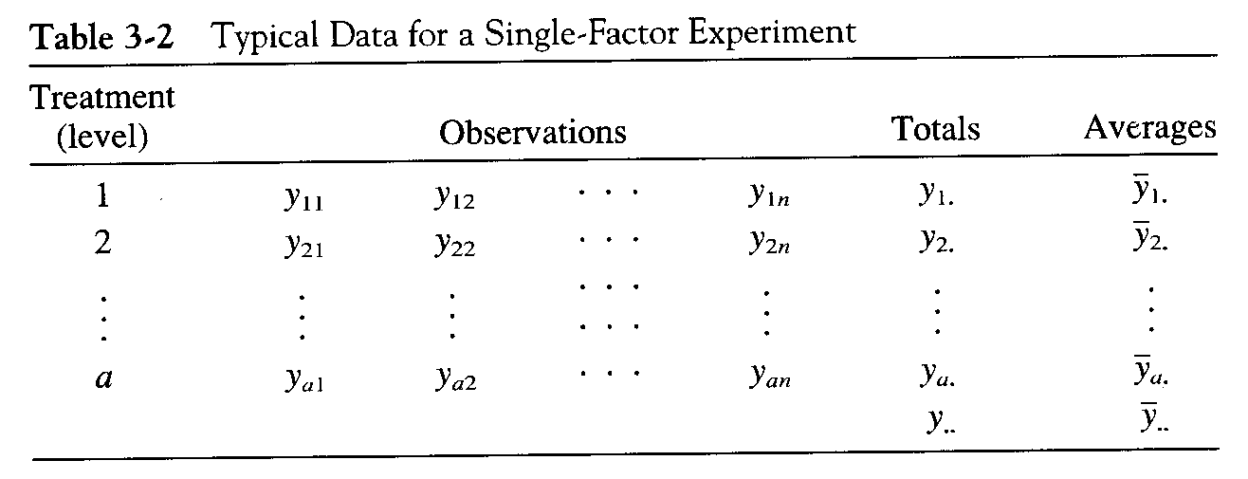
The total variation present in the set of observation quantity may under certain circumstance and be partitioned in to number of components associated with the nature of classification of the data. The systematic procedure of achieving this is called ANOVA.
Example: Consider a random sample of grade 10 students in 3 Gondar secondary schools. A certain intelligence test is applied to the selected student and their performances as determined by the score are noted. The total variation is measured by the sum of square of deviation of scores from the mean score.
In this case there are two sources of variation present in to which the total variation may be portioned. (1) The score with a school differ and it is true for all schools and (2) There may be an effect due to schools; i.e. the mean score from the three schools may vary (between schools).

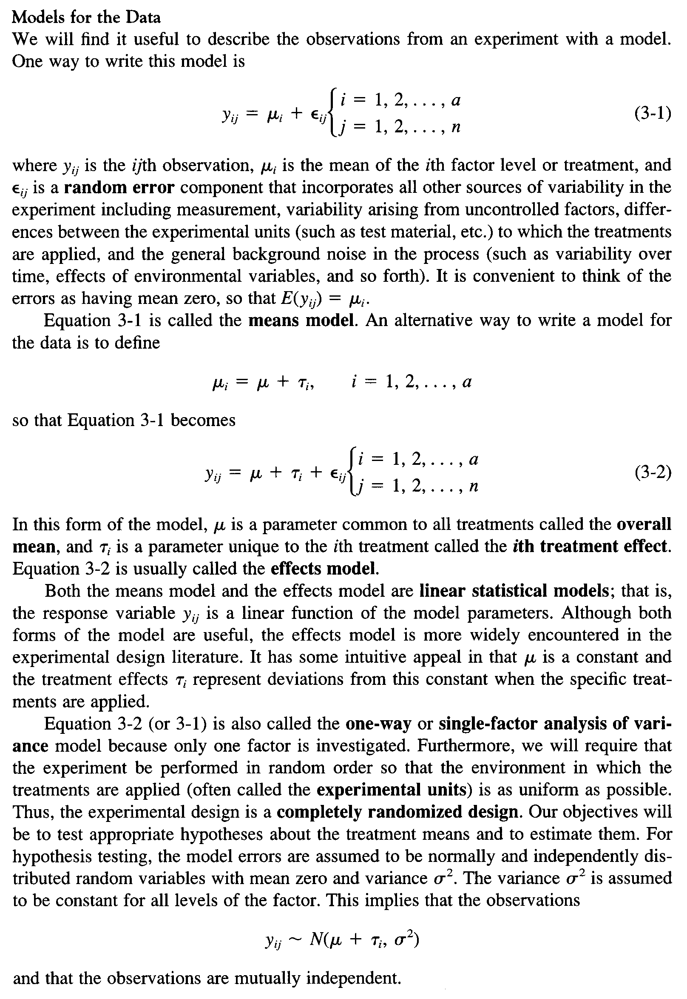
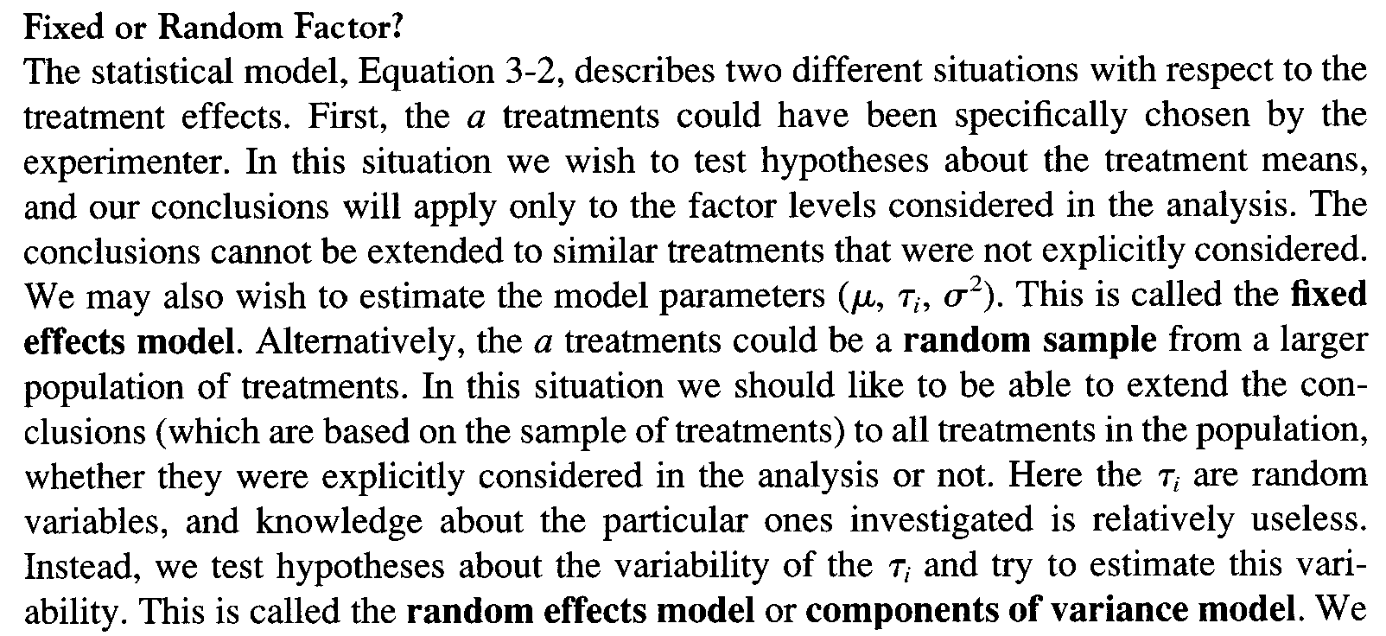

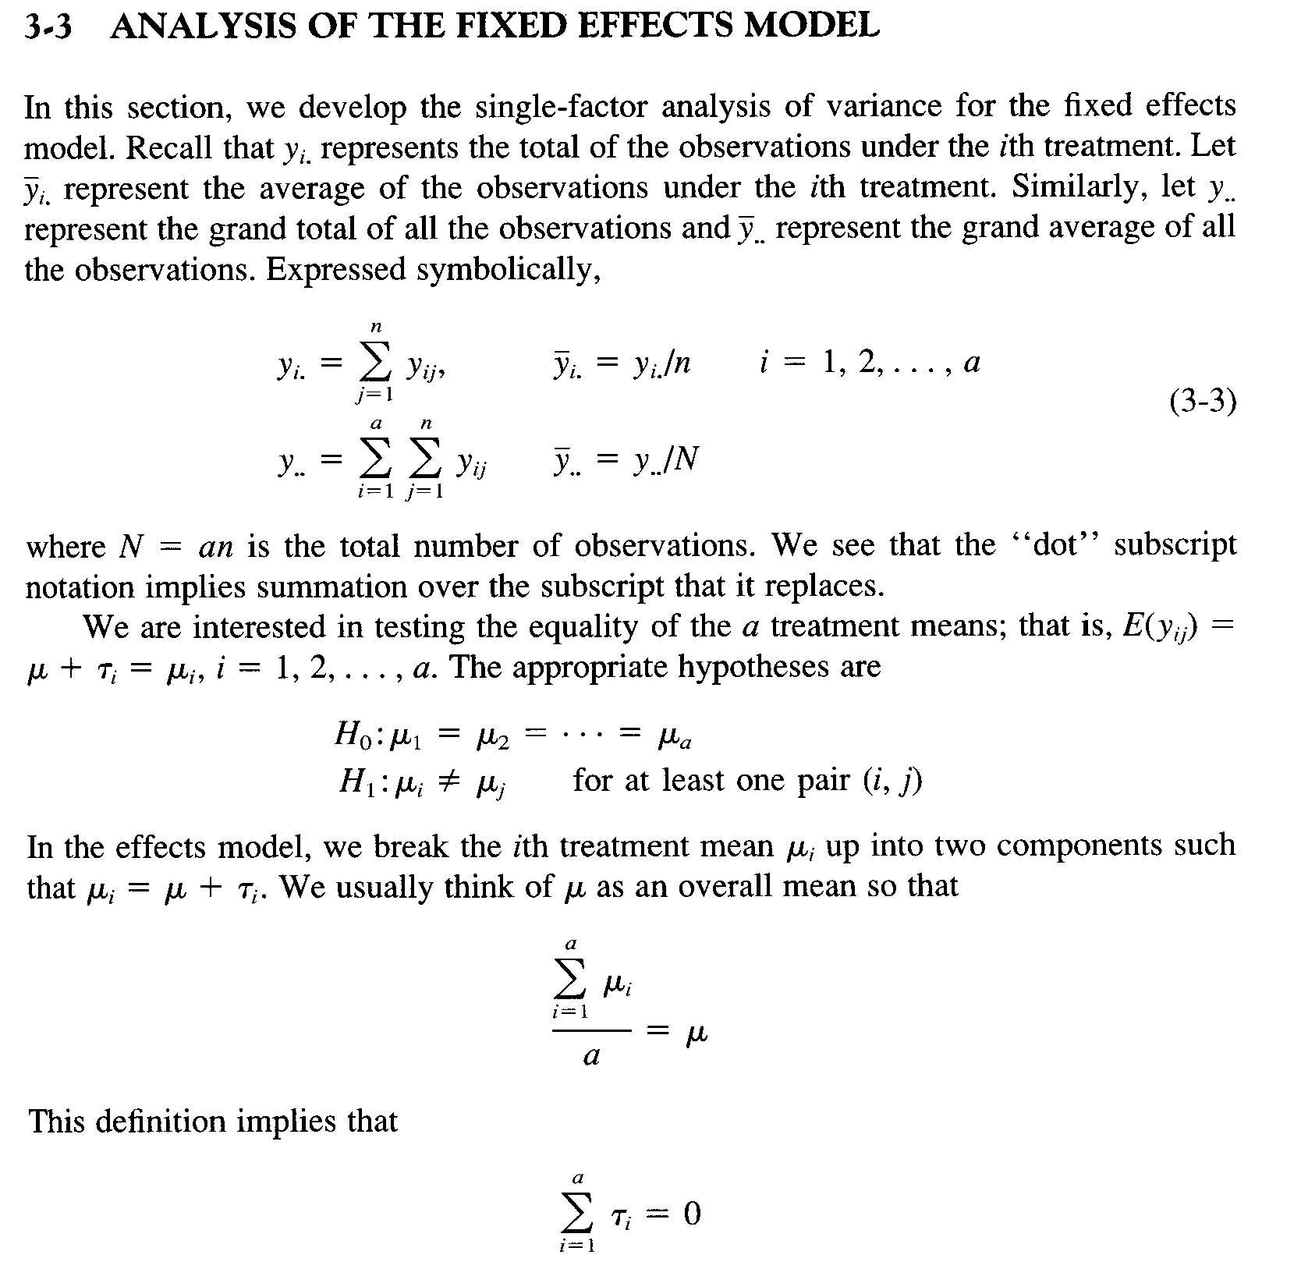

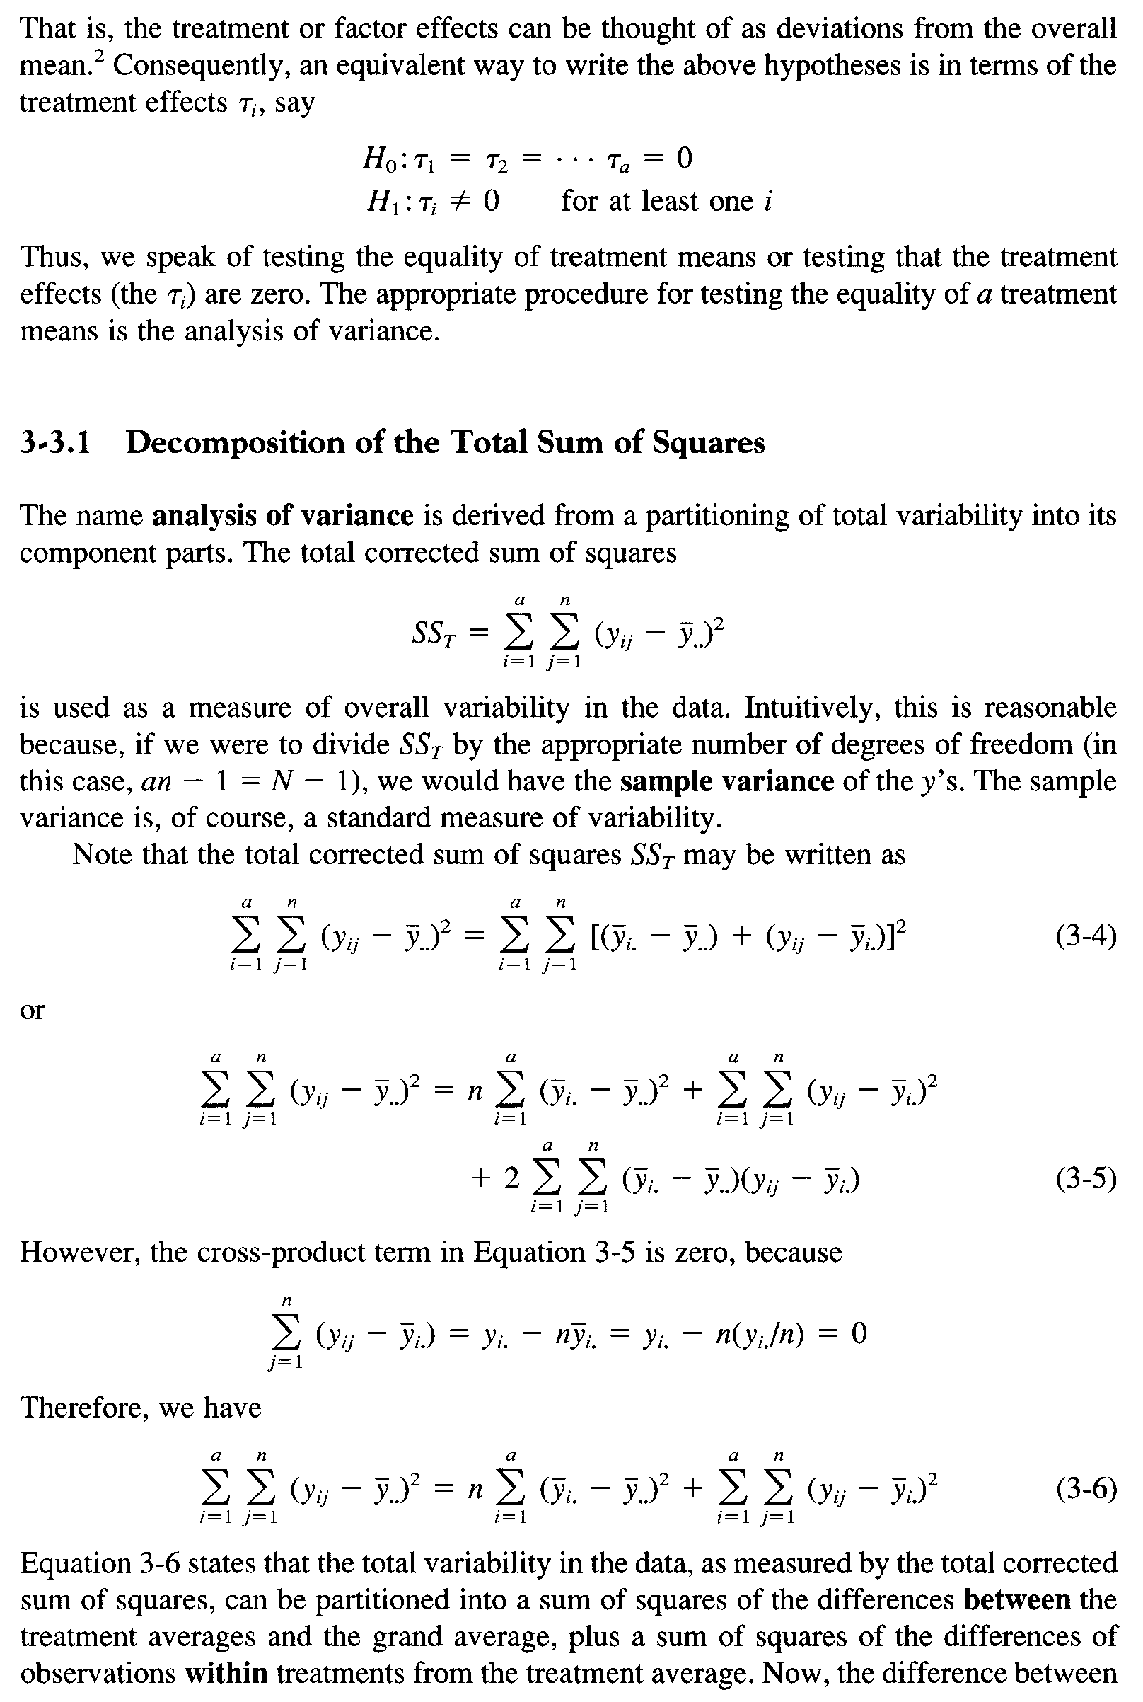
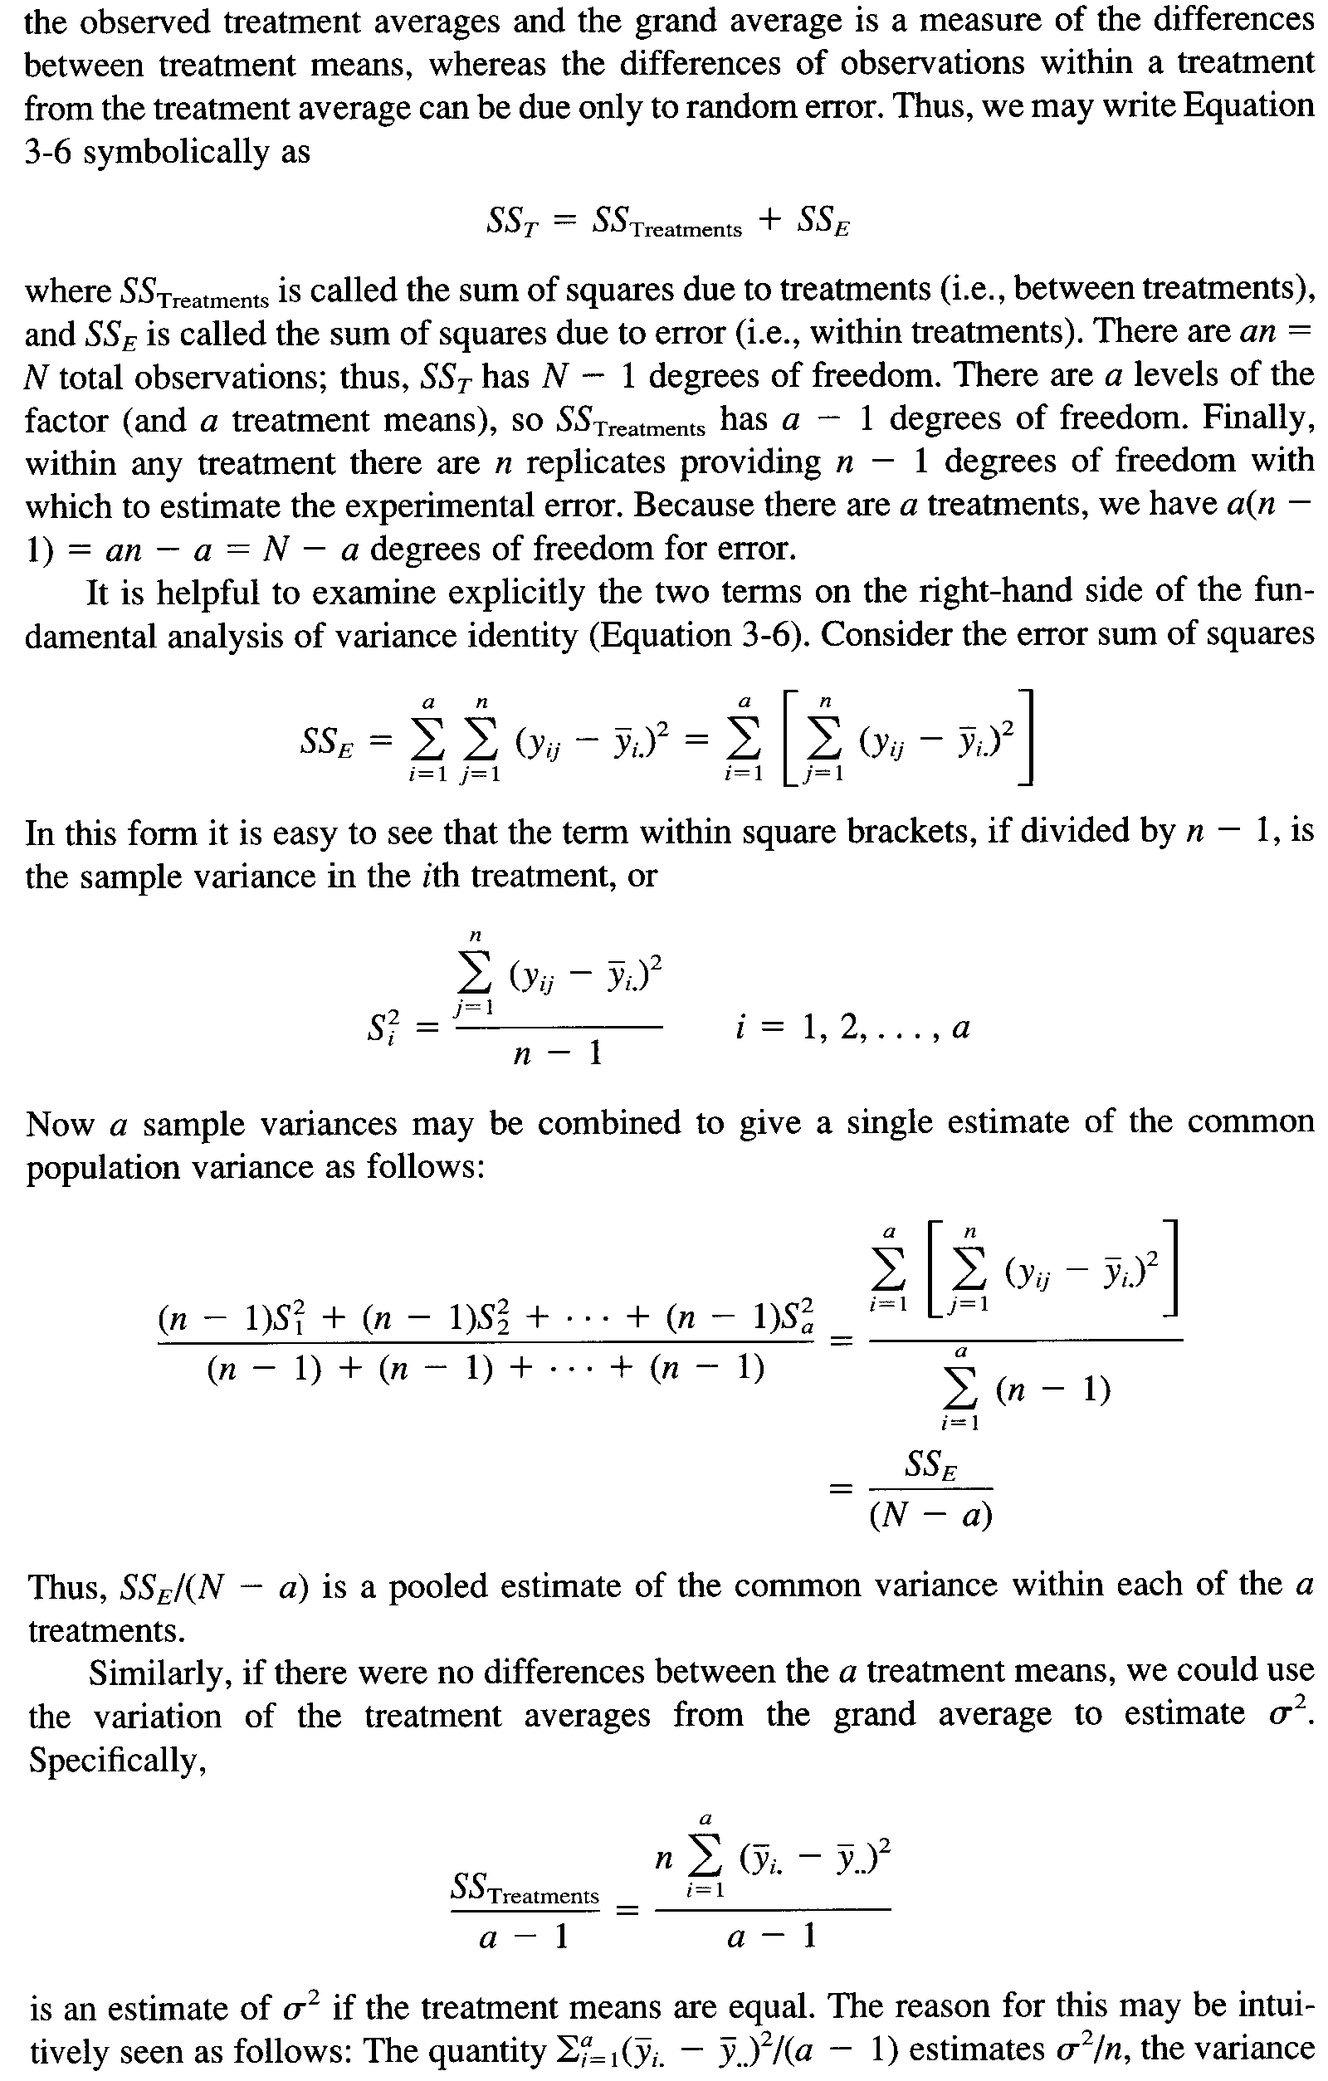
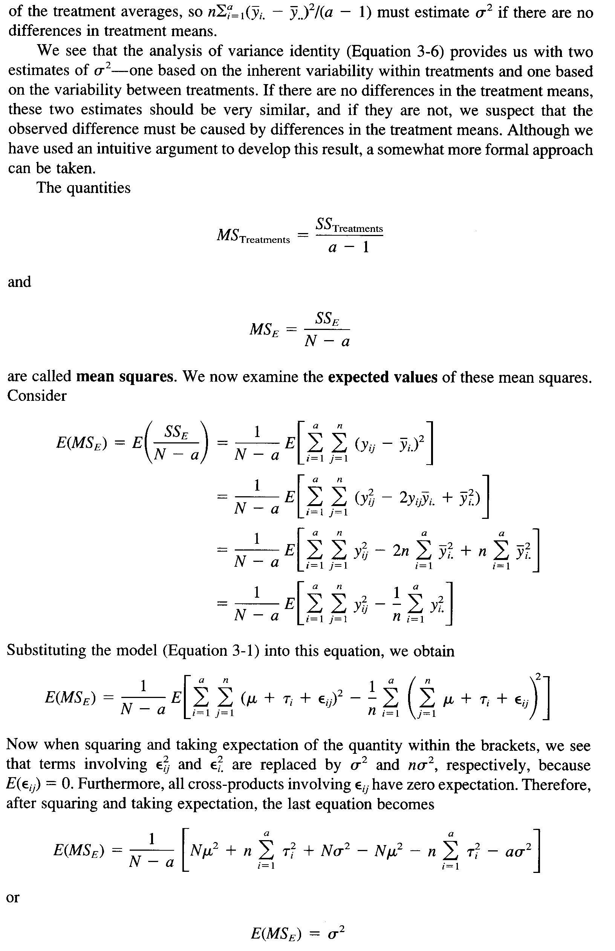
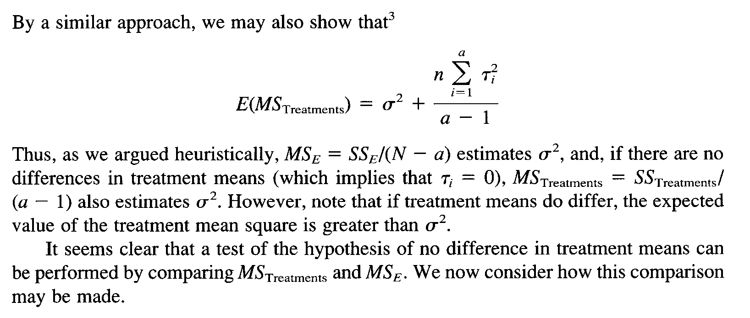

Statistical Analysis
- Total variation

=

where N=an
- Within Variation

- Between variation
In general the table of ANOVA is given as follows:
Source of variation | Degree of freedom | Sum square | Mean square | F
Between group | a-1 | SS_{between} | SS_{between}/a-1 | MS_{between}/MS_{within}
Within group | N-a | SS_{within} | SS_{within}/N-a
Total | N-1 | SS_{total}

Example: Suppose that the development engineer is interested in determining if the cotton weight percentage in a synthetic fiber affect the tensile strength and he has run a complete randomized experiment with five level of cotton weight percentage and five replicates.
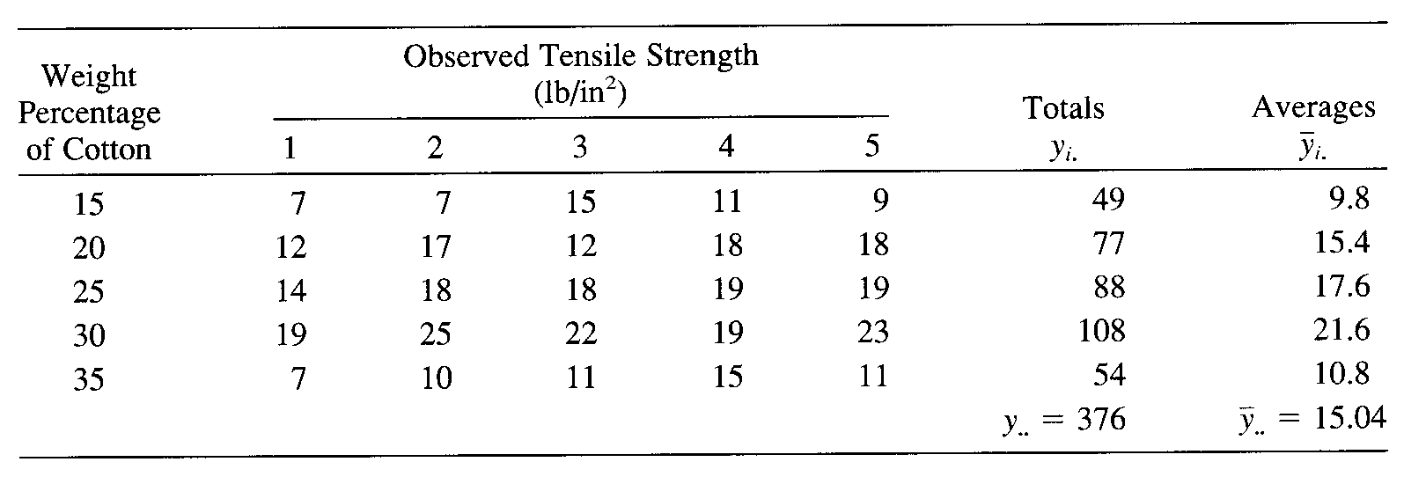
Analysis the above data.
Model:

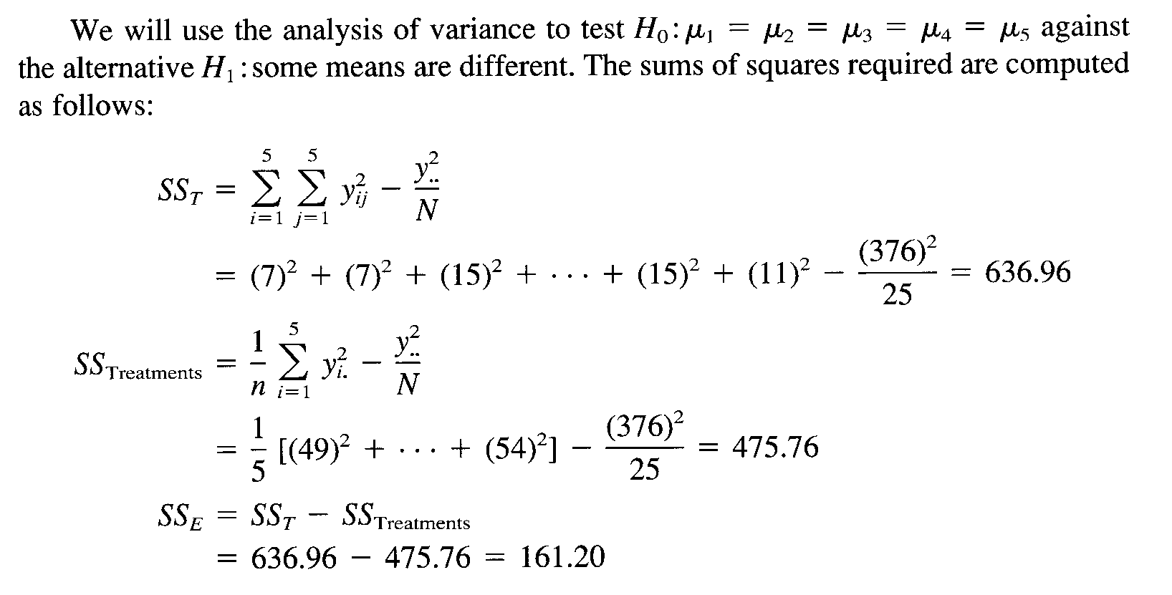
ANOVA table:
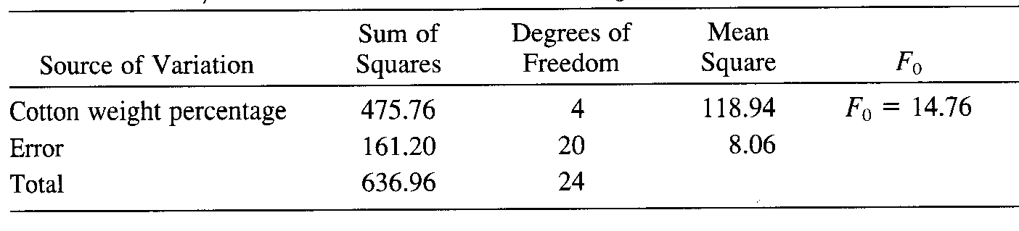

Decision: Since Fcal>Ftab reject H0
Conclusion: We conclude that the treatment means differ; that is the cotton weight percentage in the fiber significantly affects the mean tensile strength.
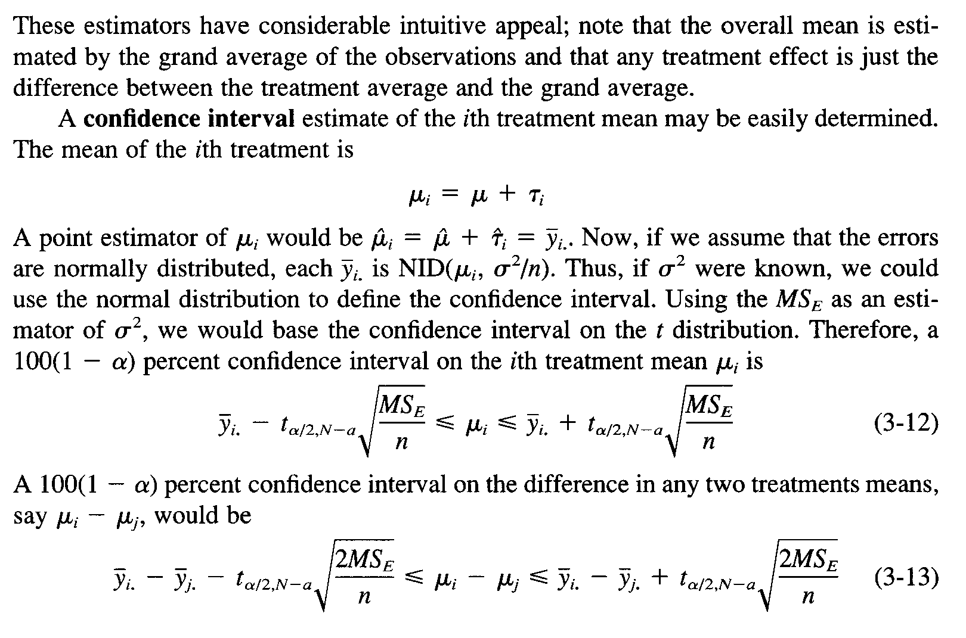
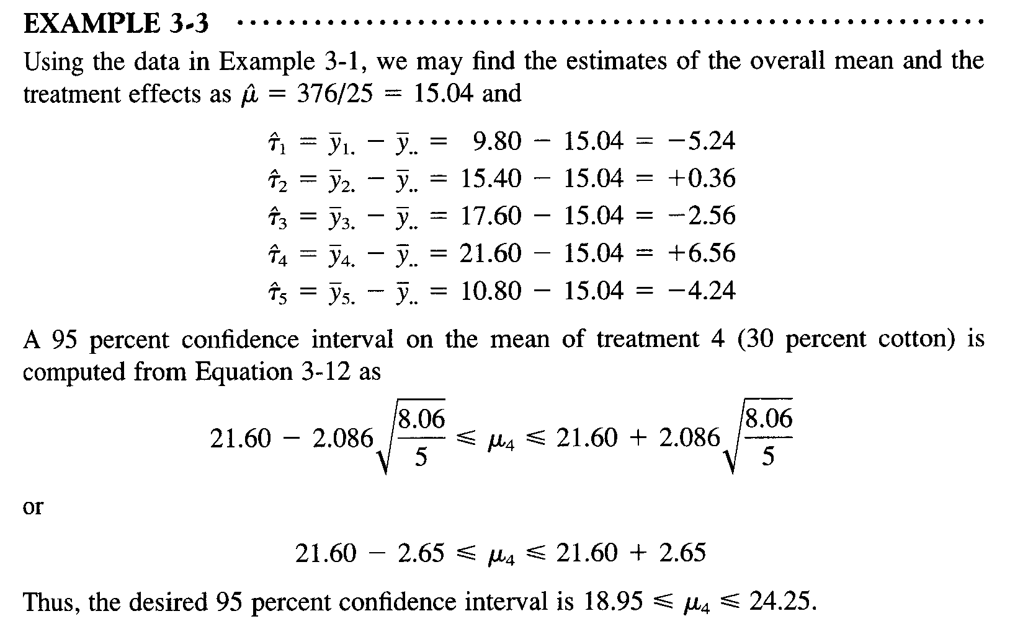
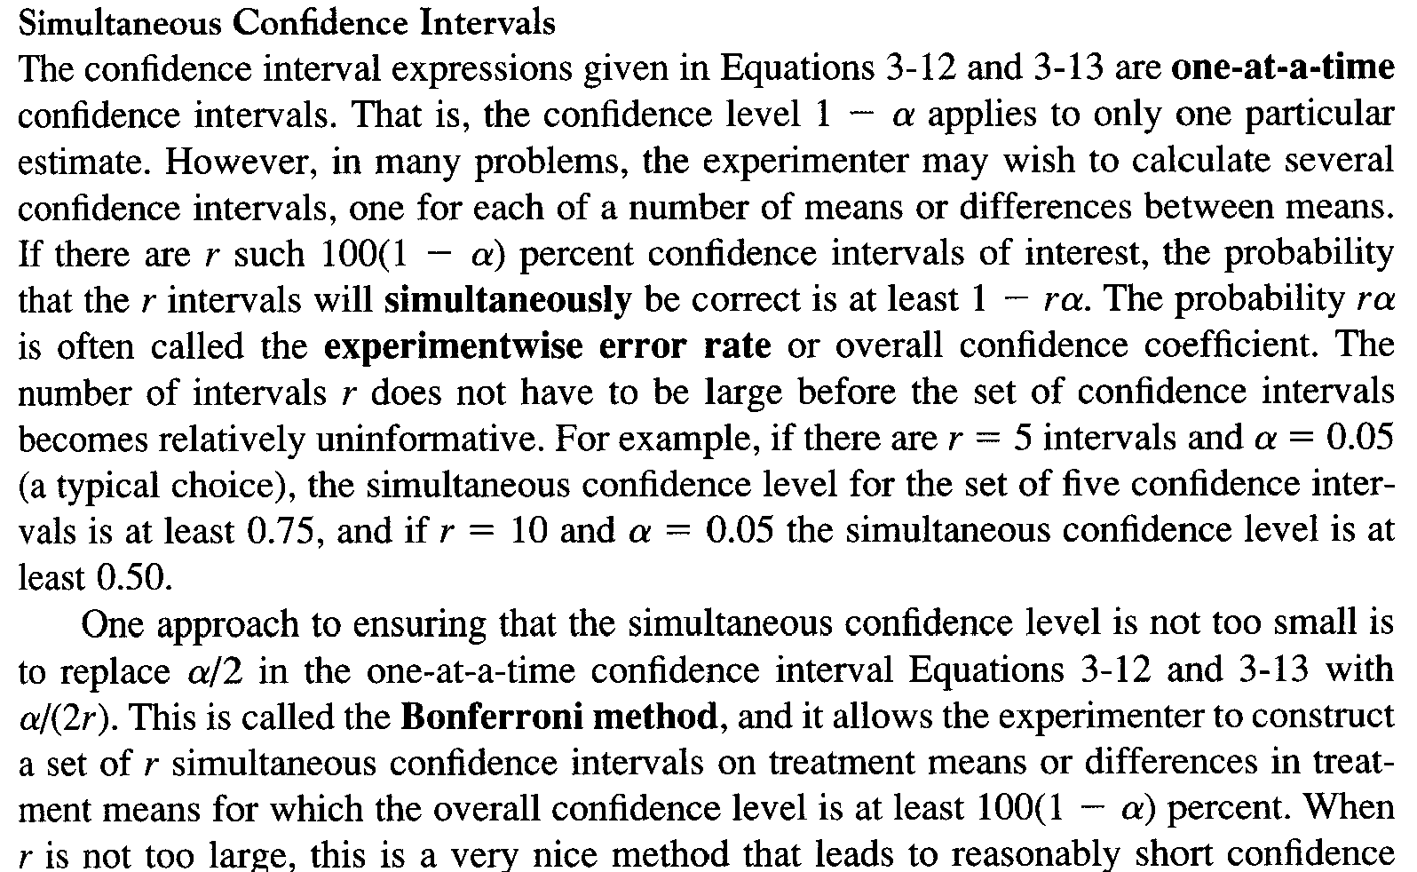
interval
Unbalanced Data
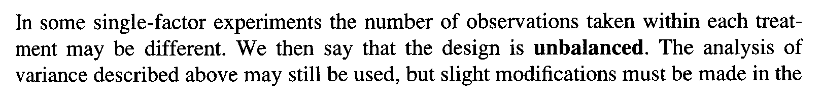

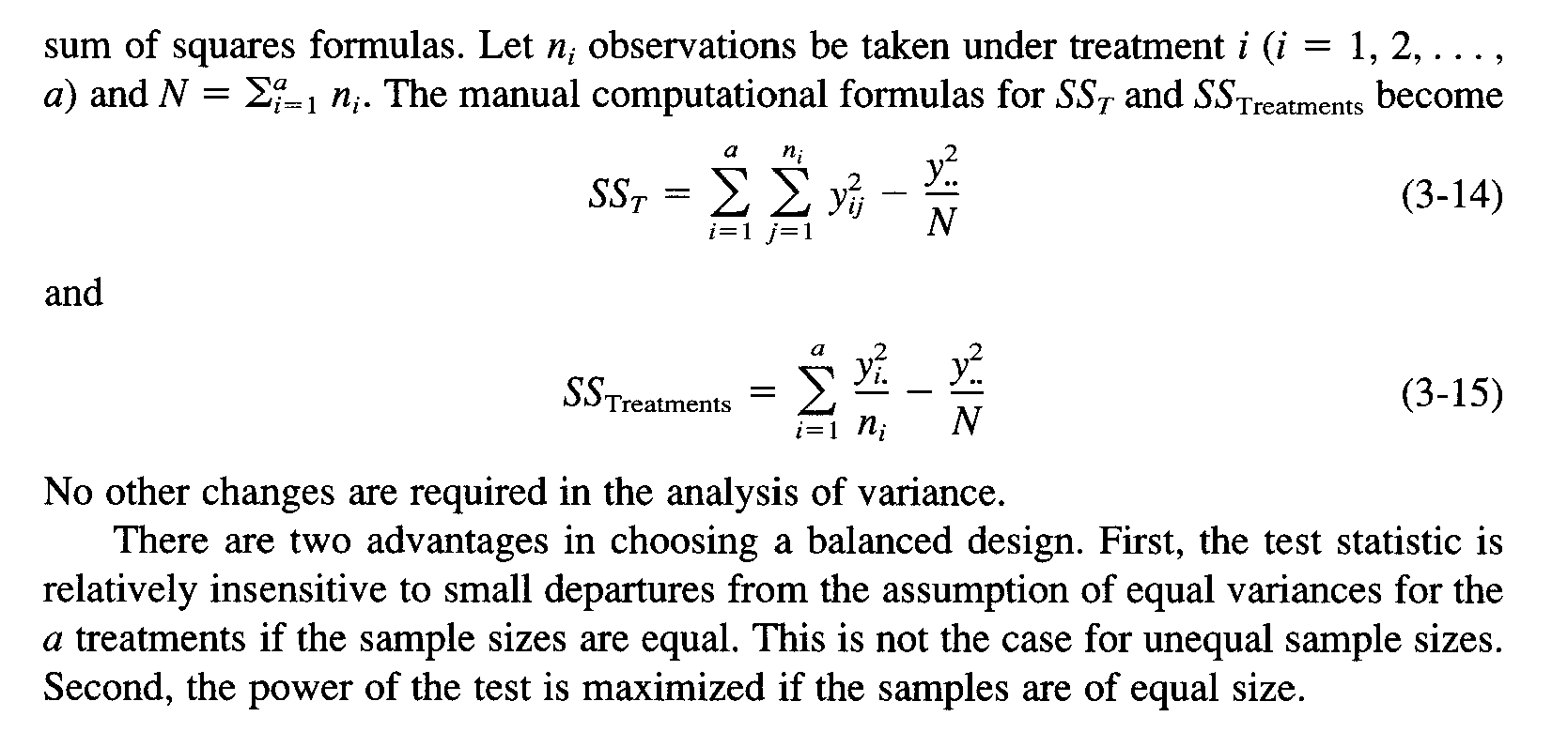
Model Adequacy Checking
The decomposition of the variability in the observation through an analysis of variance is pure algebraic relationship. However the use of the partitioning to test formally for no difference in treatment means requires that certain assumptions be satisfied. Specifically, these assumptions are that the observations are adequately described by the model and that the error is normally and independently distributed with mean zero and constant but unknown variance. The violation of this assumption can easily be investigated by the examination of residuals () where is an estimate of the corresponding observation of. Examination of the residuals should be an automatic part of any analysis of variance. If the model is adequate, the residuals should be structure less that is they should contain no obvious pattern.

Normality Assumption
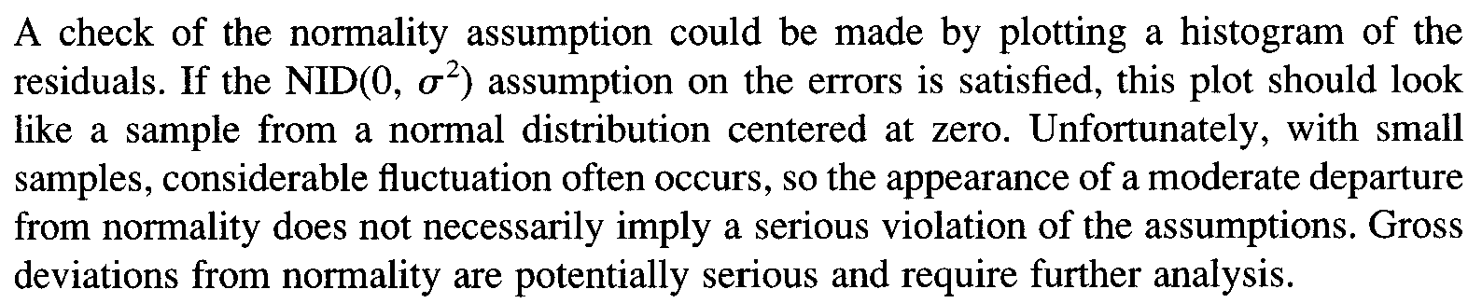
Plot of residuals in time sequence
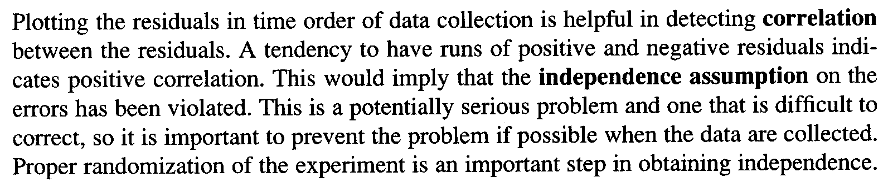
Plot of residual versus fitted value
If the model is correct and if the assumptions are satisfied, the residuals should be structures; in particular they should be unrelated to any other variables including the predicted response. The simple cheek is to plot the residuals versus the fitted values. This plot should not reveal any obvious pattern. A defect that occasionally shows up on this plot is non-constant variance. A simple check is to plot the residual versus the fitted value; shows the constant of variance.
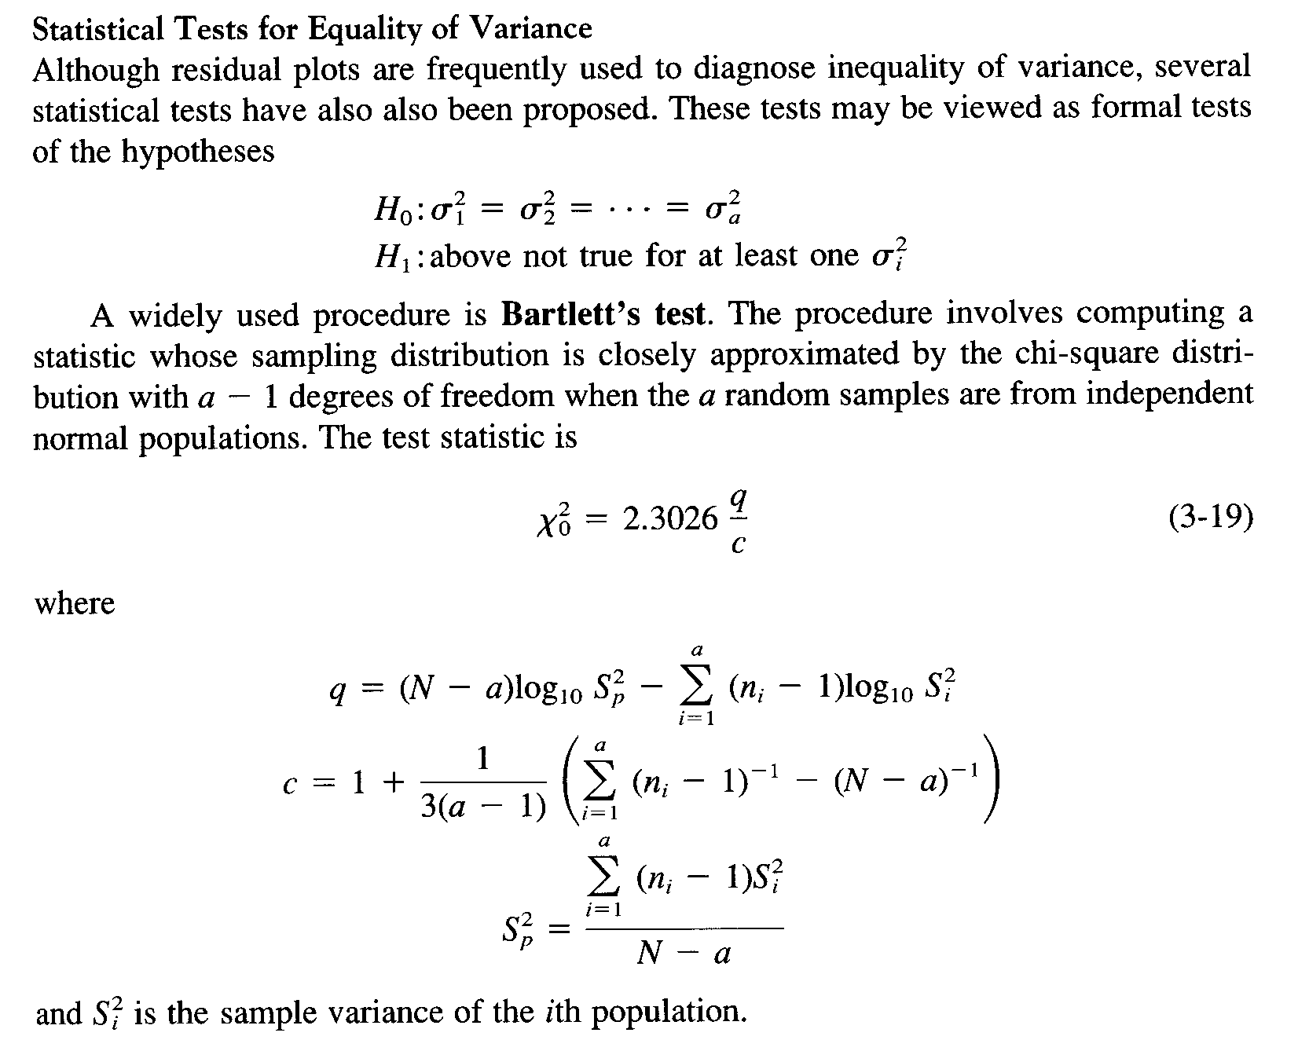
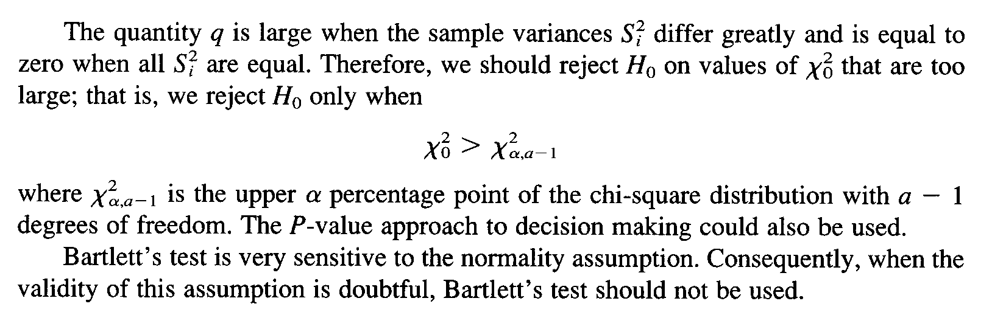

Comparison among Means
Having completed that, there is significance different between class means or significance effect due to treatment questions naturally arises regarding the mean such as “which mean are different or which of the mean are responsible for the rejection of H0”.
We can handle this problem depending upon when a selection is made of the contrast among means that are to be interested before the experiment is performed. Such comparison can be usually to be set without adjusting the risk of orthogonal “ANOVA”.
Recall that:
L is called contrast if the contribution of L to the treatment SS is:

And with a set of (a-1) mutually orthogonal components,
Q₁+Q₂+…………………+Q_{a-1=}SS_{treat}
- There are (a-1) contrasts. The method used is known as orthogonal contras
L1 and L2 are orthogonal, Iff=0
Example: Suppose we have four different diets which we want to compare the diet are labeled diet A, B, C and D. we are interested in how the diet affect the coagulation rate of 16 rabbit. The coagulation rate is the time in second that it take for a cut to stop bleeding. The measured coagulation time for each diet are given below.
 | Diet A | Diet B | Diet C | Diet D
 | 62 | 63 | 68 | 56
 | 60 | 67 | 66 | 62
 | 63 | 71 | 71 | 60
 | 59 | 74 | 69 | 61
Y_{i.} | 244 | 265 | 272 | 239 | 1020(Y..)
 |  | 66.25 | 68 | 59.75 | 63.75 ()
The ANOVA table for the following data is:
SV | Df | SS | MS | F
Treatment | 3 | 191.5 | 63.85 | 9.17(*)
error | 12 | 83.5 | 6.96
Total | 15 | 275

From the above ANOVA table we can conclude that the treatment means are not all equal. But here we don’t know which treatments mean is responsible for rejection of Ho. But through considering different types of contrast we can assure the responsible means.
Then from the above example, the contrast may be:

By considering contrast (iii) check the above example
Hypothesis:
And the respective components of treatments are:
There for the ANOVA table becomes to
SV | Df | SS | MS | F
Treatment | 3 | 191.5 | 63.85 | 9.17(*)
L1 | 1 | 40.33 | 40.33 | 5.80(*)
L2 | 1 | 15.04 | 15.04 | 2.16
L3 | 1 | 136.25 | 136.25 | 19.56 (*)
Error | 12 | 83.5 | 6.96
Total | 15 | 275

F_{0.05(3,12)}=3.49 and F_{0.05(1,12)}=4.75
So L1 and L2 are rejected. That is the average mean of diet B, C and D are different from diet A and diet C and diet D are not equal. At the reverse the average of C and D are equal to the mean of diet B.
Comparing Pairs Of Treatment Means
Suppose that we are interested in comparing all pairs of a treatment means and that the null hypothesis that we wish to test are for all i and j. we now list for methods for making such comparison
- Turkeys test
- Duncan’s multiple range test
- Newman-Keuls test
- The fisher least significance difference method
Exercise: Discuss on the above test with examples
Comparison Treatment Means With a Control
In many experiments, one of the treatments is a control and the analysts are interested in comparing each of the other a-1 treatments means with the control. Thus there are only a-1 comparisons to be made. Suppose that treatment a is the control and we wish to test the hypothesis:
Vs for i=1,2,3,…………………a-1
This procedure is developed by Dunnett (1964). It is a modification of the usual t-test. For each hypothesis we compute the observed differences in the sample means.

The null hypothesis is rejected using a type one error rate alpha if
Where is the Dunnett table.

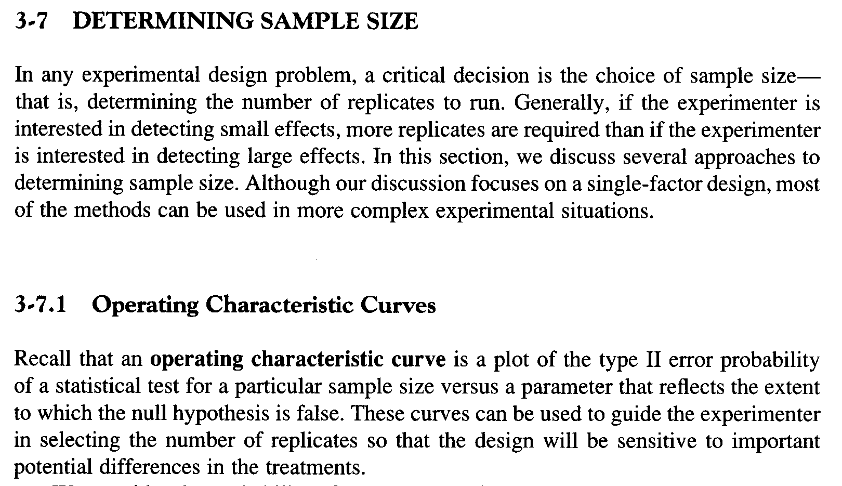
Regression Approach to ANOVA
General Regression Significance Test
Considering CRD in the model and are LS estimate of respectively.
Step 1: Obtain the total for each term in the model
Step 2: Obtain the grand total of the experiment
Step 3: Obtain the normal equation in (terms of the estimates of the parameter). The equation for each total in steps 1 and 2.
We come to the expanding for of the above equation:
Step 4: Solve equation of abd
Step 5: Obtain the regression sum of due to the estimates
Step 6: Rewrite the model, omitting the parameter assuming to be zero when the hypothesis under test is true (H0 is true). Or
Step 7: Determine the normal equation for this reduced formula
Step 8: Solve the normal equation and determine the regression sum of square due to estimates:
Step 9: obtain treatment SS
Step 10: Obtain with in treatment SS
Step 11: Make F test
Example: Suppose we have four different diets which we want to compare the diet are labeled diet A, B, C and D. we are interested in how the diet affect the coagulation rate of 16 rabbit. The coagulation rate is the time in second that it take for a cut to stop bleeding. The measured coagulation time for each diet are given below.
 | Diet A | Diet B | Diet C | Diet D
 | 62 | 63 | 68 | 56
 | 60 | 67 | 66 | 62
 | 63 | 71 | 71 | 60
 | 59 | 74 | 69 | 61
Y_{i.} | 244 | 265 | 272 | 239 | 1020(Y..)
 |  | 66.25 | 68 | 59.75 | 63.75 ()

The ANOVA table for the following data by using Regression approach is:
By using the above equation
The notation means the notation reduction in the sum of square from fitting the model containing and also the notation is called the regression sum of squares for the CRD model.
ANOVA
SV | Df | SS | MS | F
Treatment | 3 | 191.5 | 63.85 | 9.17(*)
Error | 12 | 83.5 | 6.96
Total | 15 | 275
F_{0.05(3, 12)=} 9.17
Conclusion: Reject H₀, that is there is a significance difference between diets A, B, C and D.
Chapter 4
Randomize Complete Block and Related Design
In any experiment, variability arises from the nuisance factor can affect the result. Generally we define a nuisance factor as a design factor that probably has an effect on the response, but we are not interested in the effect. Sometimes a nuisance factor is un-known and uncontrolled; that is, we don’t know that the factor exists and it may even be changing level while we are conducting the experiment. Randomization is a design technique used to guard against such a “lurking” nuisance factor in other case, the nuisance factor known but controllable. If we can at least observe the value that the nuisance factor takes on at each run the experiment. When the nuisance source of variability is known and controllable, a design technique is called blocking can be used to systematically eliminate its effect on the statistical comparison among treatments. Blocking is extremely important design technique.
CRD is not applicable if the experimental units are not alike. But the simplest design which enables as to take care of variability among the unit is called Randomized complete block design (CRBD). It consists:
- First divide the unit in to “b” homogenous group (blocks) in each block we take as many units as a treatment.
- Assign the treatments at random to the units of block
Remark: The word complete indicates that each block contains all treatments.
Block | Treatment
 | 1 | 2 | ……………. | a
1 | Y₁₁ | Y₂₁ |  | Y_{a1}
2 | Y₁₂ | Y₂₂ |  | Y_{a2}
.  .  .  . |  |  |  | .  .  .  .
b | Y_{1b} | Y_{2b} |  | Y_{ab}
Always the specialist knowledge of the experimenter about his/her experimental unit must be most important source of information in determining block of units.
Example: suppose that an experimental unit may be an animal, in this case block can be based on
- The genetic similarity of the animal
- The weight of the animal
- The history of the animal
Note: RCBD can be employed whenever it is possible to identify and isolate one extraneous source of variation. And in which requires that each treatment be used once in each block.
Example:
C(1) A(2) B(3) D(4)
A(5) D(6) B(7) C(8)
D(9) B(10) C(11) A(12)
A(13) C(14) D(15) B(16)

A B C D
2 3 1 4
5 7 8 6
12 10 11 9
13 16 14 15
Analysis of Variance (ANOVA)
Suppose we have in general “a” treatments that are to be composed and “b” block. The data lay out is:
Treatment (i) | Block (j) |  |  |  | Y_{i.}
 | 1 | 2 | ……………. | b
1 | Y₁₁ | Y₁₂ |  | Y_{1b} | Y_{1.}
2 | Y₂₁ | Y₂₂ |  | Y_{2b} | Y_{2.}
.  .  .  . |  |  |  | .  .  .  .
a | Y_{a1} | Y_{a2} |  | Y_{ab} | Y_{a.}
Y_{.j} | Y_{.1} | Y_{.2} |  | Y_{.2} | Y..

Model of RCBD

Where
- is the ij^{th} observation
- is over all mean (a parameter common for all treatments)
- is the i^{th} treatment effect
- is the j^{th} block effect
- is the random error
When the treatments and the blocks are assumed to be fixed,
Hypothesis
Analysis: To determine the Sum of Square

ANOVA TABLE
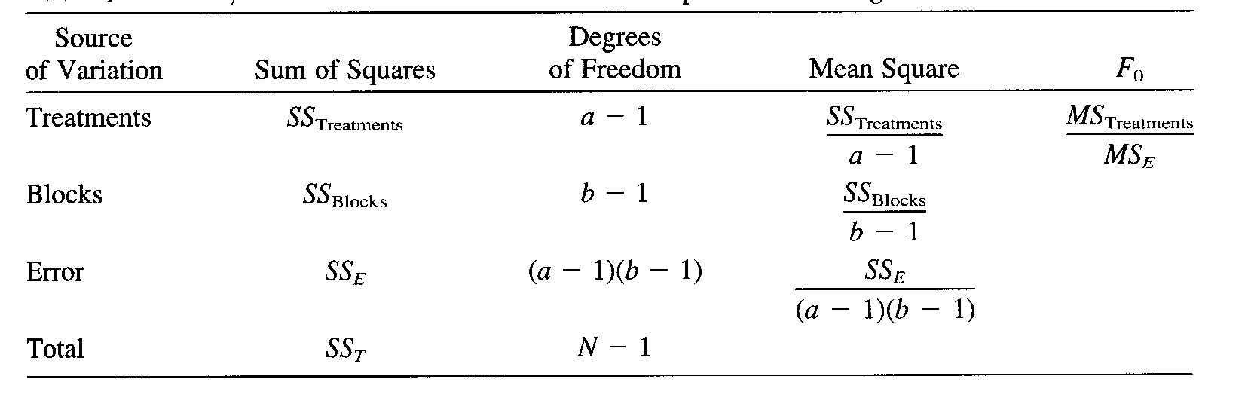
Example: there are four brands to be compared in an exp’t. Each brand contains “4 tires”. Assigning the 16 tires to the four cars in a complete random manures result each car get one tire of each brand. The measured loss in thickness of the 16 tires is given as follows:
Brand | Car |  |  |  | Y_{i.}
 | I | II | III | IV
A | 17 | 14 | 13 | 13 | 57
D | 14 | 14 | 13 | 8 | 49
C | 12 | 12 | 10 | 9 | 43
D | 13 | 11 | 11 | 9 | 44
Y_{.j} | 56 | 51 | 47 | 39 | 193
Analyze the above data.
Solution
ANOVA table
SV | df | SS | MS | F
Treat | 3 | 30.69 | 10.23 | 8.00(*)
Block | 3 | 38.69 | 12.90 | 10.08(*)
Error | 9 | 11.56 | 1.28
Total | 15 | 80.94

F0.05(3, 9)=3.86
Since the calculated value is greater than the tabulated, we reject Ho. Therefore there is significance difference between brand name and type of cars or a brand name affect the loss thickness of tires in four cars.
Missing Value
Occasionally in a CRBD an object is lost i.e. an animal may be die, a tire may be disintegrated. So there occurs one or missing observation in the data.
Suppose one observation is the missing and let this observation denoted Y’ and Let
- be the grand total with missing value
- be the treatment total with missing value
- be the block total with missing value
Then the missing value is calculated by
Therefore the sum of square is calculated as follows:
Exercise: Proof that
Example: Estimate the value of Y and analyze the data
Treatment | Block
 | 1 | 2 | 3 | 4
1 | 4 | 1 | 0 | 0 | 5
2 | 1 | 1 | 0 | -5 | -3
3 | -1 | -1 | Y | -4 | -6
4 | 0 | -2 | -2 | -4 | -8
 | 4 | -1 | -2 | -13 | -12

Solution:
Incomplete Block Design (IBD)
Some randomized block design; it may not be possible to all treatments in every block. i.e when a large number of treatment must be included in an experiment or when the number of blocks is less than the number of treatments.
An IBD is a design in which there are more treatments than that can be put in a single block. Example to compare 6 brand of tire on a four wheel cars or two compare 8 types of fertilizers on a block of 6 plots. When all treatment comparison is equally important the treatments comparison used in each block should be selected in a balanced manner. I.e. any pair of treatment occurs together at the same number of times as any other pairs. Thus a BIBD (balanced incomplete black design) is IBD (Incomplete Block Design) in which any two treatment appears together at equal number of times. It can be derived in terms of:
- The number of treatments (a)
- The number of block (b)
- The number of treatments in each block or block size (k)
- The number of replicates or plots of each treatment (r)
- The number of times each pairs of treatments appears throughout the experiment

- Total observation N=ar=bkr=bk/a
- If a=b, the design is said to be symmetric
Example:
Block | Treatment combinations
1 | AB
2 | AC
3 | AD
4 | BC
5 | BD
6 | CD

- a=4 (A, B, C, D) , b=6 (1, 2,……,6), k=2, r=bk/a3,
- each pairs occurs one time in a given experiment.
Statistical Analysis of a BIBD
Model:
Analysis:
Where &
Note: The adjusted treatment total for the ith treatment always sum to zero.
Example:
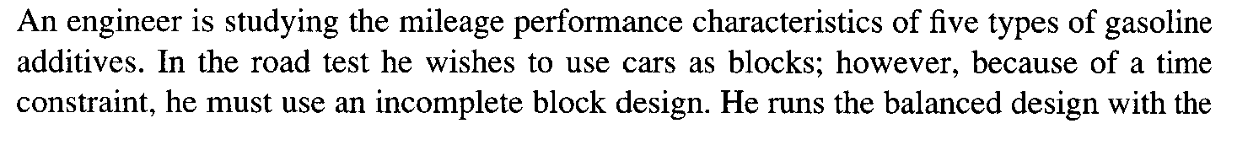
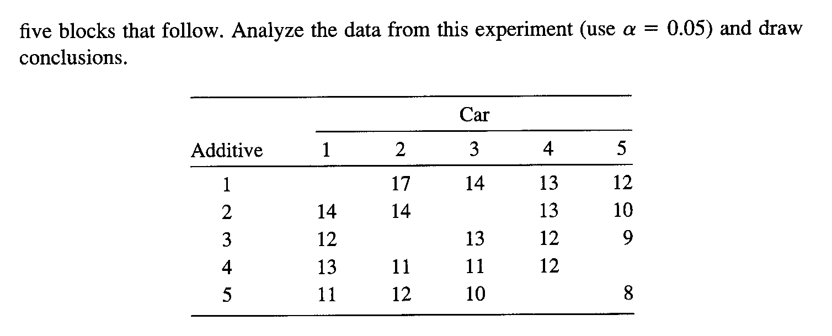
- Write the ANOVA and identify all terms
- Analyze the data and draw conclusion
Solution
- Model:
- a=5, b=5, k=4, r=bk/a4,

- where &

ANOVA table
SV | Df | SS | MS | F
Treat (adj) | 4 | 35.73 | 8.94 | 9.81(*)
Block | 4 | 31.2 | 7.80
Error | 11 | 10.02 | 0.91
Total | 9 | 76.95
F0.05(4,11)=3.36
Conclusion: There are highly significance differences between gasoline additives with regard to the car.

Latin Square Design (LSD)
In this we introduced the randomized block design as a design to reduce the residual error in an experiment by removing variability due to a known and controlable nusiance variable. There are several other types od designs that utilize the blocking principle.
Latin square design is a square arrangement and that the treatments are denoted by the Latin letters (A, B, …….) hence the name latin letters. It is used to eliminate to nuisance source of variability that is it systematically allows blocking in two directions. Thus, the rows and columns are actually to represent two directions on randomization. In general, latin square for P factors or “pxp” latin square is, containing ‘p’ rows and ‘p’ columns and each treatment appears once and once only in each row and columns.
Example: If 3X3 Latin square
Rows | Column
 | 1 | 2 | 3
1 | A | B | C
2 | B | C | A
3 | C | A | B

Standard Latin Square (SLS): It is a Latin square of which first row and column are written in alphabetical order.
Model of Latin square design:
- = Over all mean
- = i^{th} treatment effect
- =j^{th} row effect
- =random error

Assumption:
- Grand Total
- Treatment Total
- Rows total
- Column Total
Analysis
with (p-1) d.f.
with (p-1) d.f.
with (p-1) d.f.
with (p²-1) d.f.
with (p-1)(p-2) d.f.
Example: The following is 5*5 latin square for data taken from a numerical experiment with sugar cane. The five treatments are denoted by (A, B, C, D, E) and yield of sugar cane (in suitable unit) per plot.
Row | Columns |  |  |  |  | Y.j.
 | I | II | III | IV | V
I | A=52 | E=46 | D=44 | C=48 | B=41 | 231
II | D=44 | B=43 | A=51 | E=49 | C=33 | 220
III | B=49 | A=47 | C=38 | D=41 | E=47 | 222
IV | C=43 | D=43 | E=67 | B=55 | A=45 | 253
V | E=47 | C=43 | B=47 | A=46 | D=43 | 226
Y_{..K} | 235 | 222 | 247 | 239 | 209 | 1152

Solution:
Treat | A | B | C | D | E
Yi.. | 241 | 235 | 205 | 215 | 256

ANOVA
SV | d.f. | SS | MS | F
Row | 4 | 114.84 | 35.46
Column | 4 | 179.84 | 44.96
Treat | 4 | 334.24 | 83.56 | 3.46(*)
Error | 12 | 289.92 | 24.16
Total | 24 | 945.84
F_{0.05 (4, 12)}=3.26
Since Fcal. > Ftab. reject Ho that is no treatment effect is rejected at 5% level of significance.
Youden Square
When the condition for latin square are met except for the fact that lack of treatment i.e. (it may be row or columns) that is called Youden square.

Row | Column
 | 1 | 2 | 3 | 4
1 | A | B | C | D
2 | B | C | D | A
3 | C | D | A | B
4 | D | A | B | C
Row | Column
 | 1 | 2 | 4
1 | A | B | D
2 | B | C | A
3 | C | D | B
4 | D | A | C
Model:
Analysis
where and
Note: The block is taken to be the extraneous factors with largest number of levels.
Examples: The figures in the following Youden square are the number of minute’s engines E1, E2, E3, E4 turned by operator O1, O2, O3, O4 and O5 run with a gallon of few A, B, C, D & E.
Operator | Engines |  |  |  | Y.j.
 | E1 | E2 | E3 | E4
O1 | A=31 | B=24 | C=20 | D=20 | 95
O2 | B=21 | C=27 | D=23 | E=25 | 96
O3 | C=22 | D=27 | E=25 | A=29 | 103
O4 | D=20 | E=25 | A=33 | B=25 | 103
O5 | E=18 | A=37 | B=24 | C=33 | 103
Y..k | 112 | 140 | 125 | 123 | 500
Analyze the data and test whether treatments affects are the same.
Solution:
Treat | A | B | C | D | E
Yi.. | 130 | 94 | 93 | 90 | 93
Where and
Q1=4(130)-(95+103+103+103)=116
Q2=4(94)-(95+96+103+103) = -21
Q3=4(93)-(95+96+103+103) = -25
Q4= 4(93)- (96+103+103+103)= -33

ANOVA
SV | d.f. | SS | MS | F
Treat (adj) | 4 | 283 | 70.75 | 12.75(*)
Row | 4 | 17
Column | 3 | 79.6
Error | 8 | 44.4 | 5.55
Total | 19 | 424

F0.05(4, 8)=3.84, reject H0 since the calculate value is greater than the tabulated, therefore there is a significance difference between treatment means (treatment).
Greco Latin Square
This is another name for a pair of orthogonal latin square super imposed on one another. The treatment being represented by Greek letters in one square, and latin letters in others.
Example: 4X4 Greco-latin letters square is the following, that is:

Latin letters
Row | Column
 | 1 | 2 | 3 | 4
1 | A | B | C | D
2 | B | C | D | A
3 | C | D | A | B
4 | D | A | B | C

Greek letters
Row | Column
 | 1 | 2 | 3 | 4
1
2
3
4
Greco-Latin Squares
Row | Column
 | 1 | 2 | 3 | 4
1 | A
2
3
4

Model:

Where effect due the extraneous factor represent by Greek letters
Analysis
with (p-1) d.f.
with (p-1) d.f.
with (p-1) d.f.
with (p-1) d.f.
with (p²-1) d.f.
with (p-1)(p-3) d.f.
Example: 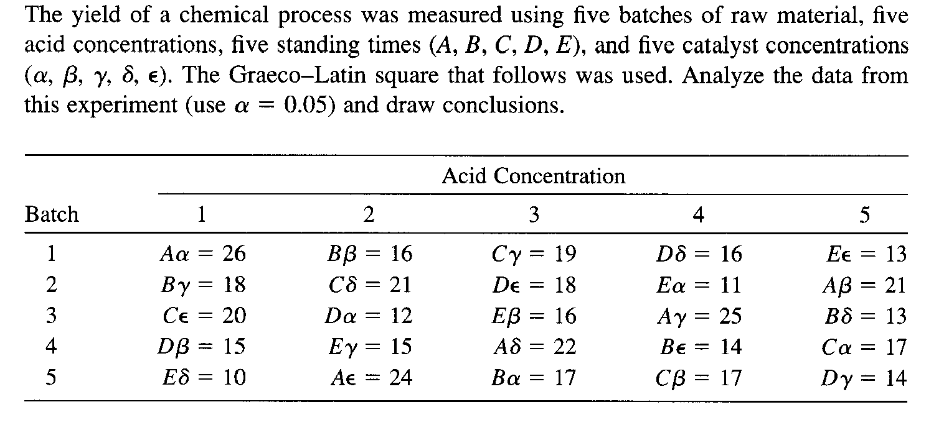
Solution
Y_{.j..} | 90 | 89 | 76 | 83 | 82
Y_{..k.} | 79 | 88 | 92 | 83 | 78
Y_{i…} | A | B | C | D | E
 | 118 | 78 | 94 | 75 | 65
Y_{…l}
 | 83 | 85 | 91 | 82 | 89

ANOVA
SV | d.f. | SS | MS | F
Treatment | 4 | 342.8 | 85.7 | 14.65(*)
Row (batch) | 4 | 10
Column (Acidic Concentration) | 4 | 24.4
Greek (catalyst ) | 4 | 12
Error | 8 | 46.8 | 5.85
Total | 24 | 436

F_{0.05(4, 8)}=3.84 < 14.65 Reject H0
Therefore, there is no significance difference between treatment means (standing time)

