Chapter Three
Banking and the Management of Financial Institutions

Because banking plays such a major role in channelling funds to borrowers with productive investment opportunities, this financial activity is important in ensuring that the financial system and the economy run smoothly and efficiently.
In this chapter, we examine how banking is conducted to earn the highest profits possible: how and why banks make loans, how they acquire funds and manage their assets and liabilities (debts), and how they earn income. Although we focus on commercial banking because this is the most important financial intermediary activity, many of the same principles are applicable to other types of financial intermediation.

The Bank Balance Sheet
To understand how banking works, we start by looking at the bank balance sheet, a list of the bank’s assets and liabilities. As the name implies, this list balances; that is, it has the characteristic that
total assets = total liabilities + capital
A bank’s balance sheet is also a list of its sources of bank funds (liabilities) and uses to which the funds are put (assets). Banks obtain funds by borrowing and by issuing other liabilities such as deposits. They then use these funds to acquire assets such as securities and loans. Banks make profits by charging an interest rate on their asset holdings of securities and loans that is higher than the interest and other expenses on their liabilities.
1. Liabilities
A bank acquires funds by issuing (selling) liabilities, such as deposits, which are the sources of funds the bank uses. The funds obtained from issuing liabilities are used to purchase income-earning assets.
[Checkable Deposits Checkable deposits are bank accounts that allow the owner of the account to write checks to third parties. Checkable deposits include all accounts on which checks can be drawn: non-interest-bearing checking accounts (demand deposits), interest-bearing NOW (negotiable order of withdrawal) accounts, and money market deposit accounts (MMDAs). MMDAs are not subject to reserve requirements as checkable deposits are.
Checkable deposits and money market deposit accounts are payable on demand; that is, if a depositor shows up at the bank and requests payment by making a withdrawal, the bank must pay the depositor immediately. Similarly, if a person who receives a check written on an account from a bank presents that check at the bank, it must pay the funds out immediately (or credit them to that person’s account).

A checkable deposit is an asset for the depositor because it is part of his or her wealth. Because the depositor can withdraw funds and the bank is obligated to pay, checkable deposits are a liability for the bank. They are usually the lowest cost source of bank funds because depositors are willing to forgo some interest to have access to a liquid asset that can be used to make purchases. The bank’s costs of maintaining checkable deposits include interest payments and the costs incurred in servicing these accounts—processing, preparing, and sending out monthly statements, providing efficient tellers (human or otherwise), maintaining an impressive building and conveniently located branches, and advertising and marketing to entice customers to deposit their funds with a given bank.
Nontransaction Deposits Nontransaction deposits are the primary source of bank funds. Owners cannot write checks on nontransaction deposits, but the interest rates paid on these deposits are usually higher than those on checkable deposits. There are two basic types of nontransaction deposits: savings accounts and time deposits (also called certificates of deposit, or CDs). In these accounts, to which funds can be added or from which funds can be withdrawn at any time, transactions and interest payments are recorded in a monthly statement or in a passbook held by the owner of the account.
Time deposits have a fixed maturity length, ranging from several months to over five years, and assess substantial penalties for early withdrawal (the forfeiture of several months’ interest).
Borrowings Banks also obtain funds by borrowing from the central bank system, other banks, and corporations. Borrowings from the Fed are called discount loans (also known as advances).
Bank Capital The final category on the liabilities side of the balance sheet is bank capital, the bank’s net worth, which equals the difference between total assets and liabilities. Bank capital is raised by selling new equity (stock) or from retained earnings. Bank capital is a cushion against a drop in the value of its assets, which could force the bank into insolvency (having liabilities in excess of assets, meaning that the bank can be forced into liquidation).
2. Assets
A bank uses the funds that it has acquired by issuing liabilities to purchase income earning assets. Bank assets are thus naturally referred to as uses of funds, and the interest payments earned on them are what enable banks to make profits.
Reserves All banks hold some of the funds they acquire as deposits in an account at the central bank. Reserves are these deposits plus currency that is physically held by banks (called vault cash because it is stored in bank vaults overnight). Although reserves currently do not pay any interest, banks hold them for two reasons. First, some reserves, called required reserves, are held because of reserve requirements, the regulation that for every birr of checkable deposits at a bank, a certain fraction (10 cents, for example) must be kept as reserves. This fraction (10% in the example) is called the required reserve ratio. Banks hold additional reserves, called excess reserves, because they are the most liquid of all bank assets and a bank can use them to meet its obligations when funds are withdrawn, either directly by
a depositor or indirectly when a check is written on an account.
Cash Items in Process of Collection Suppose that a check written on an account at another bank is deposited in your bank and the funds for this check have not yet been received (collected) from the other bank. The check is classified as a cash item in process of collection, and it is an asset for your bank because it is a claim on another bank for funds that will be paid within a few days.
Deposits at Other Banks Many small banks hold deposits in larger banks in exchange for a variety of services, including check collection, foreign exchange transactions, and help with securities purchases. This is an aspect of a system called correspondent banking.

Collectively, reserves, cash items in process of collection, and deposits at other banks are referred to as cash items.
Securities A bank’s holdings of securities are an important income-earning asset:
Securities are made up entirely of debt instruments for commercial banks, because
banks are not allowed to hold stock.
Loans Banks make their profits primarily by issuing loans. A loan is a liability for the individual or corporation receiving it, but an asset for a bank, because it provides income to the bank. Loans are typically less liquid than other assets, because they cannot be turned
into cash until the loan matures. If the bank makes a one-year loan, for example, it cannot get its funds back until the loan comes due in one year. Loans also have a higher probability of default than other assets. Because of the lack of liquidity and higher default risk, the bank earns its highest return on loans.
Other Assets The physical capital (bank buildings, computers, and other equipment) owned by the banks is included in this category.

General Principles of Bank Management
Now that you have some idea of how a bank operates, let’s look at how a bank manages its assets and liabilities to earn the highest possible profit. The bank manager has four primary concerns. The first is to make sure that the bank has enough ready cash to pay its depositors when there are deposit outflows—that is, when deposits are lost because depositors make withdrawals and demand payment. To keep enough cash on hand, the bank must engage in liquidity management, the acquisition of sufficiently liquid assets to meet the bank’s obligations to depositors. Second, the bank manager must pursue an acceptably low level of risk by acquiring assets that have a low rate of default and by diversifying asset holdings (asset management). The third concern is to acquire funds at low cost (liability management). Finally, the manager must decide the amount of capital the bank should maintain and then acquire the needed capital (capital adequacy management).
Liquidity Management and the Role of Reserves
Let us see how a typical bank, the First National Bank, can deal with deposit outflows
that occur when its depositors withdraw cash from checking or savings accounts or write
checks that are deposited in other banks. In the example that follows, we assume that
the bank has ample excess reserves and that all deposits have the same required reserve
ratio of 10% (the bank is required to keep 10% of its time and checkable deposits as
reserves). Suppose that the First National Bank’s initial balance sheet is as follows:
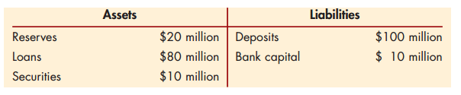
The bank’s required reserves are 10% of $100 million, or $10 million. Given that it holds $20 million of reserves, the First National Bank has excess reserves of $10 million. If a deposit outflow of $10 million occurs, the bank’s balance sheet becomes
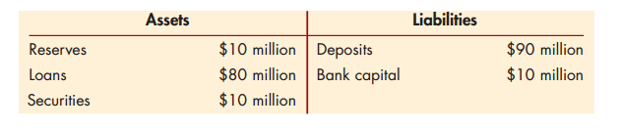
The bank loses $10 million of deposits and $10 million of reserves, but because its required reserves are now 10% of only $90 million ($9 million), its reserves still exceed this amount by $1 million. In short, if a bank has ample excess reserves, a deposit outflow does not necessitate changes in other parts of its balance sheet.
The situation is quite different when a bank holds insufficient excess reserves. Let’s assume that instead of initially holding $10 million in excess reserves, the First National Bank makes additional loans of $10 million, so that it holds no excess reserves. Its initial balance sheet would then be
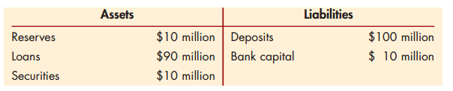
When it suffers the $10 million deposit outflow, its balance sheet becomes
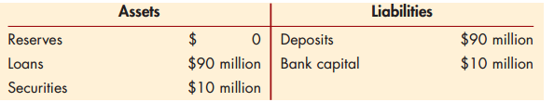
After $10 million has been withdrawn from deposits and hence reserves, the bank has a problem: It has a reserve requirement of 10% of $90 million, or $9 million, but it has no reserves! To eliminate this shortfall, the bank has four basic options. One is to acquire reserves to meet a deposit outflow by borrowing them from other banks in the federal funds market or by borrowing from corporations. If the First National Bank acquires the $9 million shortfall in reserves by borrowing it from other banks or corporations, its balance sheet becomes
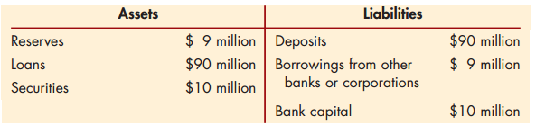
The cost of this activity is the interest rate on these borrowings, such as the government funds rate. A second alternative is for the bank to sell some of its securities to help cover the deposit outflow. For example, it might sell $9 million of its securities and deposit the proceeds with the central bank, resulting in the following balance sheet:
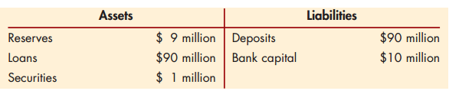
A third way that the bank can meet a deposit outflow is to acquire reserves by borrowing from the central bank. In our example, the First National Bank could leave its security and loan holdings the same and borrow $9 million in discount loans from the central bank. Its balance sheet would then be
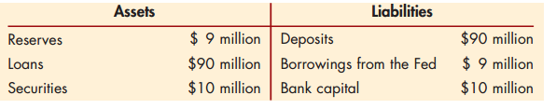
The cost associated with discount loans is the interest rate that must be paid to the central bank (called the discount rate).
Finally, a bank can acquire the $9 million of reserves to meet the deposit outflow by reducing its loans by this amount and depositing the $9 million it then receives with the central bank, thereby increasing its reserves by $9 million. This transaction changes the balance sheet as follows:
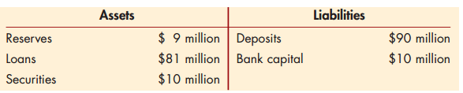
The First National Bank is once again in good shape because its $9 million of reserves satisfies the reserve requirement. However, this process of reducing its loans is the bank’s costliest way of acquiring reserves when there is a deposit outflow. If the First National Bank has numerous short-term loans renewed at fairly short intervals, it can reduce its total amount
of loans outstanding fairly quickly by calling in loans—that is, by not renewing some loans when they come due. Unfortunately for the bank, this is likely to antagonize the customers whose loans are not being renewed because they have not done anything to deserve such treatment. Indeed, they are likely to take their business elsewhere in the future, a very costly consequence for the bank.
A second method for reducing its loans is for the bank to sell them off to other banks. Again, this is very costly because other banks do not personally know the customers who have taken out the loans and so may not be willing to buy the loans at their full value. (This is just the lemons adverse selection problem described in
The foregoing discussion explains why banks hold excess reserves even though loans or securities earn a higher return. When a deposit outflow occurs, holding excess reserves allows the bank to escape the costs of (1) borrowing from other banks or corporations, (2) selling securities, (3) borrowing from the central bank, or (4) calling in or selling off loans. Excess reserves are insurance against the costs associated with deposit outflows. The higher the costs associated with deposit outflows, the more excess reserves banks will want to hold.
Just as you and I would be willing to pay an insurance company to insure us against a casualty loss such as the theft of a car, a bank is willing to pay the cost of holding excess reserves (the opportunity cost, the earnings forgone by not holding income-earning assets such as loans or securities) to insure against losses due to deposit outflows. Because excess reserves, like insurance, have a cost, banks also take other steps to protect themselves; for example, they might shift their holdings of assets to more liquid securities (secondary reserves).

Asset Management
Now that you understand why a bank has a need for liquidity, we can examine the basic strategy a bank pursues in managing its assets. To maximize its profits, a bank must simultaneously seek the highest returns possible on loans and securities, reduce risk, and make adequate provisions for liquidity by holding liquid assets. Banks try to accomplish these three goals in four basic ways.
First, banks try to find borrowers who will pay high interest rates and are unlikely to default on their loans. They seek out loan business by advertising their borrowing rates and by approaching corporations directly to solicit loans. It is up to the bank’s loan officer to decide if potential borrowers are good credit risks who will make interest and principal payments on time (i.e., engage in screening to reduce the adverse selection problem). Typically, banks are conservative in their loan policies. It is important, however, that banks not be so conservative that they miss out on attractive lending opportunities that earn high interest rates.
Second, banks try to purchase securities with high returns and low risk. Third, in managing their assets, banks must attempt to lower risk by diversifying. They accomplish this by purchasing many different types of assets (short- and long-term, treasury bills, and bonds) and approving many types of loans to a number of customers.
Finally, the bank must manage the liquidity of its assets so that it can satisfy its reserve requirements without bearing huge costs. This means that it will hold liquid securities even if they earn a somewhat lower return than other assets. The bank must decide, for example, how much in excess reserves must be held to avoid costs from a deposit outflow. Again, it is not wise for a bank to be too conservative. If it avoids all costs associated with deposit outflows by holding only excess reserves, the bank suffers losses because reserves earn no interest, while the bank’s liabilities are costly to maintain. The bank must balance its desire for liquidity against the increased earnings that can be obtained from less liquid assets such as loans.
Liability Management
Flexibility in liability management requires that banks can take a different approach to bank management. They no longer need to depend on checkable deposits as the primary source of bank funds and as a result no longer treat their sources of funds (liabilities) as given. Instead, they aggressively set target goals for their asset growth and try to acquire funds (by issuing liabilities) as they are needed. For example, today, when a money center bank finds an attractive loan opportunity, it can acquire funds by selling a negotiable CD. Or, if it has a reserve shortfall, it can borrow funds from another bank without incurring high transaction costs. Because of the increased importance of liability management, most banks now manage both sides of the balance sheet together in an asset–liability management (ALM) committee.
Capital Adequacy Management
Banks have to make decisions about the amount of capital they need to hold for three reasons. First, bank capital helps prevent bank failure, a situation in which the bank cannot satisfy its obligations to pay its depositors and other creditors and so goes out of business. Second, the amount of capital affects returns for the owners (equity holders) of the bank. Third, a minimum amount of bank capital (bank capital requirements) is required by regulatory authorities.
Trade-off Between Safety and Returns to Equity Holders Bank capital benefits the owners of a bank in that it makes their investment safer by reducing the likelihood of bankruptcy. But bank capital is costly because the higher it is, the lower will be the return on equity for a given return on assets. In determining the amount of bank capital, managers must decide how much of the increased safety that comes with higher capital (the benefit) they are willing to trade off against the lower return on equity that comes with higher capital (the cost).
In more uncertain times, when the possibility of large losses on loans increases, bank managers might want to hold more capital to protect the equity holders. Conversely, if they have confidence that loan losses won’t occur, they might want to reduce the amount of bank capital, have a higher equity multiplier, and thereby increase the return on equity.
Bank Capital Requirements Banks also hold capital because they are required to do so by regulatory authorities. Because of the high costs of holding capital for the reasons just described, bank managers often want to hold less bank capital relative to assets than is required by the regulatory authorities. In this case, the amount of bank capital is determined by the bank capital requirements.

