Principles of Taxonmoy (Biol 3063)
Credit hour----- 2
Biology 3rd year regular

By: Dereje Denu (PhD)
Jimma University

Jimma, Ethiopia
April, 2020
Table of Contents
Preface 5
Chapter 1 6
Principles of Taxonomy 6
Introduction 6
The scope of taxonomy 6
Taxonomic terms and its scope 7
Definitions of important taxonomic terms 8
Taxonomy etymology 11
Narrow and broad meanings of taxonomy 11
Phases of taxonomy 11
Classification, identification and nomenclature 12
Feedback Questions 13
Chapter 2 15
Historical Development of Taxonomy 15
Inception of taxonomic thinking (The origin of taxonomy) 15
Non-human taxonomists 15
Preliterate period 15
Folk Taxonomies 16
The practice by early Greek Philosophers 16
Medieval- Dark Ages and Renaissance periods 17
Medieval-Dark Ages 17
Renaissance 18
The Herbalists (1500’s) 18
Early Taxonomists 18
Linnaean and post Linnaean Taxonomists 19
The Linnaean Period 19
Post-Linnaean period of Natural systems (phenetics) 19
Post-Linnaean Taxonomist 20
The Impact of Darwin’s book on ‘the Origin of Species on taxonomy’ (Modern taxonomy) 21
Summery 21
Feedback Questions 21
Chapter 3 23
Classification systems 23
Artificial system of classification 23
Natural system of classification 24
Steps in numerical Taxonomy 24
Main advantages of Numerical taxonomy over conventional taxonomy 25
Evolutionary Classification 25
Phyletic classification 25
Cladistics 26
Summery 27
Feedback Questions 27
Chapter 4 28
Taxonomic structure 28
Taxonomic structure 28
Taxonomic hierarchy 29
Categories of classification in different groups of organisms and standard endings in plants, animals and bacteria 30
The Two Kingdoms Classification system 31
Merits and Demerits of Two Kingdoms Classification system 33
Corolus Linnaeus, 1758 (Two kingdom system of classification) 34
Earnst Haeckel, 1866 (Three kingdom system of classification) 34
Copeland, 1966 (Four kingdom system of classification) 35
Whittaker, 1969 (Five kingdom system of classification) 36
Species concept 37
Feedback Questions 37
Chapter 5 38
Taxonomic characters 38
The nature of characters 39
Continuous variation, Discontinuous variation, Diagnostic characters 39
Sources of taxonomic characters 39
Morphological characters 39
Anatomical characters 40
Common Taxonomic Characters for Animals and Plants 41
Secondary plant compounds 41
Amino acid sequencing 41
Ethological characters 41
Ecological Characters 41
Feedback Questions 42
Chapter 6 42
Biological nomenclature 42
The Purpose of giving names to organisms 42
The codes of nomenclature 43
Differences between codes 44
Other codes 44
Common names 45
The International code of nomenclature 45
International Code of Botanical Nomenclature (ICBN) 45
International Code of Zoological Nomenclature (ICZN) 46
International Code of Nomenclature of Bacteria (ICNB) 46
Operative principles of nomenclature 46
Feedback Questions 47
Chapter 7 48
Taxonomic techniques 48
Botanical techniques (Herbarium and field techniques) 48
Collection procedure 49
Field Note 49
Pressing 50
Repressing 50
Drying Techniques 50
Mounting herbarium specimens 50
Poisoning 51
Label 51
Feedback Questions 51
References 52

Preface
This handout deals with principles of taxonomy. It is composed of seven chapters: Introduction, Historical Development, Classification system, Taxonomic structure, Taxonomic character, Biological Nomenclature and Taxonomic techniques. Each chapter is preceded by objectives of the chapter (what the students attain after the study). Each chapter is followed by feedback questions. Students are expected to do all the questions given at the end of each chapter. For further information and knowledge students are expected to read the reference materials listed at the end of the handout and any additional source which is relevant to the course.

Chapter 1

Principles of Taxonomy
Objectives
At the end of this unit students will be able to:
- Define “taxonomy” and other terms related to it.
- Explain the scope of taxonomy.
- Differentiate taxonomy and systematics.
- List some important concepts on the two and five kingdom classification systems

Introduction
In the early time, taxonomy was defined in terms of its relationship to Identification. Classification is nomenclature of taxa including its basic principles, rules and procedures. It is probably the oldest science where the ancient Greek philosophers like Aristotle began the discussion with taxonomy. E.g. plants classified as poisonous and edible. Moreover, taxonomy is a very dynamic, synthetic and basic to all other sciences.

The scope of taxonomy
Taxonomy is defined as the study and description of variation of organisms, investigation of causes and consequences of this variation, and the manipulation of the data obtained to produce a system of classification. Such a definition is wider than that sometimes given, and has internationally been drawn up to coincide with the meaning of the term systematic. Some authors used the two terms synonymously, whereas some prefer to differentiate the terms, in which case systematics has more or less broad definition than taxonomy.
In other words, taxonomy is a branch of biology which deals with collection of organisms, their identification, nomenclature and systematic grouping or classification into various categories. This can be done based on the similarities and differences of their Morphology, Anatomy, cytology, Genetics, Physiology, Biochemistry, Developmental and other characteristics.

Taxonomic terms and its scope
Taxonomy is far from a simple subject, particularly owing to many disputes over the rules for classifying organisms. In terms of real life application, taxonomy is related to the entire world of life on earth. On the other hand, it might seem an ivory-tower discipline that it has nothing to do with the life of ordinary people. Nonetheless to understand the science of life or biology, it is essential to understand taxonomy. In turn to understand taxonomy it is crucial to understand basic taxonomic terms.
The term taxonomy was coined by De Candole (1813) in his “Theories elementaire de la botanique”. The word “taxonomy” came from a Greek word “taxis”, meaning arrangement or order, and “nomos”, meaning law or science. It is known as law of arrangement/order.
What is systematics and how it differs from taxonomy?
Systematics is the scientific study of the Kinds and diversities of organisms and their relationships. In other words, it is a discipline within biology with the goal of determination of Evolutionary history, relationships among organisms which is termed as phylogeny and the use of that phylogeny in categorization of organisms. Thus, the term systematics is a broader field of study that includes taxonomy and phylogeny.
Systematics includes not only the traditional activities of taxonomy but also it is includes: Investigation of evolution, Speciation, Natural variation, Reproductive biology and Variation and variety of biological phenomenon. It is often used synonymously with taxonomy, yet it has the connotation with recently developed techniques like: Chromosomal studies, Electron microscopy, or Molecular biology to answer questions about organism’s relationships.
In general, “systematics” is the more general term, being defined as the study of organismal diversity, whereas taxonomy is more narrowly the set of procedures and rules for naming biological entities and producing classifications.

Definitions of important taxonomic terms
The description of term is one of the most significant aspects of biological taxonomy. The recognition of individuals is based principally on the study of organs.
Taxa (taxon) or taxonomic units: - are names designating an organism or group of organisms at any rank (kingdom, Division/phylum, class). A taxon is a rank placed at particular level in systematic hierarchy to reflect evolutionary relationship. Description of taxon is a statement of its characteristics, which constitutes the definition of that taxon.
Taxonomic character: - is any attribute of form, structure, physiology or behavior which is considered separately from the whole organism to particular purpose such as comparison, identification or interpretation. There are different forms of taxonomic characters.
Qualitative characters: - characters that can’t be represented in numerical value such as Flower color, leaf arrangement and ovary position. Most qualitative characters have only two character states like leaf simple/ compound.
Quantitative character: - is measurable character, like, leaf size (4 cm). Measurements of quantitative character yield Continuous data. If any value within a range is possible, e.g. leaf length; Discontinuous data- if any discrete values are obtained, e.g. Petal number
Character states: - distinct form of characters; or different expression of a character. Flower color could be white, yellow or brown, which range as few as two to many states. Same characters may have several character states, like leaf arrangement, alternate, opposite, whorled and spiral.
Analytic characters: - characters of limited occurrence used in identification of different entities. Synthetic characters: - are characters of wide occurrence and help their placement in higher taxa.
Good characters: - are characters which don’t exhibit wide variation or high intrinsic genetic variability and are highly correlated within the group.
Diagnosis/ key character: - is a shortened description covering only those characters, necessary to distinguish a taxon from other related taxa.
Diagnostic features of some families of flowering plants are:
For Fabaceae- Papilionaceous corolla
For Rubiaceae- Interpetiolar stipule
For Euphorbiaceae- Trilocular seed--- etc
Categories (Sing. Category):- In the system of classification, various taxa are assigned to definite ranks or positions according to their taxonomic status, each taxonomic rank is called the taxonomic category. Major categories in classification of organisms are Kingdom, Division (Phylum), Class, Order, Family, Genus and Species.
Obligatory hierarchy: - is the seven taxonomic ranks by which all species must be identified, these are: Kingdom, Division/Phylum, Class, Order, Family, Genus and Species. Kingdom is the most general ranking in the obligatory taxonomic system.
Herbarium: is a collection of dried, pressed, mounted, labeled and stored plants in strong cup for systematic study.
Deme: - a group of related individuals of a particular taxon; by adding a prefix a deme we can have various meanings like:
Topdeme- a deme occurring within a specific geographical habitat.
Ecodeme-a deme occurring within a specified kind of habitat;
Gamodeme-a deme composed of individuals which interbreed in nature.
Phenodeme-a deme differing from others phenotypically.
Plastodeme-a deme differing from others phenotypically but not genotypically;
Genodeme- a deme differing from others genotypically
Systematics: - is science of classifying and studying organisms in natural relationship.
Homonyms: are identical names for two different taxa.
Synonyms: are different names for the same taxon.
Nomenclature: - The assignment of correct names to taxa; e.g. Homo sapiens.
Phylogeny: - the natural, evolutionary relationships between groups of living things.
Analogous features: morphological characteristics of two or more taxa that are superficially similar.
Binomial nomenclature is a system of nomenclature in Biological taxonomy, where each organism will be given a two-word name, with the first name genus and the second name species. Genus name is always capitalized and abbreviated after the first use, and species name is lowercased. Both are always shown in italics; e.g. Homo sapiens.
Numerical/Phenetics taxonomy: - known as taximetrics is specific morphological characteristics of an organism can be measured and assigned numerical values, similarities between two organisms can be compared mathematically by algorithm.
Algorithm: - is specific set of step-by-step procedures for computing answers to a mathematical problem.
Cladistics: - a system of taxonomy that distinguishes taxonomic groups or entities based on shared derived characteristics.
Monophyletic: - Group including all species or other taxa descended from a single common ancestor (e. g. angiosperms or seed plants).
Out-group:- Primitive ancestor of all organisms being classified by cladistics, used to identify primitive and derived characteristics.
Apomorphic: - derived character (seeds in angiosperms and gymnosperms relative to ferns)
Plesiomorphic: - an ancestral character (stomata in angiosperms and gymnosperms) .
Note: apo and plesiomorphic are relative terms
Vascular tissue is apomorphic to the monophyletic group above the bryophytes, but plesiomorphic to the angiosperms.
Synapomorphies: - shared derived characters and are what define monophyletic groups because the members of that group have the common character (e.g., seeds in seed plants).
Symplesiomorphies: - shared ancestral characters (e.g., chl. seed plants).
Autapomorphies are derived characters unique to one group (flowers in angiosperms).
Paraphyletic group includes some but not all of the descendants of a common ancestor (ferns and seed plants).
Sister taxa are two lineages that descend from a common ancestor following a splitting event.

Taxonomy etymology
Etymology is an explanation of where a word came from; or the history of a word or it is the study of word histories. The word taxonomy came from the Greek taxis, meaning arrangement or order, and nomos, meaning law or science. Etymologically-taxonomy refers to putting in order, and systematic means putting together. It is the science of classification based on pre-determined system, to provide conceptual framework for discussion, analysis and information retrieval. In theory, the development of good taxonomy takes into account the importance of separating elements of groups into sub-groups that are mutually exclusive and unambiguous. In practice, good taxonomy should be simple, easy to remember and use.

Narrow and broad meanings of taxonomy
Taxonomy in narrow sense is restricted to the study of classification that is production of formal classification of living things on the basis of genetic relationship. But, in broad sense it is the study and description of variation of organisms, investigation of causes and consequences of their variation and manipulation of the data obtained to produce a system of classification. In the narrow sense, to mean a hierarchical classification or categorization system, and in the broad sense, in reference to any means of organizing concepts of knowledge.

Phases of taxonomy
- Pioneer: - the discovery and collection phase, still continue in the tropics.
- Consolidation phase: - synthesis phase mostly based on morphology of field and herbarium in preparation of floras and form classification systems.
- Experimental or biosystematics phase: - analysis of a wide variety of things such as reproductive systems, variation patterns, chemical, cytological, genetical relationships or evolutionary patterns.
- Encyclopedic or holotaxonomic phase: - analysis and synthesis of all information and types of data to develop classification systems based on phylogenetic relationships.
Generally, phases one and two are often alpha taxonomy, and phase four is often called omega taxonomy.
Alpha taxonomy is based only on more or less obvious external morphological characters, which is considered as an old science. Omega taxonomy incorporates data from all other fields of biology, like genetics, cytology, palynology, serology, organic chemistry, biogeography, and based on all available characters. Some of the well-studied groups are in the omega taxonomy since the final accumulation of all the data is ultimately incorporated while others are still in the alpha taxonomy stage that form basis of biology.

Classification, identification and nomenclature
Classification is the production of logical system of categories, each containing any number of organisms, which allows easier references to its components or kinds of organisms. It has many sorts, as most modern taxonomists agree classification systems should reflect evolutionary relationships.
As a result, one should distinguish between homologous features and analogous features in constructing a classification system.
Analogous Features are different in origin but similar in function and lacks recent common ancestor.
Homologous: - have common evolutionary origin, but differ in superficial morphology.
E.g., The arms of a human, fins of a whale, and wings of a bird.
It is similar in origin, but different in function and recent common ancestor
Identification is the naming of an organism by referring already existing classification. To identify an organism is to determine which taxon it belongs to. Taxonomic identification is recognition of identity or essential character of an organism. Taxonomists organize written descriptions of characteristics of similar species, other biologists use it for identification of unknown organisms. This is known as taxonomic keys, which often contain pictures of the species.

Feedback Questions
- Define the following taxonomic terms:
  - Classification
  - Identification
  - Nomenclature
- The term “Taxonomy” was coined by _________________________________
- The term “systematics” is a broadr field of study that includes _____________________ and ________________________________.
- ___________________ or taxonomic units are names designating an organism or group of organisms at any rank (kingdom, Division/phylum, class).
- __________________________ is a character that cannot be represented by numerical values.
- A character represented by numbers (numerical values) is referred to as ______________________
- What are synthetic characters?
- What are the diagnostic character for:
  - Apiaceae
  - Rubiaceae
  - Euphorbiaceae
- List the seven taxonomic ranks from higher to lower.
- What is deme?
- Differentiate:
  - Homonyms
  - Synonyms
  - Nomenclature
- What do you call the morphological characteristics of two or more taxa that are superficially similar?
- ________________________________ is known as taximetrics is specific morphological characteristics of an organism can be measured and assigned numerical values.
- Define the following terms:
  - apomorphic character
  - Plesiomorphic character
  - Monophyletic group
  - Synapomorphy
  - Symplesiomorphy
- List and discuss each taxonomic phase.
- What is the difference between Alpha and Omega taxonomy?
- What is the difference between homologous and analogous characters?

Chapter 2

Historical Development of Taxonomy
Objectives
At the end of this unit students will be able to:
- Explain the role of non-human taxonomists.
- Identify the role of folk taxonomic to scientific taxonomic development.
- Discuss the contribution of Greek and Roman fathers to the development of taxonomy.
- Explain the events of taxonomy during herbalist period
- Discuss the roles of early taxonomists in taxonomic development

Inception of taxonomic thinking (The origin of taxonomy)
Before the development of formal taxonomy by Greeks, taxonomic science passed through many up and downs. In the earlier time the ancient hunter-gatherer learned about edible and none edible plants/ animals. Those who failed to learn this distinction remained extinct.

Non-human taxonomists
In earlier time, in order to survive, non-human animals developed skill to identify their enemies that kill them or their friends. That means the predator recognizes the harmful prey and such type of identification is called animal-animal recognition. This shows that non-human animals were taxonomists of their own.

Preliterate period
In this period there was little direct knowledge, and through the years all cultures have learned which of the plants around them are useful, whether for food, clothing, medicines, shelter, etc. They know edible and poisonous plants/animals so they are practical plant taxonomists, because they can classify plants edible/non-edible, safe/poisonous, medicinal/non medicinal, sweet /repulsive, etc. Even if no written document are found, such systems of classification reflect the knowledge and philosophical concepts of historical and available technology of the period.

Folk Taxonomies
Classification, which grows up in both primitive and civilized communities through need and without the influence of science is known as folk taxonomy. It is vernacular naming system, and can be contrasted with scientific taxonomy. Shortly, naming of organisms locally is called folk taxonomies.
The practice by early Greek Philosophers
Aristotle (About 384–322 BC)
Greek philosophers- are the first to classify all living things, and some of his groups are still used today, like the vertebrates and invertebrates, which he called animals with blood and without blood. He further divided animals with blood into live-bearing and egg-bearing. Groups without blood recognize today, as insects, crustacean and mollusks, probably Greeks laid the base for the foundation.
Aristotle classified organisms into three groups:
- Sensitive animals
- Nutritive plants
- Rational man
He was the first to form a useful system of classification, during 300s BC. He is father of Natural history who provided the concept of essentialism.
According to Aristotle, individuals have two sets of properties: (1) Essential-refers to fundamental, vital and indispensable characteristics for a particular. (2) Accidental- arise from extrinsic causes occur by chance/ non-essential among the members of a group. Its demerit is difficulty to determine as to what are the essential properties of an organism.
Theophrastus (about 370–285 BC)
He was student of Aristotle and Plato who wrote classification in a permanent and logical form for the first time. He wrote classification of about 480 plant species in De Historia Plantarum. His classification was based on growth form, and still recognize as his plant genera, like Narcissus, Asparagus, Crocus and Cornus, because they are accepted by Carl Linnaeus as generic names. De Historia Plantarum was used for taxonomic purposes until the middle Ages in Europe.
The most significant contribution of Theophrastus includes:
- Classification of plants into trees, shrubs, sub-shrubs, herbs, annuals, biennuals and perennials.
- Distinction between flowering (such as superior and inferior ovaries, free and sympetalous corollas) vs. non-flowering plants.
- Differences between external (organs) vs. internal structures.
- Recognition of different kinds of sexual (ovary position, hypo-, peri- and epigynous, fruit type, etc) and asexual reproduction.
- Understood basic anatomy of sepals and petals, modified leaves.
Dioscorides (1st century AD) was a Greek physician, who travelled in Roman and Greek empires to gather knowledge about medicinal plants. He wrote De Materia Medica, in which he described about 600 species.
Pliny the Elder (23–79 AD) wrote many books, but only one is survived “Naturalis Historia”, which contains 160 volumes, described about 1,000 useful plants with Latin names. Many of these names were still recognized, like Populus alba and Populus nigra, and since Latin was later kept for botanical science, we may call him the Father of Botanical Latin.

Medieval- Dark Ages and Renaissance periods

Medieval-Dark Ages
This is the period from the fall of Rome to the Renaissance often called Dark ages because of very little original thought or work. Many texts were translated in to Arab language. Cultures flourished from Arabia, China, Japan, India and America. This led to loss of information or much misinformation. In other words, it is a discipline within biology with the goal of determination of Evolutionary history. Relationships among organisms which is termed as phylogeny and the use of that phylogeny in categorization of organisms. Thus, the term systematics is a broader field of study that includes taxonomy and phylogeny.

Renaissance
It is the transition period between medieval and modern times (14th to 17th c), and considered as the beginning of modern science. Two technological innovations contributed to Renaissance and taxonomy were Printing press and Science of navigation.
The former made knowledge available to all and botanical-medical books called herbals became popular. Navigation started the age of exploration and almost immediately the number of known plants increased dramatically.
Basically, four distinct periods were recorded in this era.
- Herbalists
- Pre-Linnean period (17th c)
- Linnaean period (18th c) and
- Post Linnean period (Natural systems)

The Herbalists (1500’s)
The period was motivated by practical considerations, i.e. medical and agricultural uses of plants. Exploration brought new, unknown plants to Europe to be described, this helped for medical information.
Some herbalists are:
Otto Brunfels (1464-1534) Herbarum vivae Eicones, flower perfect and imperfect.
JeromeBock (1469-1554) distinguished trees, shrubs and herbs
Leonhart Fuchs (1501-1566)-(Fuchsia) De historia stirpium
Three of them were Germans, who represented the father of Botany of the period.

Early Taxonomists
Pre-linnean period (17th c)
Andrea Caesalpino (1519-1603). Italian botanist tried to base classification on logic rather than utilitarian concepts.
Joseph Pitton de Tournefort (1656–1708). French botanist constructed botanical classification to rule botanical taxonomy until the time of Carolus Linnaeus. He published Institutiones Rei Herbariae, around 9000 species were listed in 22 classes and 698 genera, give emphasis to classification of genera.

Linnaean and post Linnaean Taxonomists

The Linnaean Period
During this period advances in navigation, early microscopes, and widespread use of herbarium specimens, printed books, and groundwork of herbalists and so on were widely available.
Carolus Linnaeus (1707-1778): Swedish botanist who found modern concept of taxonomy of plants and animals. Today he is popular for the following reasons
I. In his “Systema Naturae (1735)” he classified all known plants, animals and minerals.
He developed sexual system of classification, and called marriages of plants (Nuptiae Plantarum).
II. He was incredibly named 12,000 species (7, 700 plants and 4,300 animals).
III. His Genera plantarum - described plant genera as described by Tournefort, and followed Tournefort arrangement but he modified. If the stamen number is one = Monandric; if two, diandric and three triandric, etc respectively.
IV. In his philosophy of botany (1751)-presented fragments of natural system of classification with names of 67 orders.
Linnaeus Apostles
Smith (1790-1814) - was writer of English botany based on sexual system of Linnaeus. Founded the Linnaean Society of London (1788).

Post-Linnaean period of Natural systems (phenetics)
Universality (typological species thinking) was replaced by population thinking. It stresses uniqueness of every individual in the world (no individuals are alike). By late 1700’s botanist began to think about the purposes of taxonomy and to try to provide more information in their classifications.

Post-Linnaean Taxonomist
Michael Adanson (1727-1806)
Adanson rejected a priori choice of characters and felt that using as many characters as possible would give the most natural or useful classification, which are characters with high predictive value. This is the precursor of phenetic or modern computer aided Numerical taxonomy which is often called Adansonian Taxonomy. Adanson produced the book Des plantes in1763 and recognized 58 families, and developed empirical approach.
Antoine L. de Jussieu (1748-1836)
In his classification, plants which look alike were grouped together, and set in Paris botanical garden. Many of the families are still familiar today, and in his Genera Plantarum he divided plants into three based on the number of cotyledons, ovary position, presence /absence, and the union of petals. These are Acotyledons (all cryptogams), Monocotyledons and Dicotyledons. Dicotyledons could be apetalae, monopetalae and polypetalae. In the latter two groups, he used modern familiar characters, like ovary position, stamen (free/attached to corolla), and petal (free/fused).
Jean Baptist de Lamarck (1744-1829)
Best known for an early theory of evolution by inheritance of acquired characters. He wrote a book “Flore Francoise” in 1778 that contained analytic method, i.e. identification keys similar to dichotomous keys of modern flora.
Augustin Pyramus de Candolle (1778-1841)
He is Swiss botanist who wrote the book ‘The’orie elementarie de la botanizue (1813).
He was the first to place Pteridophytes in separate group, he introduced the word taxonomy, and he set an outline for classification of plants as well as the governing principles for classification. Divided plant kingdom into two based on presence or absence of cambium, vascular tissues and cotyledons.
- Cellulares (non-vascular & acotyledon) - could be foliaceous + afoliaceous
- Vasculares (vascular tissue + cotyledon) include: Exogenes (dicotyledons with ringed vascular bundles); Endogenes (monocotyledons with scattered vascular bundles and include phanerogams and cryptogams).

The Impact of Darwin’s book on ‘the Origin of Species on taxonomy’ (Modern taxonomy)
Pre-Darwinian natural system: - George Benthum and Sir Joseph D. Hooker (1817-1911). The natural classification period was ended by English botanists Benthum and Hooker. They produced a three volume book Genera Plantarum. It deals only with seed plants and divided them into 3 classes: monocotyledons, dicotyledons and gymnosperms, 200 families with 7,569 genera, and included all plant families of the time. 97,205 plant specimens, grouped dicots as polypetalae, gamopetalae and monochlamydae.

Summery
Linnaeus was the founder of modern taxonomy, and he classified all known Plants, animals and minerals in his book Systamae Naturae, Developed sexual system of classification, Founded International Code of Nomenclature in his philosophy of botany. He Introduced Binomial system of Nomenclature. However, unlike him French scientists used as many natural characters as possible in their classification system to introduced natural or phonetic system of classification. During 19th century Darwin incorporated evolution to taxonomy.

Feedback Questions
- What is non-human taxonomy?
- What is folk’s taxonomy?
- What was the contribution of:
  - Aristotle
  - Theophrastus
  - Dioscorides
  - Pliny the Elder
- What were the events of medieval period which assisted taxonomic development?
- What are the two technological innovations contributed to Renaissance and taxonomic development?
- Discuss the contributions of herbalists in taxonomic developments?
- List some herbalists and give their contribution.
- Discuss the contribution of two Pre-linnean taxonomists.
- Discuss the contribution of Carolus Linnaeus.
- Discuss the contribution of the following Post-Linnaean Taxonomists.
  - Michael Adanson (1727-1806)
  - Antoine L. de Jussieu (1748-1836)
  - Jean Baptist de Lamarck (1744-1829)
  - Augustin Pyramus de Candolle (1778-1841)

Chapter 3

Classification systems
Objectives
At the end of this chapter you will be able to:
- Differentiate the schemes of classification used over the historical development of taxonomy
- Identify the five basic classification systems
- Investigate the role of Darwin’s work in changing the system of classification
- Realize the basis for each classification systems

Artificial system of classification
System of classification based on a few characters chosen without look upon to the naturalness of the groups, not derived by reasoning from observed facts. Started by Theophrastus (370-285 BC), and it is quite simple. Purpose oriented on and few characters like habit, color, form, or edible versus poisonous plants. Theophrastus”s classification was based on plants habit, like herbs, shrubs, sub-shrubs and trees, while herbalists grouped plants based on medicinal as well as food values to man. Moreover, Linnaeus in his Genera Plantarum used sexual characteristic for classification, and grouped plant kingdom into 24 classes based exclusively on the number and nature of stamens. However, artificial system of classification is monothetic, which is based on unique set of characters that consist of monothetic groups. Generally, it is easy to use and reproducible, but it has little predictive value, So it is difficult to understand the evolution of organism.

Natural system of classification
It is based on similarity, however it uses different characters and lack pre-selected features. It is called posteriori classification because of the groupings are made after the features are observed. Grouping organisms in this way produces phenetic/overall similarity systems yet, lack emphasizing one over the other. Generally, features such as anatomy, physiology, pathology, biochemistry, reproduction and cytology are used to compare the organisms and establish relationship between them. Bernard de Jussieu who used empirical approach and Michael Adanson who compared features of plant families, Families des Plantes by numerical taxonomy should be acknowledged for their contribution. Finally, Bentham, Hooker and de Candolle were also contributed great information about members and groups of organisms in natural classification.
As everything is not perfect, Natural system of classification also has drawback like, Considers species as fixed, unchanged entities (static relative to time). Identification of taxa is difficult and increased knowledge may change it. Phenetic/Numerical taxonomy or Taxometrics (computerized phenetic systems).
Phenetic is somewhat similar to evolutionary systematics. Both of them include all available data regarding the study of organisms and both are antagonistic to the cladistic analysis model, (classification in which organisms are categorized based on shared derived characteristics).
The taxonomic structure is mainly based on morphological principles where all characters are of equal weight, and its aim is to develop nomenclature, identification and classification. Generally, it is based on analysis of characters, like morphology (leaf, flower, fruits); Biochemistry (DNA, secondary compounds); chromosomes (number, staining). The method does not produce new data or new system of classification but develop method of organizing data by using computers to process large amount of data in a short period of time, and obtaining a classification from them.

Steps in numerical Taxonomy
- Select individual organism by observing and measuring as many characters as possible, and treat the characters equally. Taxa are called Operational Taxonomic Unit (OTU).
- Record all features in the form of data matrix
- Use some mathematical formula to describe the degree of similarity of distance between each pair wise comparison of OTU’s.
- Group taxa based on overall similarity.
- Name the groups by interpretation of OTU or dendrogram that is taxa with high similar values would be interpreted as similar and those with low values interpreted as very dissimilar.

Main advantages of Numerical taxonomy over conventional taxonomy
- The greater the number of information in the taxa of classification and the more characters it is based, the better will be the classification (more predictive).
- A posteriori, every character is of equal weight in creating natural taxa.
- The overall similarity between any two entities is a function of their individual similarities in each of the characters being compared.
- Distinct taxa can be recognized as the result of differences in the correlations of characters under the study group of organisms.
- Phylogenetic inference can be made from the character correlations of the taxonomic structures of a group.
- Classifications based on phenetic similarity except the above most principles are basically similar to the methods of Adanson, and thus called Neo-Adansonian principles.
- Today the method is applied to all groups of microorganisms, plants and animals.

Evolutionary Classification

Phyletic classification
Phyletic system of classification groups organisms according to their evolutionary relationship. The aim of phyletic classification is construction of evolutionary trees starting with most primitive and ends with most advanced group, and to ensure that all organisms share common ancestors.
During post-Darwinian classification, evolution was incorporated into classification, and species are regarded as dynamic units (phylogenetic continuum). Species thinking concept was replaced by population thinking and not by type, yet, there were no changes in the concept of pre-Darwinian Family and Genus that were considered as natural.
Some of the phyletists include:
Eichler: - Started early to utilize the concept of evolution as a guiding principle in classification. Adolph Engler (1844-1930) and K.A.E. Prantl (1849-1893):- both believed that the classification system should reflect the evolutionary history.
Charles Bessey (1845-1945):- American botanist who developed set of rules about which characters were primitive and which were advanced in flowering plants.

Cladistics
It is branch of taxonomy that determines the evolutionary relationships between organisms based on derived similarities. It is a method of exact analysis, using "shared derived traits" (synapomorphies) of the organisms being studied. It forms the basis for most modern systems of biological classification, which seek to group organisms by evolutionary relationships. The word cladistics is derived from the ancient Greek, klados, which means "branch." As the end result of cladistic analysis, tree like relationship-diagrams called "cladograms" can be drawn up to show different hypotheses of relationships.
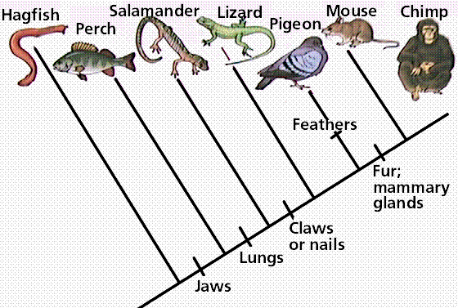

Summery
Four classification systems were seen; artificial, natural, phenetic and phylogenetic. Artificial classification is based on a few characters e.g. Linnaean sexual system whereas Natural classification takes many characters, has more predictive value than artificial classification; e.g. Michael Adanson’s system. Phenetics is a classification process by which taxa are clustered together based on the number of their similarities.
Darwin brought impacts on artificial and natural systems of classification. Phyletics is aimed to construct evolutionary tree starting with most primitive and ends with advanced groups, Cladistics is a method of classification of organisms based on shared derived characteristics that were not present in their distant ancestors and are assumed to indicate common ancestry.

Feedback Questions
- Discuss the difference between artificial and natural classifications.
- What is Operational Taxonomic Unit (OTU)?
- What are the advantages of numerical taxonomy?
- Discuss the contribution of Some Phyletists.
- What is cladistics in taxonomy?

Chapter 4

Taxonomic structure
Objectives
At the end of this chapter students will be able to:
- Recognize diversity of living things into a classification scheme to communicate easily with others.
- Explain what is meant by hierarchical classification
- Explain what is meant by stable and predictive classification.
- Define basic taxonomical units, such as species, genus, family etc
- Explain the ranked hierarchy in animals and plant classification and its associated suffix endings.
- Explain what species concepts is.

Taxonomic structure
Taxonomic hierarchies were introduced by Linnaeus, and they are known as Linnaean hierarchies. It is also defined as sequence of categories in a decreasing or increasing order from kingdom to species and vice versa. Each taxonomic rank is called the taxonomic category, and Kingdom is the highest rank followed by division (phylum), class, order, family, genus and species. The hierarchy has two categories; obligate and intermediate, obligate means they are followed strictly and ranges from kingdom to species. Intermediates are not strict and they are added in obligate list such as sub-division, super family, super class, sub-order, sub-species.

Taxonomic hierarchy
Since Linnaeus, the father of taxonomy, species have been arranged in taxonomic hierarchy. Each species, is member of genus, family, order and so on. The problem is how to group the species into higher categories, this is an important theoretical issue with conflicting taxonomic schools of classification. Under this topic you are going to study taxonomic categories, rank and taxa. Taxa (Sing. Taxon) is the taxonomic group of any rank in the system of classification. E.g. In plant kingdom, like Angiosperms, Dicotyledons, Malvaceae, Cordia africana, etc. represents a taxonomic group i.e. a taxon. A taxon may be very large group such as a Division (angiosperms), or it can be very small group such as species (Cordia africana).
Major categories in the classification of plant kingdom are Kingdom, Division (Phylum), Class, Order, Family, Genus and Species.
The difference between the taxon and the category should be clearly understood. When we say "Division- Angiosperms". Division represents the taxonomic category while angiosperms represents the taxon. Therefore, a taxon is a group of organisms (living things), whereas a category only indicates the rank or status of the taxon in the systematic hierarchy. Arranging taxonomic categories in their proper order on the basis of their taxonomic ranks is called taxonomic hierarchy (systematic hierarchy). A broad scheme of ranks in hierarchical order: Domain, Kingdom, Phylum (animals/plants) or Division (plants), Class, Order, Family, Genus, Species, Subspecies.
The prefix super- indicates a rank above; the prefix sub-indicates a rank below, while, in zoology the prefix infra- indicates a rank below sub.
Kingdom: - the highest or most general ranking in the obligatory taxonomic system. In the system used in some books, there are five kingdoms: Monera, Protista, Fungi, Plantae, and Animalia (all animals).
Division (phylum) for animals while division for plants):- It is a collection of similar classes. Phylum chordata of animals has class mammalia, along with birds, reptiles and amphibians.
Class: - consists of one or more than one order. Class Mammalia includes all mammals such as bats, rodents, kangaroos, whales, great apes, and man.
Order: - contain one or more than one families. Family Felidae is included in the order Carnivora.
Family: - formed by collection of similar genera, and it can be separated from genera by reproductive and vegetative features. For example, cats and leopard are included in the family Felidae.
Genus: - it is defined as group of similar species, yet it is not mandatory to have many species.
Some genera have only one species known as monotypic. If there are more than one species it is known as polytypic. E.g. lion, tiger are quite similar species placed under the genus Panthera.
Species: - group of population which is similar in form, shape and reproductive features so that fertile sibling can be produced. Species is followed by sub-species, varieties and races, and these categories are inferior as compared to species.
Below is another example of a hierarchial system for the group of animals that includes humans. Phylum Chordata, Subphylum Vertebrata, Class Mammalia, Order Primates, Family Hominidae, Genus Homo, Species–sapiens

Categories of classification in different groups of organisms and standard endings in plants, animals and bacteria
Rank | Plants | Algae | Fungi | Animals | Bacteria
Division/Phylum | -phyta |  | -mycota
Subdivision/Subphylum | -phytina |  | -mycotina
Class | -opsida | -phyceae | -mycetes |  | -ia
Subclass | -idae | -phycidae | -mycetidae |  | -idae
Order | -ales |  |  |  | -ales
Suborder | -ineae |  |  |  | -ineae
Infraorder | -aria
Superfamily | -acea |  |  | -oidea
Epifamily |  |  |  | -oidae
Family | -aceae |  |  | -idae | -aceae
Subfamily | -oideae |  |  | -inae | -oideae
Infrafamily |  |  |  | -odd
Tribe | -eae |  |  | -ini | -eae
Subtribe | -inae |  |  | -ina | -inae
Infratribe |  |  |  | -ad

The Two Kingdoms Classification system
Carlos Linnaeus divided living organisms in to Plant and Animal Kingdoms, based on motility and non-motility.
Kingdom Plantae
Kingdom Plantae includes bacteria, fungi, algae, liverworts, mosses, ferns, conifers and flowering plants. The plant kingdom in general exhibit the following distinguishing characters. Plants exhibit great variation in their form and size. They are usually asymmetrical. However, in higher plants structures like leaves and flowers have a definite form and shape. Plants are rooted and lack motility. However, certain localized movements may occur in a plant body. They exhibit unlimited growth, almost throughout their life span. They lack locomotory organ. They are largely autotrophic or saprotrophic in nutrition. Their body is composed of distinct cell wall, vacuole filled with sap and plastids. Cells lack centrioles and lysosomes, yet can synthesize all amino acids, coenzymes and vitamins for their functions, and store starch as a reserve food. The Plant kingdom was initially classified as follows.
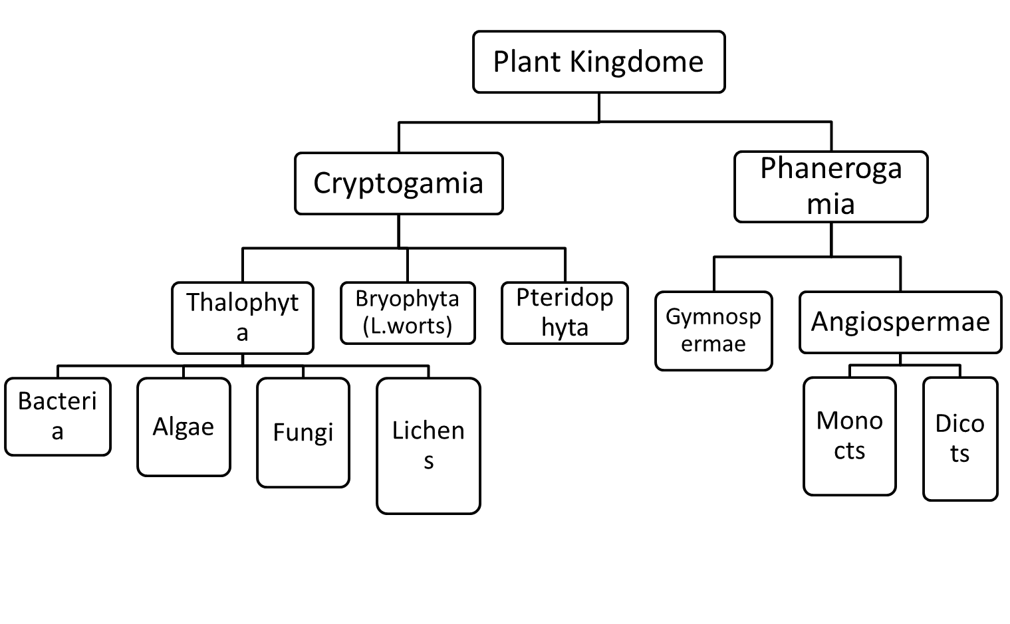
Kingdom Animalia
The Animal Kingdom proposed by Linnaeus included the Protozoans, sponges, jelly fishes, worms, crabs, insects, spiders, snails, starfishes, sharks, bony fishes, frogs, lizards, birds and mammals.
General characteristics of the animal kingdom includes:
- Show definite symmetry, form and shape;
- They are motile and show determined and proportional growth
- They are heterotrophic and Show irritability (capacity to respond to a stimulus).
- Lack cell wall, Plastids and large vacuoles;
- Cells contain centrioles and lysosomes
- Lack ability to synthesize all necessary amino acids, vitamins, coenzymes.
- Store reserve food in the form of glycogen.

The animal kingdom was initially classified as follows
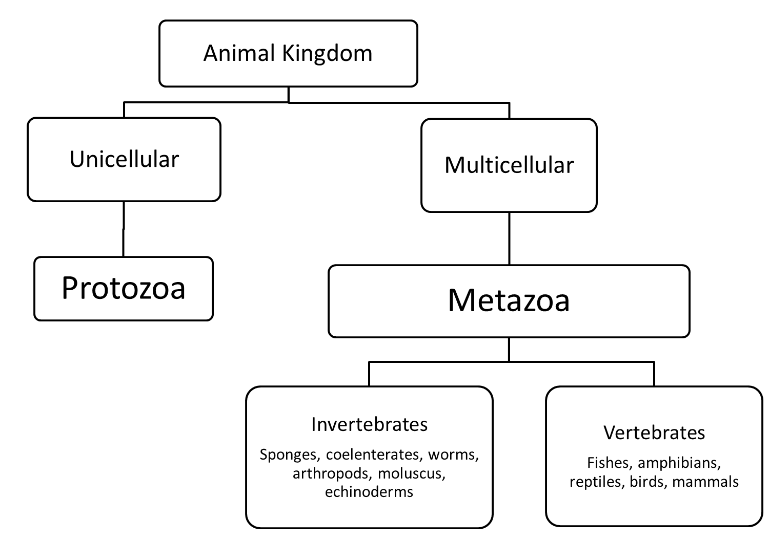

Merits and Demerits of Two Kingdoms Classification system
This classification received considerable recognition from biologists and was in use for a long period of time. The two kingdom classification has certain demerits such as:
- There is no clear distinction between lower forms of life, plants and animals.
- Euglena contain animals and plant like features.
- Chlamydomonas is purely autotrophic but has flagella like protozoans.
- Slime molds lack cell wall in vegetative phase however, develop cell wall in reproductive phase like other fungi. Thus, they resemble animals in one phase and plants in the other.
- Sponges are sessile, irregular animals which look like plants.
- Fungi- differ from plants because they lack chlorophyll and are saprotrophic in nature.
In view of all these, the two kingdom classification had been revised. One of the earliest attempts in this direction was that of Earnst Haeckel in 1868. He proposed the three-kingdom system by adding kingdom Protista for all unicellular organisms, from plants and animals. The advent of electron microscope opened new situations, and hence discovery of prokaryotic and eukaryotic cells made the scholars to list the organisms based on the cell types. The blue-green algae among algae and bacteria were taken as prokaryotes, yet other algae, fungi, protozoans and multicellular animals were considered as eukaryotics. Copeland in 1966, suggested the assembly of Monera to prokaryotes and it is the 4th kingdom; in Protista, Metaphyta and Metazoa.

Corolus Linnaeus, 1758 (Two kingdom system of classification)

Earnst Haeckel, 1866 (Three kingdom system of classification)
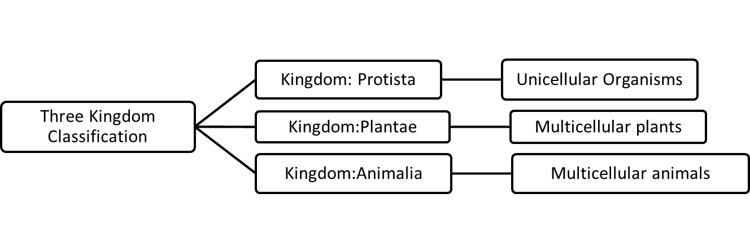

Copeland, 1966 (Four kingdom system of classification)
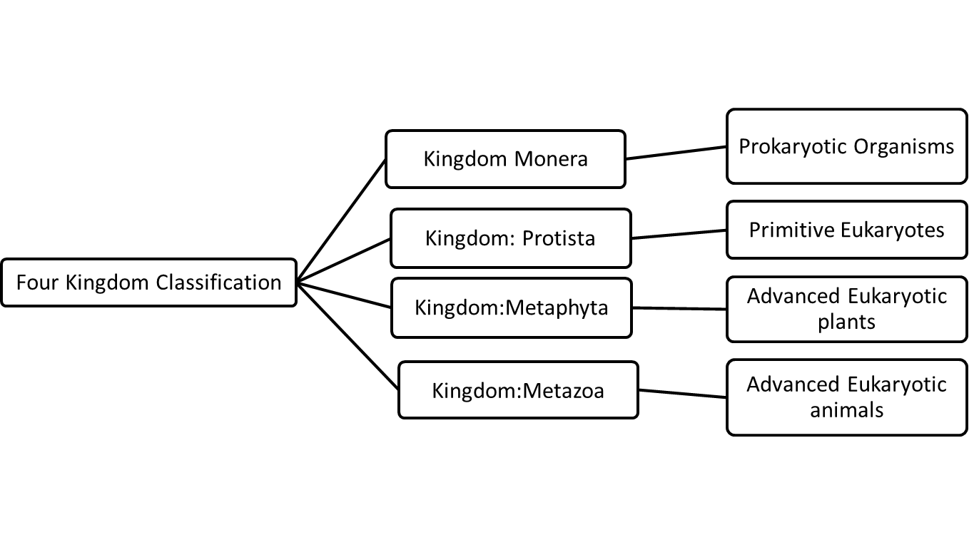

Whittaker, 1969 (Five kingdom system of classification)
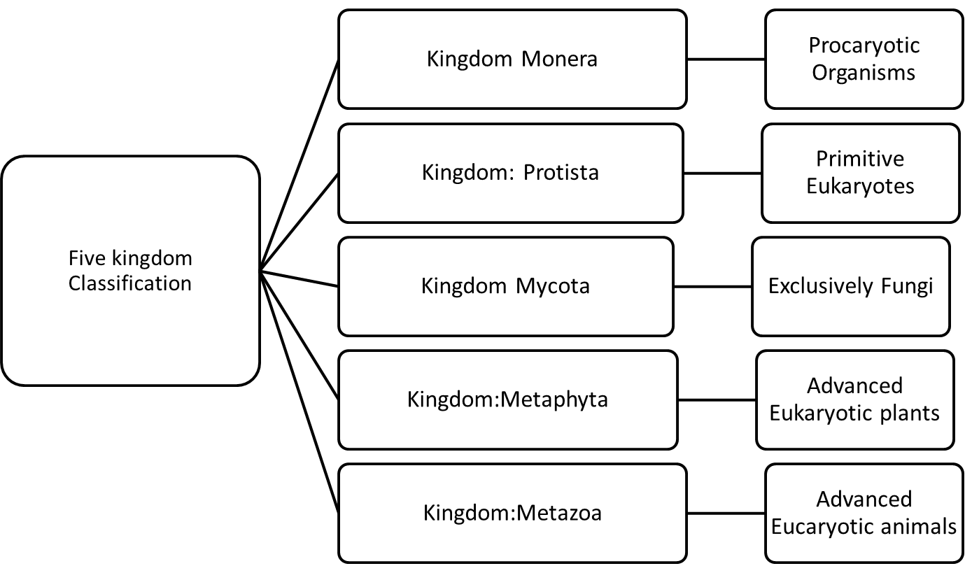
The five kingdom system of classification was proposed by Robert H. Whittaker in 1969, by suggesting Mycota as a new kingdom. The classification is in agreement with phylogenetic relationships among organisms, and hence, it is accepted among taxonomists all over the world.
This system has certain merits and demerits, however, it is highly accepted system of classification because of the phylogenetic alignment of organisms. It is more scientific and natural because of:
- Separation of prokaryotes into separate kingdom due to cellular organization.
- Grouping of all unicellular eukaryotes in to kingdom Protista.
- Alignment of fungi to separate kingdom.
- Metaphyta and Metazoa are more homogenous than they were in the two kingdom classification.
- The system gives clear indication for organization and modes of nutrition.
- Monera and Protista are diverse and are autotrophic as well as heterotrophic in feeding (demerit). Both the kingdoms include organisms which have cells with cell wall as well as without cell wall. Viruses have not been given proper place in this system of classification.
- Nevertheless, the five-kingdom classification has found a wide acceptance with biologists all over the world.

Species concept
Biological Species Concept: - It is interbreeding organisms that can produce viable offspring.
Morphological Species Concept: - It is morphospecies, the recognition is based on overall similarity.
Phylogenetic Species Concept: - This concept considers the evolutionary relationships among organisms and relies on common ancestry and shared evolutionary history to define species.
Genetic Species Concept: - This concept can be thought of as the geneticists’ equivalent of the morphospecies concept, but the measure is genetic similarity or distance.

Feedback Questions
- Distinguish between “taxon” and “category”.
- _____________________ is the highest or most general ranking in the obligatory taxonomic system.
- What is the demerits of the two kingdom system of classification?
- What are the key differences between plants and animals in the two kingdom system of classification?
- Who proposed the three kingdom system of classification?
- Who proposed the five kingdom system of classification?
- Define species taking into consideration:
  - Biological Species Concept
  - Morphological Species Concept
  - Phylogenetic Species Concept
  - Genetic Species Concept

Chapter 5

Taxonomic characters
Objectives
At the end of this Chapter, you will be able to:
- Define taxonomic character
- Differentiate, continuous, discontinuous and diagnostic characters
- List and explain taxonomic characters
Taxonomic characters
Taxonomic Characters: is any attribute of a member of a taxon by which it differs or may differ from a member of a different taxon.

The nature of characters
Every character has potential value, but its real value is always relative, since all taxonomic characters lack absolute value. There is no golden character, all characters are theory of equal value of different result from the nature of characters, the nature and purpose of the particular taxonomic procedures is also varied.

Continuous variation, Discontinuous variation, Diagnostic characters
Continuous variation: - is variation with a complete range of characters. There is a complete range of measurements from one extreme to the other. E.g.: Height
Discontinuous variation: - It refers to the variation of limited to distinct groups, which cannot be measured across a complete range. E.g. Blood group. You will be either one blood group or another - you can't be in between. Such data is called discrete (or categorical) data. Discontinuous variation is controlled by alleles of a single gene or a small number of genes.
Diagnostic characters: - Taxonomic characters useful in separating a taxon from other related taxa.

Sources of taxonomic characters
The following taxonomic characters are useful in classification of all organisms.
- Morphological characters
- Anatomical characters
- Embryological characters
- Biochemical characters
- Ethological/behavioural characters
- Ecological characters
- Geographical characters
- Molecular characters (Chromosome, protein, DNA. RNA hybridization and sequences)

Morphological characters
Species external appearance, used for practical activities. These features have been utilized for a long time or before the use and discovery of molecular evidences.
In duration of life of plants: Annual; biennial; and perennial.
In growth habit: Trees, shrubs, herbs, climbers and herbaceous (vines).
Growth architecture: erect (Orthotropic), and horizontal (Plagiotropic).
Plant organs
- Stems with buds, Shoots (long and short shoots).
- Trees and shrubs areal part characteristics:
  - Main axis orthotropic and monopodial; lateral branches plagiotropic and monopodial;
  - main axis orthotropic and monopodial; lateral branches plagiotropic and sympodial;
  - All stems similar; orthotropic and sympodial
Roots: - Morphologically there are different types of roots
- Adventitious- roots grow on stem cuttings after planting the cutting stem; e.g sweet potato
- Fibrous- branched roots in the absence of main root e.g., maize
- Tap root- the major root grow down; e.g., Vernonia amygdalina
- Prop roots- are aerial roots that arise from a stem and subsequently sink into the soil to provide additional support to the plant such as in corn and Ficus.
- Aeral- roots grow above the ground or on water; e.g., Urea
- Fleshy- thick with water and carbohydrate storage;
- Haustorial- specialized root for penetrating host plant to absorb water and minerals from the host; e.g., Mistletoe
- Pneumatophores- These are specialized roots in some plants that grow in watery places and which function mainly for oxygen absorption.

Anatomical characters
Anatomy is the study of characters related to internal structure of plants used in practical identification and in the study of phylogenetic relationships. Can be investigated through light, Electron and scanning microscope.
Source of Animal Taxonomic characters
1. Body symmetry: - Animals show bilaterally or radial symmetry, but few primitive organisms are asymmetrical.
2. Type of body skeleton:- could be Hydroskeleton, Exoskeleton, Endoskeleton
3. Segmentation; multiple body units
4. Body covering
5. Presence of body appendages

Common Taxonomic Characters for Animals and Plants
Chromosome number and structure. Chromosome number is useful systematic character. Its size, position of centromers and banding pattern is features of taxonomic classification characters; moreover, it make up what is called the karyotype, and useful in discriminating taxa. Chromosomes differ not only in overall length, but also in the length of the two chromosomal arms.

Secondary plant compounds
Secondary metabolites are chemicals that perform non-essential functions in plant and in the information constraining proteins, DNA and RNA

Amino acid sequencing
Phylogenetic information is contained in amino acid sequence of proteins. It is used as taxonomic characters, just as the nucleotides sequences of DNA and RNA are used to reconstruct phylogenetic relationships.

Ethological characters
Behavior is one of the most important sources of taxonomic characters. Indeed, behavioral characters are often clearly superior to morphological characters in the study of closely related species, particularly sibling species. However, there are two major technical drawbacks. Behavior cannot be studied in preserved material, and it is irregular even in a living animal. Some types of behavior occur only during the breeding season; other only during part of the 24 hour period.

Ecological Characters
Every species has its own niche in nature, and differ from its nearest relatives in food preference, habitat; breeding; tolerance to various physical factors; altitude, resistance to predators, competitors, and pathogens; and other ecological factors. When two closely related species coexist in the same general area, they avoid fatal competition by means of these species=specific niche characteristics (principle of competitive exclusion).

Feedback Questions
- What is the difference between Continuous and Discontinuous variation?
- ________________________________is taxonomic characters useful in separating a taxon from other related taxa.
- What are the sources of taxonomic characters?
- Discuss some plant morphological characters.
- Discuss anatomical characters.
- Discuss the common taxonomic characters of plants and animals.
- Discuss the contribution of Ethological characters in taxonomy.

Chapter 6

Biological nomenclature
Objectives
At the end of this chapter, you will be able to:
- Explain the use of Nomenclature
- Types of Codes of existing Nomenclatures
- The difference among different Nomenclatures
- The difference between common names and nomenclatures

The Purpose of giving names to organisms
The purpose of naming organisms is primarily from its economy, widespread use, uniqueness and stability of names they generally favors.
Economy: Compared to the polynomial system which replaced, a binomial is shorter and easier to remember.
Widespread use: The binomial system of nomenclature is governed by international codes and is used by biologists worldwide.
Clarity: Binomial names avoid the confusion that can be created when attempting to use common names to refer to a species. Moreover, the scientific name can be used all over the world, in all languages, avoiding confusion and difficulties of translation.
Uniqueness: Provided that taxonomists agree as to the limits of a species, there can only be one name for it that is correct under the various nomenclature codes. However, species may have more than one name (these are "synonyms").
Stability: Although stability is far from absolute, the procedures associated with establishing binomial names tend to favor stability. Since taxonomists can legitimately disagree as to whether two genera or two species are distinct or not, more than one name can be in use.

The codes of nomenclature
Nomenclature codes or codes of nomenclature are various rule books that govern biological taxonomies, each in their own broad field of organisms. Introduction of two-part names for species by Linnaeus was the start for an ever-expanding system of nomenclature, and all naturalists adopting the approach.
The following are the present nomenclature codes governing the naming of:
1. Animals – International Code of Zoological Nomenclature (ICZN)
2. Plants (including fungi and cyanobacteria) – International Code of Botanical Nomenclature (ICBN), with supplementary codes
3. Bacteria – International Code of Nomenclature of Bacteria (ICNB)
4. Viruses – International Committee on Taxonomy of Viruses (ICTV)
5. Plant associations – International Code of Phytosociological Nomenclature

Differences between codes
Starting point: - The starting point is that the time from which these codes are in effect (usually retroactively), varies from group to group, and sometimes from rank to rank. In botany the starting point was 1753, in zoology 1758, while bacteriology started in 1980, by maintaining the original authors and dates of publication.
Workings: - There are also differences in the way codes work. For example, the ICBN (the plant code) forbids tautonyms, while the ICZN, (the animal code) allows them, it is a scientific name of a species in which both parts of the name have the same spelling. Example: Vulpes vulpes
Terminology: - The codes differ in terminology, and there is a long-term project to "harmonize“.
For instance,
The ICZN uses "valid name“
ICBN uses “Correct name”
ICBN’s “Correct name” is equivalent to the ICZN’s “Valid name”.
Types: - There are differences with respect to kinds of types to be used.
The bacteriological code prefers living cultures, but allows other kinds too, but there is ongoing debate regarding type preference cyanobacteria.

Other codes
Replacing all existing codes with a new BioCode is radical approach, basically planned implementation date for the BioCode draft was January 1, 2000, but agreement was not reached. However, paper of 2004 concerning the cyanobacteria advocate a future adoption of a BioCode and acting steps consisting of reducing the differences between the codes. A revised Biocode, instead of replacing the existing codes, would provide a unified context was proposed in 2011.
Another code development is Phylo Code, which would regulate phylogenetic nomenclature rather than Linnaean nomenclature, and tentative scheduled for implementation of it was before 2010.
The formal names of cultivated plants are specified in the International Code of Nomenclature for Cultivated Plants (ICNCP), and this code operates within the limited sets of ICBN, but use different basic principles.

Common names
Many plants and animals have common and familiar names in the countries where they occur. In the case of plants, and even animals, the same common name is often applied to different organisms within one country.

The International code of nomenclature
From the mid-19th onwards rules was necessary to govern scientific names, and they are considered as nomenclature codes.
"Binomial nomenclature" is the correct term for botany, and also it is used by zoologists, since 1953. In zoological nomenclature the second part is called the "species name", whereas in botanical nomenclature the second part is called the "species epithet", and the term "species name" should only be used for the whole name, i.e. the combination of the two parts.
The ICBN, does not allow the two parts of a binomial name to be the same (tautonym), whereas ICZN, does, like the American bison has the binomial Bison bison; Gorilla gorilla; and Vulpes vulpes, such system is not allowed for plants.
Generally, the application of binomial nomenclature is now governed by various internationally agreed rules, of which the three most important are the
- International Code of Zoological Nomenclature (ICZN) for animals
- International Code of Botanical Nomenclature (ICBN) for plants and
- International Code of Bacteriological Nomenclature (ICBN) or prokaryotes.

International Code of Botanical Nomenclature (ICBN)
The ICBN is the set of rules and recommendations dealing with the formal botanical names that are given to plants, fungi and a few other groups of organisms. At the XVIII IBC in Melbourne, it was agreed to rename the code the "International Code of Nomenclature for algae, fungi, and plants" to be abbreviated ICN. Its intent is that, each taxonomic group of plants has only one accepted name, provided that it has the same circumscription, position and rank. The value of scientific name is as an identifier; it is not necessarily descriptive value, or even accurate. Botanical nomenclature is independent of zoological and bacteriological nomenclature, which is governed by their own codes. For the naming of cultivated plants there is a separate code, the International Code of Nomenclature for Cultivated Plants, it gives supplementary rules and recommendations. The International Code of Nomenclature for Cultivated Plants (ICNCP) regulates the names of cultigens and it is specified in the 2009 Cultivated Plant Code.

International Code of Zoological Nomenclature (ICZN)
The International Code of Zoological Nomenclature (ICZN) is a widely accepted convention in zoology that rules the formal scientific naming of organisms treated as animals.
The rules principally regulate:
- how names are correctly established in the frame of binominal nomenclature,
- which name has to be used in case of conflicts among various names,
- How names are to be cited in the scientific literature.
The 1st edition was proposed in 1895 in Leiden (3rd meeting for Zoology) and published in three languages in 1905 (French, English, German). The 2nd edition was in 1961, and the 3rd in 1985, the present one is the 4th edition (effective since 2000). Zoological nomenclature is independent of other systems of nomenclature, for example botanical nomenclature.

International Code of Nomenclature of Bacteria (ICNB)
The International Code of Nomenclature of Bacteria (ICNB) or Bacteriological Code (BC) governs the scientific names for bacteria &Archaea. It is one of the Nomenclature Codes of biology, originally the International Code of Botanical Nomenclature dealt with bacteria, and helped as a references to bacteria until 1975 IBC. An early Code for the nomenclature of Bacteria was approved at the 4th International Congress for Microbiology in 1947, but was later discarded. The latest version to be printed in book form is the 1990 Revision

Operative principles of nomenclature
Publication
Publication is effected, under this Code, only by distribution of printed matter (through sale, exchange, or gift) to the general public or at least to botanical institutions with libraries accessible to botanists generally. It is not effected by communication of new names at a Public meeting, placing of names in collections or Gardens open to the public, Issue of microfilm made from manuscripts, Typescripts or other unpublished material, or solely by distribution electronically or through any electronic medium.
Publication of nomenclatural novelties in periodicals that distribute an electronic version as well as a printed version, should only be in those with the following features:
- The printed and electronic versions are identical in content and pagination;
- The electronic version is in a platform-independent and printable format;
- The electronic version is publicly available via the World Wide Web or its successors.

Feedback Questions
- Why do we need giving names to organisms?
- What is code of nomenclature?
- The present nomenclature codes governing the naming of:
  - Plants is ____________________________________________
  - Animals is ___________________________________________
  - Bacteria _____________________________________________
  - Virus ________________________________________________
- Discuss the differences between codes.
- Discuss the Operative principles of nomenclature Publication.

Chapter 7

Taxonomic techniques
Objectives
At the end of this chapter you will be able to:
- Define herbarium
- Explain botanical field and herbarium techniques
- Explain what mounting mean
- Explain labeling
- List the sequence of events in botanical techniques.

Botanical techniques (Herbarium and field techniques)
The collection of plants began in the 16th century. J.P.Tourefort (ca 1700, France) used the term herbarium for plants (Bridson and Forman 1999). Plant collections are essential for taxonomic researches and serve as voucher specimens to identify the family, genus and species. Herbarium is basically a storehouse of botanical specimens, which are arranged in the Sequence of an accepted classification system, and available for reference or other scientific study. Once specimens are mounted and deposited in the herbarium, the collections are referred to as herbarium specimens.
The collected herbarium specimens can be stored for many years and as such, they can serve as:
Historical collection, Reference collection for checking the identity of newly collected plants, as an aid in teaching, and as a source of research material. Because, taxonomic research, relies upon a collections of preserved plants built up over a long period of time.
Herbarium materials like
- Plant cutter (secateurs), pruner, digger, knife, leather gloves.
- Field note book, pencil, permanent ink pens, magnifying glass, digital camera, flora book (colorful), forceps.
- Newspaper, blotters, corrugated plates, herbarium pressure, straps, tissue paper, plastic (poly) bags, herbarium bags.
- Drying table, mountain survival blanket, clipper, and heater.
- First aid box, topographic maps, computer, binocular microscope are important in botanical techniques.

Collection procedure
The collection of the diversity of plant species is based on the growth habit of plants. Twig with good flowers need to be collected for the specimen. The portion of the specimen should have to contain clear phyllotaxy and the branching system, yet for small herbs, collection of more specimens (up to six) is desirable. In general, secateurs to cut the twigs, pruner for long shrubs and trees, Leather gloves for spiny specimens, digger for ferns and herbs, aquatic plants are filmy or somewhat filamentous and are difficult to be arranged on the sheet.

Field Note
After specimen collection, field record is noted in small pocket sized notebook.
- Date of collection,
- Location (distance from definite point)),
- Collection number if possible,
- Name of the specimen, description of the floral parts
The good quality specimens become worst if it lacks good field records. Flower photos at various angle can be taken, (Dorsal and ventral); Ranges, like latitude, longitude, aspect as well as ecology of plant to be noted down by GPS. Finally the distribution status of plant also needs to be mentioned, as rare, frequent, common, locally common or occasional. Duplicate specimens of one species that are collected on the same date and same locality should be given the same collection number.

Pressing
When time and facilities permit, usual method to press is as it is collected, if not collect the specimens in plastic bags for short time, especially in high altitude and press later. Collection numbers have also to be written in newspaper. Parts of flower carefully spread in original shape, and if the specimens are long, then it needs to be folded in V and N or Z shape.If the specimen is gymnosperms, leaves fall before dry, so the specimen needs to deep in the glycerin before pressing. The specimens thus kept inside newspaper can be covered on either side by blotters and put herbarium pressure. After press is filled or all the specimens pressed, the plant press is closed and pressure applied by means of tightening the straps. Hard and dried fruits and cones- need not preserve and press, but have to keep in special boxes.

Repressing
The specimens are repressed in the evening or morning in the camp, the blotters can be changed, if they are moistened, but not the flimsies.

Drying Techniques
Drying techniques are of two types; those accomplished without heat, and with the aid of artificial heat. Drying with the aid of artificial heat is the prevalent method. It is accomplished by means of heated dry air passing up and through the canal of the corrugate. Corrugates, often referred to as ventilators, and are used in presses when plants are dried by means of artificial heat.

Mounting herbarium specimens
Mounting is the process by which a specimen is attached to a herbarium sheet and a label affixed at the lower right corner. Specimens can be mounted on sheets of standard herbarium paper (29x43 cm), by glue or paste to fasten to the sheets. Small paper envelopes called fragment packets are attached to the sheet to hold seeds, extra flowers, or any part of the specimen.

Poisoning
Herbarium specimens can be damaged by insect pests, like herbarium beetle, cigarette beetle, booklice, and silverfish. For protection insect repellants like naphthalene ball or Para dichlorobenzene in small quantities can be stored in herbarium cabinet. Dangerous and hazardous chemicals like HgCl, provides long term protection against insect attack.

Label
Herbarium label is an important and essential part of permanent plant specimens. The size and shape of label may vary slightly but usually rectangular and range between 10 ×15 cm (4 x 6 in.). The best position for the main label is generally the bottom right; this makes the label easier to read when kept in genus covers which open on the right hand side.
Generally herbarium label should contain the following information.
- Heading- name of the institution in which the specimens deposited.
- Scientific name- Genus, specific epithet, author, or authors
- Family-
- Locality-
- Range, latitude and longitude-
- Habitat-
- Date of collection-
- Name of collector(s)-
- Determined by-

Feedback Questions
- What is herbarium?
- List some Herbarium materials used for sample specimen collection.
- List the collection procedure.
- Show what field note bears.
- Discuss pressing, labeling, mounting

References
Stace, C. A. (1980). Plant Taxonomy and Biosystematics: Contemporary Biology.
Edward Arnold, London.
2. Simpson, M. G. (2006). Plant Systematic. Elsevier Academic Press, UK.
3. Jeffrey, C. (1978). Biological Nomenclature (2nd ed.). Edward Arnold, Londo

