

**Mekelle University**

**College of Business and Economics**

**Department of Cooperative Studies**

**Teaching material prepared for the course:**

**Course name: Accounting Information Systems**

**Course code: CAct3121**

**Credit hour: 3**

**Year III, Semester II**

**Compiled by: Mrs. Abrehet G/Medhin**

**April 2020**

|  |  |  |  |  |
| --- | --- | --- | --- | --- |
| **Module Name** | | **Accounting Information System** | | |
| **Module Objective** | |  | | |
| **Module total ECTS** | | **5** | | |
| **Module Out Comes** | | **After completion of this module the student able to:**   * Analyze and design accounting information systems and use proper computer application in business transaction cycles | | |
| **Courses in the Module** | | | | |
| **Course Code** | **Course Name** | | **Existing Cr. Hrs.** | **ECTS (CP)** |
| **Cact3121** | **Accounting Information System** | | **3** | **5** |
| **Total** | | | **3** | **5** |

|  |  |
| --- | --- |
| Program | Cooperative Accounting and Auditing |
| Course Code | Coop3121 |
| Course Title | Accounting Information System |
| Degree Program | B.A. in Cooperative Studies |
| Module Name | Accounting Information System |
| Module No. | 12 |
| ECTS Credits (CP) | 5 |
| Contact Hours (per week) | Lecture:3 |
| Target Group | 3nd year Cooperative Accounting and Auditing students |
| Year/semester | Year III, semester II |
| Prerequisites | Principles of Accounting I & II |
| Status of the course | Compulsory |

**Course Description**

Overview of Accounting Information system; components of AIS; types of systems; types of information systems; business operations; operating activities; financing activities; investing activities; an overview to transaction cycles; development of AIS; system analysis and design; system justification, selection and implementation; the revenue cycle; the expenditure cycle; the conversion cycle; the resource management cycle; linking business activities and the transaction cycles; Accounting software; Peachtree; e-Peachtree; Accpac.

**Course Objective**

In completing this course, the course is supposed:

* To provide students with an understanding of AIS as it is a catalyst for accounting & business courses
* To become familiar with & gain hands-on experience in the use of computers & to gain hands-on experience with a commercial accounting soft ware package
* To become aware of the relationship between AIS and the other subsystems that comprise MIS and to understand the role of accountant as designers, users, and evaluators of information system
* To gain experience working successfully in-group settings

**Course Rationale**

Accounting Information Systems (AISs) combine the study and practice of accounting with the design, implementation, and monitoring of information systems. Such systems use modern information technology resources together with traditional accounting controls and methods to provide users the financial information necessary to manage their organizations. Accountants traditionally have been viewed as the ‘bean-counters’ or ‘number-crunchers of an organization, but this is no longer their major task. Computers now do most of this work and therefore, the role of accountants has changed radically. So that the course will explore to build students’ understanding with the application of accounting information system through computer application.

**Chapter 1**

**1. The Information System An accountant’s perspective**

**1.1. The Information Environment**

The basic objective of accounting is to provide information which is useful for persons inside the organization and for persons or groups outside the organization, so accounting is a system that provides information. We begin the study of AIS with the recognition that information is a business resource. Like the other business resources of raw materials, capital, and labor, information is vital to the survival of the contemporary business organization.

**Information: -** is data that have been organized and processed to provide meaning and improve the decision-making process. As a rule, users make better decisions as the quantity and quality of information increase. Information allows users to take action to resolve conflicts, reduce uncertainty, and make decisions.

**Data:-**are facts that are collected, recorded, stored, and processed by an information system. Businesses need to collect several kinds of data, such as the activities that take place, the resources affected by the activities, and the people who participate in the activity. For example, the business needs to collect data about a sale (date, total amount), the resource sold (good or service, quantity sold, unit price), and the people who participated (customer, salesperson).

***Information Generation****: - is* the process of compiling, arranging, formatting, and presenting information to users.

**Quality of Information**

Regardless of physical form, useful information has the following characteristics:

1. ***Relevance-*** The contents of a report or document must serve a purpose. We have established that only data relevant to a user’s action have information content. Therefore, the information system should present only relevant data in its reports. Reports containing irrelevancies waste resources and may be counterproductive to the user. Irrelevancies detract attention from the true message of the report and may result in incorrect decisions or actions.
2. ***Timeliness-*** The age of information is a critical factor in determining its usefulness. Information must be no older than the time period of the action it supports. **For example**, if a manager makes decisions daily to purchase inventory from a supplier based on an inventory status report, then the information in the report should be no more than a day old.
3. ***Accuracy-*** Information must be free from material errors.
4. ***Completeness-*** No piece of information essential to a decision or task should be missing.
5. ***Summarization-*** Information should be aggregate/ comprehensive in accordance with the user’s needs. Lower-level managers tend to need information that is highly detailed. As information flows upward through the organization to top management, it becomes more summarized
6. ***Feedback***- is a form of output that is sent back to the system as a source of data. Feedback may be internal or external and is used to initiate or alter a process.

Every business day, vast quantities of information flow to decision makers and other users to meet a variety of internal needs. In addition, information flows out from the organization to external users, such as customers, suppliers, and stakeholders who have an interest in the firm

The pyramid below shows the business organization divided horizontally into several levels of activity. These activities consist of the product-oriented work of the organization, such as manufacturing, sales, and distribution. Above the base level, the organization is divided into three management tiers: operations management, middle management, and top management. Operations management is directly responsible for controlling day-to-day operations. Middle management is accountable for the short-term planning and coordination of activities necessary to accomplish organizational objectives. Top management is responsible for longer-term planning and setting organizational objectives. Every individual in the organization, from business operations to top management, needs information to accomplish his or her tasks. Notice in pyramid how information flows in two directions within the organization: horizontally and vertically. The horizontal flow supports operations-level tasks with highly detailed information about the many business transactions affecting the firm.

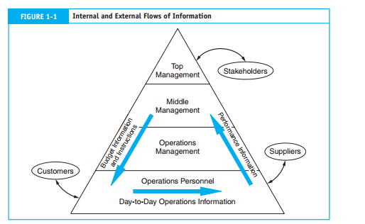

This includes information on events such as the sale and shipment of goods, the use of  
labor and materials in the production process, and internal transfers of resources from  
one department to another. The vertical flow distributes summarized information about  
operations and other activities upward to managers at all levels. Management uses this  
information to support its various planning and control functions. Information also flows  
downward from senior managers to junior managers and operations personnel in the  
form of instructions, quotas, and budgets.

A third flow of information exchanges between the organization and users in the external environment. External users fall into two groups: **trading partners and stakeholders**. Exchanges with trading partners include customer sales and billing information, purchase information for suppliers, and inventory receipts information. Stakeholders are entities outside (or inside) the organization with a direct or indirect interest in the firm. Stockholders, financial institutions, and government agencies are examples of external stakeholders. Information exchanges with these groups include financial statements, tax returns, and stock transaction information. Inside stakeholders include accountants and internal auditors

**1.2. The system environment**

**What is a System?**

Some systems are naturally occurring, whereas others are artificial. Natural systems range from the atom: a system of electrons, protons, and neutrons, to the universe: a system of galaxies, stars, and planets. All life forms, plant and animal, are examples of natural systems. Artificial systems are manmade.

**Elements of a System-** A system is a group of two or more interrelated components or subsystems that interact to serve a common purpose.

* **Multiple Components**- A system must contain more than one part. For example, Human organ system.
* **Relatedness-** A common purpose relates the multiple parts of the system. Although each  
  part functions independently of the others, all parts serve a common objective. If a particular component does not contribute to the common goal, then it is not part of the system.
* **System versus Subsystem-** The distinction between the terms system and subsystem is a matter of perspective. Most systems are composed of smaller subsystems that support the larger system. For example, a college of business is a system composed of various departments, each of which is a subsystem. Moreover, the college itself is a subsystem of the university. Each subsystem is designed to achieve one or more organizational goals. Changes in subsystems cannot be made without considering the effect on other subsystems and on the system as a whole.
* **Purpose-** A system must serve at least one purpose, but it may serve several. When a system ceases to serve a purpose, it should be replaced.

**1.3. The Information System Environment**

**What is information system:** The information system is the set of formal procedures by which data are collected, processed into information, and distributed to users

***Information System Objectives***

Specific information system objectives may differ from firm to firm. Three fundamental  
objectives are, however, common to all systems:

**1.** *To support the stewardship function of management*. Stewardship refers to management’s responsibility to properly manage the resources of the firm.

**2.** *To support management decision making*. The information system supplies managers with the information they need to carry out their decision-making responsibilities.  
**3.** *To support the firm’s day-to-day operations*. The information system provides information to operations personnel to assist them in the efficient and effective discharge of their daily tasks.

**Acquisition of Information Systems**

Usually organizations obtain information systems in two ways: (1) they develop customized systems from scratch through in-house systems development activities (called the **system development life cycle**) and (2) they **purchase preprogrammed commercial systems** from software vendors.

**Turnkey systems** are completely finished and tested systems that are ready for implementation. The better turnkey systems have built-in software options that allow the user to customize input, output, and processing through menu choices. However, configuring/designing/arranging the systems to meet user needs can be a formidable/ difficult task.

**Backbone systems** consist of a basic system structure on which to build. The primary  
processing logic is preprogrammed, and the vendor then designs the user interfaces to suit  
the client’s unique needs. A backbone system is a compromise/ cooperation between a custom system and a turnkey system.

**Vendor-supported systems** are custom (or customized) systems that client organizations purchase commercially rather than develop in-house. Under this approach, the software vendor designs, implements, and maintains the system for its client.

**1.4. A Framework for Information System**

Two points are illustrated of particular importance to the study of information systems: system decomposition and subsystem interdependency:

**System Decomposition-** Decomposition is the process of dividing the system into smaller  
subsystem parts. **Subsystem Interdependency-**A system’s ability to achieve its goal depends on the effective functioning and harmonious interaction of its subsystems. Notice in the manufacturing company set up, two broad classes of systems emerges from the decomposition: the accounting information system (AIS) and the management information system (MIS).

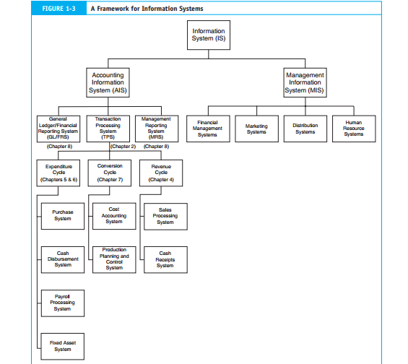

More often, MIS and AIS functions are integrated to achieve operational efficiency.  
The distinction between AIS and MIS centers on the concept of a transaction. The information system accepts input, called **transactions**, which are converted through various processes into output information that goes to users. Transactions fall into two classes: financial transactions and nonfinancial transactions. A transaction is an event that affects or is of interest to the organization and is processed by its information system as a unit of work.

This definition encompasses both financial and nonfinancial events. A financial transaction is an economic event that affects the assets and equities of the organization, is reflected in its accounts, and is measured in monetary terms. E.g Sales of products to customers. Every business organization is legally bound to correctly process these types of transactions.

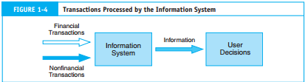

Nonfinancial transactions are events that do not meet the narrow definition of a  
financial transaction. For example, adding a new supplier of raw materials to the list of  
valid suppliers is an event that may be processed by the enterprise’s information system as  
a transaction. This is not a financial transaction, and the firm has no legal obligation to process it correctly—or at all. Financial transactions and nonfinancial transactions are closely related and are often processed by the same physical system.

**1.4.1. The Accounting Information System (AIS)**

An accounting as an information system (AIS) is a system of collecting, [storing](https://en.wikipedia.org/wiki/Information_storage) and processing financial and [accounting](https://en.wikipedia.org/wiki/Accounting) data that are used by [decision makers](https://en.wikipedia.org/wiki/Decision_maker). An accounting information system is generally a computer-based method for tracking accounting activity in conjunction with information technology resources. The resulting financial [reports](https://en.wikipedia.org/wiki/Report) can be used internally by management or externally by other interested parties including [investors](https://en.wikipedia.org/wiki/Investor), [creditors](https://en.wikipedia.org/wiki/Creditor) and tax authorities. Accounting information systems are designed to support all accounting functions and activities including [auditing](https://en.wikipedia.org/wiki/Auditing), [financial accounting](https://en.wikipedia.org/wiki/Financial_accounting) & reporting, managerial/ [management accounting](https://en.wikipedia.org/wiki/Management_accounting) and [tax](https://en.wikipedia.org/wiki/Tax).

AIS subsystems process financial transactions and nonfinancial transactions that directly  
affect the processing of financial transactions.

The **AIS** is composed of three major subsystems:

1. The transaction processing system (TPS), which supports daily business operations with numerous reports, documents, and messages for users throughout the organization;
2. The general ledger/financial reporting system (GL/FRS), which produces the traditional financial statements, such as the income statement, balance sheet, statement of cash flows, tax returns, and other reports required by law; and
3. The management reporting system (MRS), which provides internal management with special-purpose financial reports and information needed for decision making such as budgets, variance reports, and responsibility reports.

**1.4.2. The Management Information System (MIS)**

A **management information system** (**MIS**) is an [information system](https://en.wikipedia.org/wiki/Information_system)used for [decision-making](https://en.wikipedia.org/wiki/Decision-making), and for the coordination, control, analysis, and visualization of information in an organization; especially in a company. The study of management information systems examines people, processes and technology in an organizational context

Management often requires information that goes beyond the capability of AIS. As organizations grow in size and complexity, specialized functional areas emerge, requiring additional information for production planning and control, sales forecasting, inventory warehouse planning, market research, and so on. The management information system (MIS) processes nonfinancial transactions that are not normally processed by traditional AIS. The table gives examples of typical MIS applications related to functional areas of a firm.

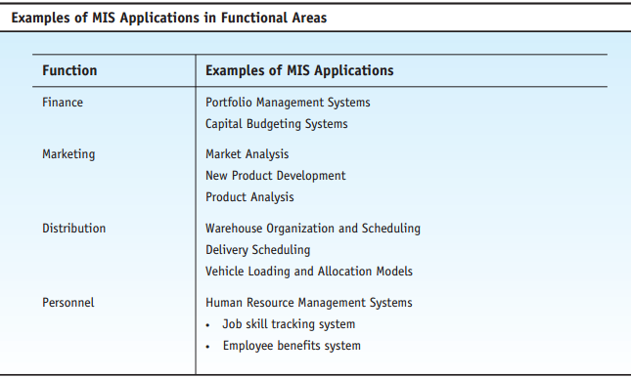

**1.4.3. A General Model for Accounting Information System**

The elements of the general model are end users, data sources, data collection, data processing, database management, information generation, and feedback.

* **End Users** -End users fall into two general groups: external and internal.
* **Data versus Information-**what is the distinction between the terms data and information?

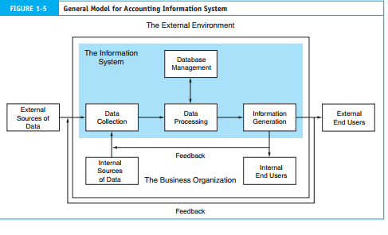

* **Data Sources-** are financial transactions that enter the information system from both internal and external sources.
* **Data Collection** - is the first *operational stage* in the information system. The objective is to ensure that event data entering the system are valid, complete, and free from material errors. In many respects, this is the most important stage in the system. Should transaction errors pass through data collection undetected, the system may process the errors and generate erroneous and unreliable output. This, in turn, could lead to incorrect actions and poor decisions by the users.

Two rules govern the design of data collection procedures: **relevance** and **efficiency**.  
The information system should capture only relevant data. Efficient data collection procedures are designed to collect data only once. These data  
can then be made available to multiple users. Capturing the same data more than once  
leads to data redundancy and inconsistency. Information systems have limited collection, processing, and data storage capacity. Data redundancy overloads facilities and reduces the overall efficiency of the system. Inconsistency among redundant data elements can result in inappropriate actions and bad decisions.

* **Data Processing-** Once collected, data usually require processing to produce information.
* **Database Management -**The organization’s database is its physical repository for financial and nonfinancial data. We use the term database in the generic sense. It can be a filing cabinet or a computer disk. Regardless of the database’s physical form, we can represent its contents in a logical hierarchy. The levels in the data hierarchy are —attribute, record, and file.
* ***Data Attribute***- The data attribute is the most elemental piece of potentially useful data in the database. An attribute is a logical and relevant characteristic of an entity about which the firm captures data. The attributes shown in Figure 1-6 are logical because they all relate sensibly to a common entity—accounts receivable (AR). Each attribute is also relevant because it contributes to the information content of the entire set. As proof of this, the absence of any single relevant attribute diminishes or destroys the information content of the set. The addition of irrelevant or illogical data would not enhance the information content of the set.
* ***Record****-* A record is a complete set of attributes for a single occurrence within an entity class. For example, a particular customer’s name, address, and account balance is one occurrence (or record) within the AR class. To find a particular record within the database, we must be able to identify it uniquely.
* ***Files*-**A file is a complete set of records of an identical class. For example, all the AR records of the organization constitute the AR file. Similarly, files are constructed for other classes of records such as inventory, accounts payable, and payroll.
* The organization’s **database** is the entire collection of such files.

***Database Management Tasks:* Database management** involves three fundamental tasks: storage*,* retrieval*,* and deletion. The storage task assigns keys to new records and stores them in their proper location in the database. Retrieval is the task of locating and extracting an existing record from the database for processing. After processing is complete, the storage task restores the updated record to its place in the database. Deletion is the task of permanently removing obsolete or redundant records from the database.

**1.5. The Evolution of Information System Models**

Over the past 50 years, a number of different approaches or models have represented  
accounting information systems. Each new model evolved because of the shortcomings  
and limitations of its predecessor. An interesting feature in this evolution is that the newest technique does not immediately replace older models. Five of these models: manual processes, flat-file systems, the database approach, the REA (resources, events, and agents) model, and ERP (enterprise resource planning) systems.

1. **The manual process model**

The manual process model is the oldest and most traditional form of accounting  
systems. Manual systems constitute the physical events, resources, and personnel that characterize many business processes. This includes such tasks as order-taking, warehousing materials, manufacturing goods for sale, shipping goods to customers, and placing orders with vendors. Traditionally, this model also includes the physical task of record keeping. Often, manual record keeping is used to teach the principles of accounting to business students. This model is employed by some cooperative societies and small businesses.

1. **The Flat-File Model**

The flat-file approach is most often associated with so-called **legacy systems.** These are  
large mainframe systems that were implemented in the late 1960s through the 1980s.  
Organizations today still use these systems extensively. Eventually, modern database  
management systems will replace them, but in the meantime accountants must continue to deal with legacy system technologies. The **flat-file model** describes an environment in which individual data files are **not related** to other files. End users in this environment own their data files rather than share them with other users. Thus, stand-alone applications rather than integrated systems perform data processing. When multiple users need the same data for different purposes, they must obtain separate data sets structured to their specific needs which results data redundancy. The data redundancy contributes to three significant problems in the flat-file environment: **data storage, data updating,** and **currency of** **information.**

***Data Storage***-An efficient information system captures and stores data only once and makes this single source available to all users who need it. In the flat-file environment, this is not possible. To meet the private data needs of users, organizations must incur the costs of both multiple collection and multiple storage procedures. Some commonly used data may be duplicated dozens, hundreds, or even thousands of times.

***Data Updating*** -Organizations have a great deal of data stored in files that require periodic updating to reflect changes. For example, a change to a customer’s name or address must be reflected in the appropriate master files. When users keep separate files, all changes must be made separately for each user. This adds significantly to the task and the cost of data management.

***Currency of Information-*** In contrast to the problem of performing multiple updates is the problem of failing to update all the user files affected by a change in status. If update information is not properly disseminated, the change will not be reflected in some users’ data, resulting in decisions based on outdated information.

***Task-Data Dependency-*** Another problem with the flat-file approach is the user’s inability to obtain additional information as his or her needs change. This problem is called **task-data dependency.**

1. **The Database Model**

An organization can overcome the problems associated with flat files by implementing the **database model** to data management. **Database** approach centralizes the organization’s data into a common database that is shared by other users. With the organization’s data in a central location, all users have access to the data they need to achieve their respective objectives. Access to the data resource is controlled by a **database** **management system (DBMS).** The DBMS is a special software system that is programmed to know which data elements each user is authorized to access. The user’s program sends requests for data to the DBMS, which validates and authorizes access to the database in accordance with the user’s level of authority. If the user requests data that he or she is not authorized to access, the request is denied.

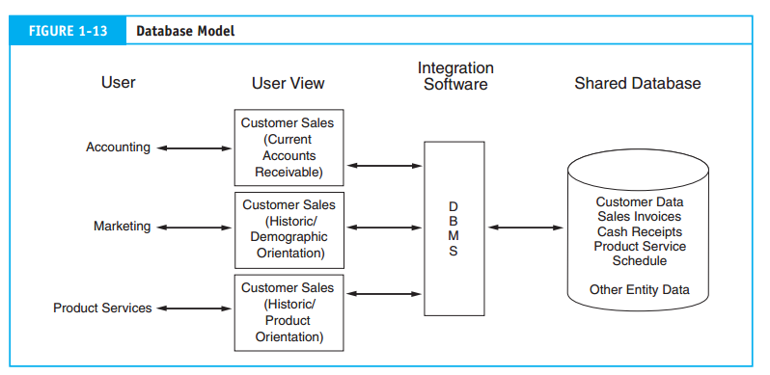

Flat-file and early database systems are called **traditional systems.** The most striking difference between the database model and the flat-file model is the pooling of data into a common database that all organizational users share. Through data sharing, the following traditional problems associated with the flat-file approach may be overcome:

***Elimination of data redundancy*-** Each data element is stored only once, thereby eliminating data redundancy and reducing data collection and storage costs.

***Single update***- Because each data element exists in only one place, it requires only a single  
update procedure. This reduces the time and cost of keeping the database current.  
***Current values*-** A single change to a database attribute is automatically made available to  
all users of the attribute.

1. **The Resources, Events, and Agents (REA) Model**

True integration, however, would not be possible until the arrival of the **relational**  
**database model.** This flexible database approach permits the design of integrated systems applications capable of supporting the information needs of multiple users from a common set of integrated **database tables.** REAis an accounting framework for modeling an organization’s critical resources*,* events, and agents (REA) and the relationships between them.

***Resources***- Economic resources are the assets of the organization. They are defined as objects that are both scarce and under the control of the enterprise.

***Events***- Economic **events** are phenomena that affect changes in resources. They can result from activities such as production, exchange, consumption, and distribution. Economic events are the critical information elements of the accounting system and should be captured in a highly detailed form to provide a rich database.

***Agents***-Economic **agents** are individuals and departments that participate in an economic event. They are parties both inside and outside the organization with discretionary power to use or dispose of economic resources. Examples of agents include sales clerks, production workers, shipping clerks, customers, and vendors.

1. **Enterprise Resource Planning Systems**

Enterprise Resource Planning Systems is an information system model that enables an organization to automate and integrate its key business processes. ERP breaks down traditional functional barriers by facilitating data sharing, information flows, and the introduction of common business practices among all organizational users.

**1.6. Accountant’s Role in the information system**

Accountants are primarily involved in three ways: as system users, designers, and auditors.

1. **Accountants as Users**- In most organizations, the accounting function is the single largest user of IT. All systems that process financial transactions impact the accounting function in some way. As end users, accountants must provide a clear picture of their needs to the professionals who design their systems. For example, the accountant must specify accounting rules and techniques to be used, internal control requirements, and special algorithms such as depreciation models.
2. **Accountants as System Designers-** Traditionally, accountants have been responsible for key aspects of the information system, including assessing the information needs of users, defining the content and format of output reports, specifying sources of data, selecting the appropriate accounting rules, and determining the controls necessary to preserve the integrity and efficiency of the information system.
3. **Accountants as System Auditors** **Auditing** is a form of independent attestation performed by an expert—the auditor—who expresses an opinion about the fairness of a company’s financial statements.

***CHAPTER TWO***

***2. AN OVERVIEW OF TRANSACTION PROCESSING***

Transaction processing applications process financial transactions. A financial transaction is an economic event that affects the assets and equities of the firm, is reflected in its accounts, and is measured in monetary terms. The most common financial transactions are economic exchanges with external parties. These include the sale of goods or services, the purchase of inventory, the discharge of financial obligations, and the receipt of cash on account from customers. Financial transactions also include certain internal events such as the depreciation of fixed assets; the application of labor, raw materials, and overhead to the production process; and the transfer of inventory from one department to another. Financial transactions are common business events that occur regularly. For instance, thousands of transactions of a particular type (sales to customers) may occur daily. To deal efficiently with such volume, business firms group similar types of transactions into transaction cycles.

***2.1. Transaction Cycles***

Transaction cycle is a group of similar activities; it is also expressed as given to get economic duality.The three transaction cycles process most of the firm’s economic activity: the expenditure cycle, the conversion cycle, and the revenue cycle.These cycles exist in all types of businesses both profit-seeking and non - profit business enterprise.**For instance,** every business

(1) Incurs expenditures in exchange for resources ***(expenditure cycle)***

(2) Provides value added through its products or services ***(conversion cycle)***, and

(3) Receives revenue from outside sources ***(revenue cycle)***.

***2.2. Expenditure Cycle***

Business activities begin with the acquisition of materials, property, and labor in exchange for cash is called the expenditure cycle.Most expenditure transactions are based on a credit relationship between the trading parties. The actual disbursement of cash takes place at some point after the receipt of the goods or services. Days or even weeks may pass between these two events. Thus, from a systems perspective, this transaction has two parts: **a physical component** (the acquisition of the goods) and a **financial component** (the cash disbursement to the supplier). The major subsystems of the expenditure cycles are Purchases/accounts payable system, Cash disbursements system, Payroll system and fixed asset system.

***2.2.1. Purchases/accounts payable system***

This system recognizes the need to acquire physical inventory (such as raw materials) and places an order with the vendor. When the goods are received, the purchases system records the event by increasing inventory and establishing an account payable to be paid at a later date.

***2.2.2. Cash disbursements system***

When the obligation created in the purchases system is due, the cash disbursements system authorizes the payment, disburses the funds to the vendor, and records the transaction by reducing the cash and accounts payable accounts.

***2.2.3. Payroll system***

The payroll system collects labor usage data for each employee, computes the payroll, and disburses paychecks to the employees. Conceptually, payroll is a special-case Purchase and cash disbursements system because of accounting complexities associated with payroll, most firms have a separate system for payroll processing.

***2.2.4. Fixed asset system***

A firm’s fixed asset system processes transactions pertaining to the acquisition, maintenance, and disposal of its fixed assets. These are relatively permanent items that collectively often represent the organization’s largest financial investment. Examples of fixed assets include land, buildings, furniture, machinery, and motor vehicles.

***2.3. Conversion Cycle***

The conversion cycle is a Process of converting raw materials into finished products through formal conversion cycle operations. The conversion cycleis composed of two major subsystems: the production system and the cost accounting system.

1. The ***production system: -*** involves the planning, scheduling, and control of the physical product through the manufacturing process. This includes determining raw material requirements, authorizing the work to be performed and the release of raw materials into production, and directing the movement of the work-in process through its various stages of manufacturing.
2. The ***cost accounting system*: -** monitors the flow of cost information related to production. Information this system produces is used for inventory valuation, budgeting, cost control, performance reporting, and management decisions, such as make-or-buy decisions.

The conversion cycle is not usually formal and observable in service and retailing establishments. Nevertheless, these firms still engage in conversion cycle activities that culminate in the development of a salable product or service. These activities include the readying of products and services for market and the allocation of resources such as depreciation, building amortization, and prepaid expenses to the proper accounting period. However, unlike manufacturing firms, merchandising companies do not process these activities through formal conversion cycle subsystems.

***2.4. The Revenue Cycle***

Firms sell their finished goods to customers through the **revenue cycle,** which involves processing cash sales, credit sales, and the receipt of cash following a credit sale. Revenue cycle transactions also have a physical and a financial component, which are processed separately.

1. ***Sales order processing*:**The majority of business sales are made on credit and involve tasks such as preparing sales orders, granting credit, shipping products (or rendering of a service) to the customer, billing customers, and recording the transaction in the accounts (accounts receivable, inventory, expenses, and sales).
2. ***Cash receipts*:**For credit sales, some period of time (days or weeks) passes between the point of sale and the receipt of cash. Cash receipts processing includes collecting cash, depositing cash in the bank, and recording these events in the accounts (accounts receivable and cash).

***Accounting Records***

This section describes the purpose of each type of accounting recordused in transaction cycles. We begin with traditional records used in manual systems (documents, journals, and ledgers) and then examine their magnetic counter parts in computer-based systems.

***I. Manual Systems***

A manual system is a [book keeping](https://www.accountingtools.com/articles/2017/5/11/bookkeeping) system where records are maintained by hand, without using a computer system. Instead, [transactions](https://www.accountingtools.com/articles/2017/5/15/transaction) are written in [journals](https://www.accountingtools.com/articles/2017/5/9/journal), from which the information is manually rolled up into a set of [financial Statements](https://www.accountingtools.com/articles/2017/5/10/financial-statements). These systems suffer from a high error rate, and are much slower than computerized systems. Manual systems are most commonly found in small enterprises that have few transactions. The concepts behind both manual and computerized systems are the same, only the mechanics have changed.

1. ***Documents***

A document provides evidence of an economic event and may be used to initiate transaction processing. Some documents are a result of transaction processing. Three types of documents: source documents, product documents, and turnaround documents.***.***

***1.1. Source Documents*:**Economic events result in some documents being created at the beginning (the source) of the transaction. These are called source documents. Source documents are used to capture and formalize transaction data that the transaction cycle needs for processing. The economic event (the sale) causes the sales clerk to prepare a multipart sales order, which is formal evidence that a sale occurred. Copies of this source document enter the sales system and are used to convey information to various functions, such as billing, shipping, and accounts receivable. The information in the sales order triggers specific activities in each of these departments.

***1.2. Product Documents*:**are the results of transaction processing rather than the triggering mechanism for the process. For example, a payroll check to an employee is a product document of the payroll system.

***1.3. Turnaround Documents:*** are product documents of one system that become source documents for another system. The customer receives a perforated two-part bill or statement. The top portion is the actual bill, and the bottom portion is the remittance advice. Customers remove the remittance advice and return it to the company along with their payment (typically a check). A turn- around document contains important information about a customer’s account to help the cash receipts system process the payment. One of the problems designers of cash receipts systems face is matching customer payments to the correct customer accounts. Providing this needed information as a product of the sales system ensures accuracy when the cash receipts system processes it.

1. ***Journals***

A **journal** is a record of a chronological entry. At some point in the transaction process, when all relevant facts about the transaction are known, the event is recorded in a journal in chronological order. Documents are the primary source of data for journals.

Special Journals**:** Special journals are used to record specific classes of transactions that occur in high volume. As example, the sales journal provides a specialized format for recording only sales transactions. Including the cash receipts journal, cash disbursements journal, purchases journal, and the payroll journals are examples of special journal

General Journals**:**Firms use the general journal to record nonrecurring, infrequent, and dissimilar transactions. For example, we usually record periodic depreciation and closing entries in the general journal.

1. ***Ledgers***

A **ledger** is a book of accounts that reflects the financial effects of the firm’s transactions after they are posted from the various journals. Whereas journals show the chronological effect of business activity, ledgers show activity by account type. A ledger indicates the increases, decreases, and current balance of each account. There are two basic types of ledgers: (1) general ledgers, which contain the firm’s account information in the form of highly summarized control accounts, and (2) subsidiary ledgers, which contain the details of the individual accounts that constitute a particular control account.

***II. Computer-Based Systems***

Computerized Accounting can be described as the accounting system that uses the computer system and pre-packaged, customized or tailored accounting software, to keep a record of financial transactions and generate financial statements, for analysis. Computerized Accounting system relies on the concept of a database. The accounting database is systematically maintained, with active interface wherein accounting application programs and reporting system are used.

***Types of Files***

1. **Transaction File:**A transaction fileis a temporary file of transaction records used to change or update data in a master file. Sales orders, inventory receipts, and cash receipts are examples of transaction files. It is similar to journals
2. **Master File:**A master filegenerally contains account data. The general ledger and subsidiary ledgers are examples of master files. Data values in master files are updated from transactions.
3. **Reference File:**A reference filestores data that are used as standards for processing transactions. For example, the payroll program may refer to a tax table to calculate the proper amount of withholding taxes for payroll transactions. Other reference files include price lists used for preparing customer invoices, lists of authorized suppliers, employee rosters, and customer credit files for approving credit sales.
4. **Archive File*:*** An archive filecontains records of past transactions that are retained for future reference. Archive files include journals, prior-period payroll information, lists of former employees, records of accounts written off, and prior period ledgers.

***Comparison Chart***

|  |  |  |
| --- | --- | --- |
| ***BASIS FOR COMPARISON*** | ***MANUAL ACCOUNTING*** | ***COMPUTERIZED ACCOUNTING*** |
| ***Meaning*** | Manual Accounting is a system of accounting that uses physical registers and account books, for keeping financial records. | Computerized accounting is an accounting system that uses accounting software for recording finacial transactions electronically |
| ***Recording*** | Recording is possible through book of original entry. | Data content is recorded in customized database. |
| ***Calculation*** | All the calculation is performed manually. | Only data input is required, the calculations are performed by computer system. |
| ***Speed*** | Slow | Comparatively faster. |
| ***Adjusting entries*** | It is made for rectification of errors. | It cannot be made for rectification of errors. |
| ***Backup*** | Not possible | Entries of transactions can be saved and backed up |
| ***Trial Balance*** | Prepared when necessary. | Instant trial balance is provided on daily basis. |
| ***Financial Statement*** | It is prepared at the end of the period, or quarter. | It is provided at the click of button. |

**CHAPTER 3**

**MANAGING DATA RESOURCES**

Data is vital organization resources that need to be managed like other important business assets. Today’s business enterprises cannot survival or succeed without quality data about their internal operation and external environment. That is why organizations and their managers need to practice data resource managements, a managerial activity that applies information system technologies like data base management, data warehousing and other data management tools to the task of managing an organization data resources to meet the information needs of their business stakeholders.

**3.1 File Organization Terms and Concepts**

A computer system organizes data in a hierarchy that starts with bits and bytes and progresses to fields, records, files, and databases

* **A bit** represents the smallest unit of data a computer can handle
* A group of bits, called **a byte**, represents a single character, which can be a letter, a number, or another symbol. Example: A, 2, $
* A grouping of characters into a word, a group of words, or a complete number (such as a person’s name or age) is called **a field**. Example: employee Last name, Customer Account number
* A group of related fields, such as the student’s name, the course taken, the date, and the grade, comprises **a record**. Example: There will be one record for every one
* A group of records of the same type is called **a file.** Example: Employee Benefits file, Employee payroll file
* Database: A group of related files about a specific entity Example: Human Resource database

Databases consist of a huge amount of data. The data is grouped within a table in DBMS, and each table has related records. A user can see that the data is stored in form of tables, but in actual this huge amount of data is stored in physical memory in form of files.

**File:** A file is named collection of related information that is recorded on secondary storage such as magnetic disks, magnetic tables and optical disks.

**File Organization** refers to the logical relationships among various records that constitute the file, particularly with respect to the means of identification and access to any specific record. In simple terms, Storing the files in certain order is called file Organization. **File Structure** refers to the format of the label and data blocks and of any logical control record.

**3.2 Approaches to File Management**

There are two approaches to file management those are traditional or flat-file and data base approach.

**3.2.1 The Traditional Approach**

In traditional approach file is independent from one another. Each file is called a flat file**.**

**Overview of the Flat-File Approaches**

Many so-called legacy systems are characterized by the **flat-file** approach to data management.

In this environment, users own their data files. Exclusive ownership of data is a natural consequence of two problems associated with the legacy-system era. The first is a business culture that erects barriers between organizational units that inhibit entity-wide integration of data. The second problem stems from limitations in flat-file management technology that require data files to be structured to the unique needs of the primary user. Thus the same data, used in slightly different ways by different users, may need to be restructured and reproduced in physically different files. Figure 9-1 illustrates this model. In the figure, the file contents are represented conceptually with letters. Each letter could signify a single **data attribute** (field), a record, or an entire file. Note also that data element B is present in all user files. This is called **data redundancy** and is the cause of three types of data management problems: **data storage, data updating,** and **currency of** **information**. Each of these, as well as a fourth problem––**task-data dependency,** which is not directly related to data redundancy is the user’s inability to obtain additional information as his or her needs change. For example, in Figure 9-1, if the information needs of User 1 change to include Data L, User 1’s program would not have access to these data.

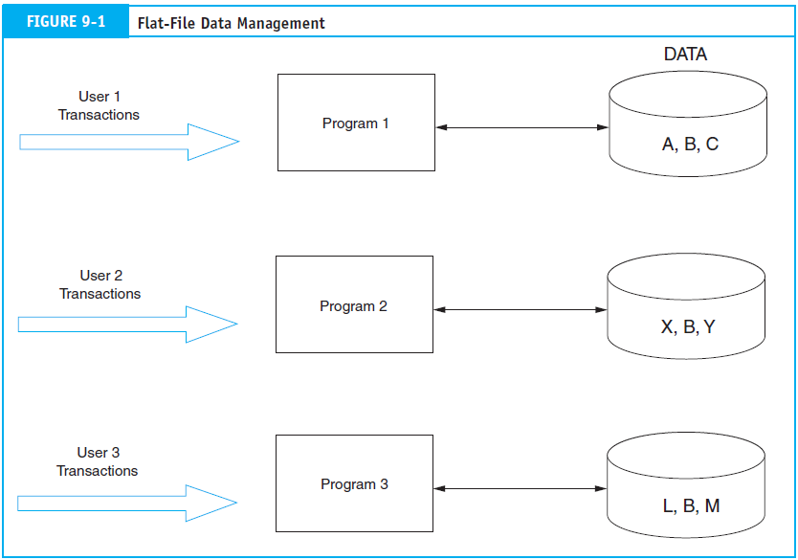

**3.2.2 The Database Approach**

Figure 9-2(a) presents a simple overview of the database approach with the same users and data requirements as in Figure 9-1. The most obvious change from the flat-file model is the pooling of data into a common database that is shared by all the users.

**Flat-File Problems Solved**

Data sharing (the absence of ownership) is the central concept of the database approach.

Let’s see how this resolves the problems identified.

1. No data redundancy- Each data element is stored only once, thereby eliminating data redundancy and reducing storage costs.
2. Single update- Because each data element exists in only one place, it requires only a single update procedure. This reduces the time and cost of keeping the database current.
3. Current values. A change any user makes to the database yields current data values for all other users. For example, when User 1 records a customer address change, User 3 has immediate access to this current information.
4. Task-data independence. Users have access to the full domain of data available to the firm. As users’ information needs expand beyond their immediate domain, the new needs can be more easily satisfied than under the flat-file approach. Only the limitations of the data available to the firm (the entire database) and the legitimacy of their need to access it constrain users.

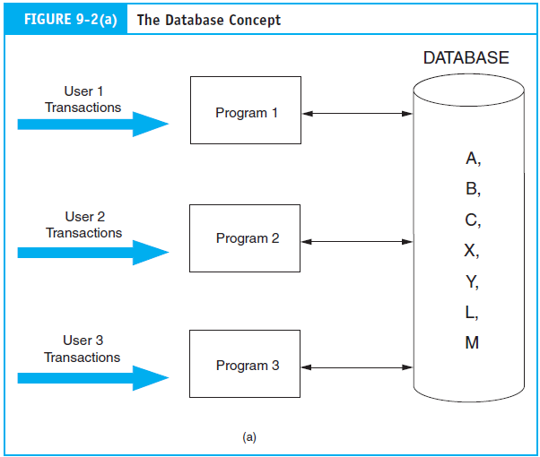

**Controlling Access to the Database**

The database approach places all the firm’s information eggs in one basket. It is essential, therefore, to take very good care of the basket. The example in Figure 9-2(a) has no provision for controlling access to the database. Assume Data X is sensitive, confidential, or secret information that only User 3 is authorized to access. How can the organization prevent others from gaining unauthorized access to it?

**The Database Management System**

Figure 9-2(b) adds a new element to Figure 9-2(a). Standing between the users’ programs and the physical database is the database management system (DBMS)**.** The purpose of the DBMS is to provide **controlled access** to the database. The **DBMS** is a special software system that is programmed to know which data elements each user is authorized to access. The user’s program sends requests for data to the DBMS, which validates and authorizes access to the database in accordance with the user’s level of authority. The DBMS will deny requests for data that the user is unauthorized to access. As one might imagine, the organization’s criteria, rules, and procedures for assigning user authority are important control issues for accountants to consider.

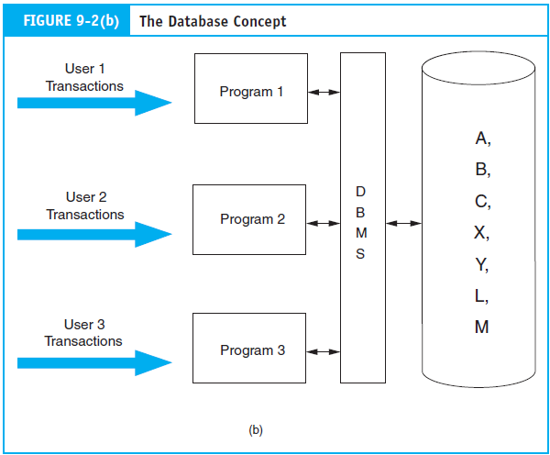

**3.3 Data Base Models**

The most common database approaches used for business information systems are the **hierarchical,** the **network,** and the **relational models.** Because of certain conceptual similarities, the hierarchical and network databases are termed **navigational** or **structured models**.

The Hierarchical Database Model

The earliest database management systems were based on the hierarchical data model. This was a popular approach to data representation because it reflected, more or less faithfully, many aspects of an organization that are hierarchical in relationship. Also, it was an efficient data processing tool for highly structured problems. Figure 9-29 presents a data structure diagram showing a portion of a hierarchical database. The hierarchical model is constructed of sets of files. Each set contains a parent and a child. Notice that File B, at the second level, is both the child in one set and the parent in another set. Files at the same level with the same parent are called siblings. This structure is also called a tree structure. The file at the most aggregated level in the tree is the root segment, and the file at the most detailed level in a particular branch is called a leaf.

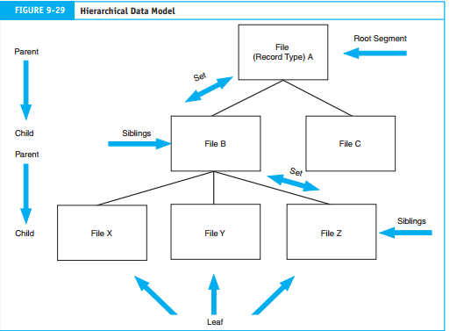

The Network Database Model

The network model is a variation of the hierarchical model. The principal distinguishing feature between the two is that the network model allows a child record to have multiple parents. The multiple ownership rule is flexible in allowing complex relationships to be represented. Figure 9-31(a) illustrates a simple network model in which the sales invoice file has two parent files––Customer and Salesperson.

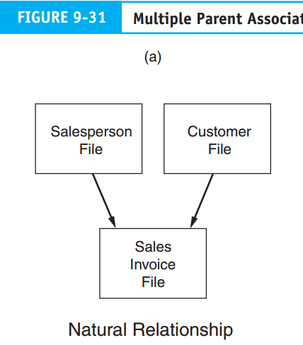

**The Relation Database Model**

The relational data base is a data base developed based on the relational. Relational database model is a data model in which everything in the database is represents as being stored in the forms of tables (Relation).

Operational definition

1 Relation: file- table: it represents a complete set of records about an entity

2. Tuple: record-row: this represents a particular instance occurrence of an entity

3. Attribute: field-column: represents characteristics of interest about an entity.

Types of Attributes

1. Primary key attribute: It is the attribute or combination of attributes that uniquely identifies a specific row (tuple) in a table. Rules* primary key cannot be null (empty) and also cannot be duplicate
2. Foreign key attribute: it is an attribute in one table which is the primary key in another table and it is used to relate its table with the table in which it appear as foreign key.
3. Non key attribute: is neither primary nor foreign key that provides additional description..

**3.4 Elements of the Database Environment**

The database environment can break down into four primary elements: users, the DBMS, the database administrator, and the physical database.

1. **Users**- access the database in two ways. The first is via user application programs that systems professionals prepare. These programs send data access requests (calls) to the DBMS, which validates the requests and retrieves the data for processing. The second method of database access is via direct query, which requires no formal user programs. The DBMS has a built-in query facility that allows authorized users.

**2. Database Management System**

The DBMS provides a controlled environment to assist (or prevent) user access to the database and to efficiently manage the data resource. Each DBMS model accomplishes these objectives differently, but some **typical features** include

1. **Program development.**The DBMS contains application development software. Both  
   programmers and end users may employ this feature to create applications to access  
   the database.
2. **Backup and recovery.**During processing, the DBMS periodically makes backup  
   copies of the physical database. In the event of a disaster (for example, disk failure, program error, or malicious act) that renders the database unusable, the DBMS can recover an earlier version that is known to be correct. Although some data loss may occur, without the backup and recovery feature, the database would be vulnerable to  
   total destruction.
3. **Database usage reporting.**This feature captures statistics on what data are being  
   used, when they are used, and who uses them. The database administrator (DBA)  
   uses this information to help in assigning user authorization and in maintaining the  
   database.
4. **Database access.**The most important feature of a DBMS is to permit authorized user  
   access to the database. There are three software modules that facilitate this task. These are the data definition language, data manipulation language, and the query language.

**Data Definition Language-**is a programming language used to define the physical  
database to the DBMS. The definition includes the names and the relationship of all data elements, records, and files that constitute the database. It is used to build data dictionary and create data bases.

**Data Manipulation Language-**is used to maintain the data base creates updates, insertions and deletions.

**Data Query Language-**is used to enquire (ask) the data base and also enables users to retrieve sort and display specific data from the data base.

**3. Database Administrator**

Database administrator (DBA)does not exist in the flat-file environment. The DBA is responsible for managing the database resource. Multiple users sharing a common database require organization, coordination, rules, and guidelines to protect the integrity of the database.

**4. The Physical Database**

The fourth major element of the database approach is the **physical database.** This is the lowest level of the database. The physical database consists of magnetic spots on magnetic disks. The other levels of the database (for example, the user view, conceptual view, and internal view) are abstract representations of the physical level.

**Chapter Four**

**4. Introduction to system development life cycle**

**4.1 Definition of System Development Life Cycle**

System development life cycle is a systematic process of developing or acquiring a new system, design a system, implementation and use of it system. Whether the systems changes are major or minor, most companies go through a systems development life cycle.There are five Steps involved in SDLC these are:-



**4.1.1. System Analysis**

* The information needed to purchase or develop a new system is gathered.
* Requests for systems development are prioritized to maximally utilize limited development resources.
* If the project passes the initial screening, the current system is surveyed to define the nature and scope of the project and understand its strengths and weaknesses.
* An in-depth study of the proposed system is conducted to determine its feasibility.
* If the proposed system is feasible, the information needs of system users and managers are identified and documented.
* These needs are used to develop and document system requirements.
* System requirements are used to select or develop a new system.

A systems analysis report is prepared and submitted to the information systems steering committee

**Steps in system analysis**

1. Initial Investigation
2. Systems Survey
3. Feasibility study
4. Information needs and system requirements
5. System analysis report

**Step1. Initial investigation**

Examines the IS problem to be solved, determine the project scope (what the project should and should not accomplish)

**Objectives:** Investigate each development activity to define the problem to be solved, Make a preliminary assessment of feasibility and prepare a proposal to conduct systems analysis.

The person conducting an initial investigation must be;

* + Gain a clear picture of the problem or need
  + Determine the project’s viability and expected costs and payoffs
  + Make an initial evaluation of the extent of the project and the nature of the new AIS
  + Recommend whether the development project should be initiated as proposed, modified, or abandoned

**Step2. System survey**

Study’s the current system to understand how it works, its strengths, and weaknesses. Collect data to identify user needs. Data can be gathered by interviews, questionnaires, observations, and systems documentation. This survey may take weeks or months, depending on the complexity and scope of the system.

**Objectives of system survey:-**

* Gain a thorough understanding of company operation, policies, procedures; data & information flow; AIS strength & weakness; & available hardware, software, and personnel.
* Make preliminary assessments of current and future processing needs, and determine the extent and nature of the changes needed.
* Develop working relationships with users and build support for the AIS
* Collect data that identifies user needs, conduct a feasibility analysis, & make recommendation

**Step3. Feasibility Study**

Develop a more thorough feasibility analysis, especially with respect to economic cost and benefits.At this point in systems analysis, a more thorough feasibility analysis is conducted to determine the project’s viability. Especially important is economic feasibility. The analysis is updated regularly as the project proceeds and costs and benefits become clearer. A feasibility study is prepared during systems analysis and updated as necessary during the remaining steps in the SDLC. The extent of these studies varies depending on the size & nature of the system. At major decision points, the steering committee uses the study to decide whether to terminate a project, proceed unconditionally, or proceed if specific problems are resolved.

**Consideration in feasibility study:** **Five** important aspects need to be considered during a feasibility study:

1. Technical feasibility
2. Operational feasibility
3. Legal feasibility
4. Scheduling feasibility
5. Economic feasibility

**Step4. Information Needs and System Requirements**

Once a project is deemed to be feasible, the company identifies the information needs of AIS users and documents system requirements. This is usually determined by: Asking users what they need, Analyzing external systems (if solution exists, no need to recreate it), Examining existing systems (determines if modification or replacement is needed) and Creating a prototype

**Step5. System Analysis Report**

It summarizes and documents the analysis activities and serves as repository of data from which systems designers can draw.

* **The report shows the following items:-**
  + The goal and objectives of the new system
  + The scope of the project
  + How it fits into the company’s master plan
  + Processing requirements and the information needs of users
  + The feasibility analysis
  + Recommendations for the new system.

The decision to terminate or continue the project is generally made three times during system analysis: During the initial investigation, to determine whether to conduct a systems survey, At the end of the feasibility study, to determine whether to proceed to the information requirements phase, and At the completions of the analysis phase, to decide whether to proceed to the design phase

**Chapter Five**

* + 1. **Conceptual Design**

The company decides how to meet user needs. The first task is to identify and evaluate appropriate design alternatives. There are different ways to obtain a new system including: buying software, developing it in-house and outsourcing the system to someone else. Detailed specifications outlining what the system is going to accomplish and how it is to be controlled must be developed. This phase is complete when conceptual system design requirements are communicated to the information systems steering committee.

**Conceptual system design:** A general framework is developed for implementing user requirements and solving problems identified in the analysis phase. There are three main steps in conceptual design: evaluate design alternatives, prepare design specifications and prepare the conceptual systems design report

**4.1.2.1 Evaluate design alternatives**

There are many ways to design AIS, so the design team must continually make design decisions like:

* + Should the company mail hard copy purchase orders or use EDI?
  + Should the company have a large centralized mainframe and database, or distribute computer power to stores?
  + Should data entry be through keyboard, optical character recognition, point-of-sale devices, or some combination of these?

The design team should identify a variety of design alternatives and evaluate each with respect to the following standards:

* + How well it meets organizational and system objectives?
  + How well it meets users’ needs?
  + How much it is economically feasible?
  + What are its advantages and disadvantages?
    - 1. **Preparing design specification**

Once a design alternative has been selected, the project team develops the conceptual design specifications for the following elements: Output, Data storage, Input and Processing procedures and operations

* + - 1. **Prepare the conceptual system design report**

At the end of each of the conceptual design phase, the project development team prepares & submits a conceptual systems design report. The purpose of this report is to: guide physical systems design activities, communicate how management and user needs will be meet, help the steering committee assess system feasibility, The main component is a description of one or more recommended system designs. This description contains the contents of each output, database, and input: processing flows and the relationship among programs, files, inputs, and outputs: hardware, software, and resource requirements: and audit, control, security processes and procedures.

* + 1. **Physical Design**

The company translates the broad user-oriented requirements of the conceptual design into detailed specification that are used to code and test the computer programs. Input and output documents are designed, computer programs are written, files are created, procedures are developed, and controls are built into the new system. This phase is complete when physical system design results are communicated to the information system steering committee. Physical system design determines how the conceptual AIS design is to be implemented and also translates the broad, user oriented AIS requirements of conceptual design into detailed specifications that are used to code and test the computer programs.

**Steps in physical design**

**Step 1 output design**

Its objective is to determine the nature, format, content, and timing of printed reports, documents, and screened displays. Output usually fit into one of the following four categories: Scheduled reports, Special- Purpose analysis, Triggered exception reports and Demand reports

**Step 2 file and data base design**

It is important that the various divisions or departments of a company store data in compatible formats

|  |  |
| --- | --- |
| **File and Database Design Considerations** | |
| **Considerations** | **Concern** |
| Medium | Should data be stored on disk, diskettes, optical disk, or tape? |
| Organization and Access | Should sequential, indexed-sequential, or random access methods be used? |
| Processing Mode | Should batch or real time processing be used? |
| Maintenance | What procedures needed to maintain data effectively? |
| Size | How many records will be stored in the data base and how large are they? How fast is the number of records expected to grow? |

**Step 3 input design**

When evaluating input design, the design team must identify the different types of data input and optimal input method. There are two principal types of data input: Forms design and computer design

**Step 4 program design**

Programs development is one of the most time-consuming activities in the entire SDLC. Programs should be subdivided into small, well-defined modules to reduce complexity and enhance reliability and modifiability. This is referred to structured programming. Modules should interact with a control module rather than with each other. Each module should have only one entry & exit point, to facilitate testing & modification. To improve the quality of their software, organizations should develop programming standards. This contributes to consistency among programs, making them easier to read & maintain. They should also conduct a structured walk-through to find incorrect logic, errors, logics, or other problems.

**Step 5 procedure design**

Everyone who interacts with the newly designed AIS should follow procedures that answer who, what, where, when, why, & how questions related to all AIS activities. Procedures should cover, input preparation, transaction processing, error detection and correction Controls, reconciliation of balances database access, output preparation and distribution, computer operator instructions.

Procedures may take the form of:

* + - system manuals
    - user instruction classes
    - training materials
    - On-line help screen.

They may be written by development teams, users, or teams representing both groups.

**Step 6 control design**

Improperly controlled input, processing, and data base functions produce information of little value. Controls must be built into AIS to ensure its Effectiveness, efficiency, and accuracy. they should minimize errors and detect and correct them when they do occur. Accountants play a vital role in this area by concern on topics like validity, authorization, accuracy, access.

**Physical system design report**: At the end of physical design phase the team prepares a physical systems design report. This report becomes the basis for management’s decision whether to proceed to the implementation phase.

* + 1. **Implementation and Conversion**

This phase is the capstone phase where all the elements and activities of the system come together. Because of this phase’s complexity and importance, an implementation and conversion plan is developed and followed. As part of implementation, any new hardware or software is installed & tested. New processing procedures must be tested and perhaps modified. Standards and controls for the new system must be established and the system documentation completed. The organization must convert the new system and dismantle the old one. After the system is up and running, any fine- tuning adjustments needed are made and post implementation review is conducted to detect and correct and design deficiencies. The final phase in this step is to deliver the operational system to the organization. A final report is prepared and sent to the information system steering committee

**Systems implementation**: is the process of installing hardware and software and getting the AIS up and running. This process generally consists of: developing Implementation plan**,** developing and testing**,** prepares the site**,** installing and testing hardware**,** selecting and training personnel**,** developing documentationandtesting the system.

**1. Implementation planning:** Consists of implementation tasks, expected completion dates, cost estimates, and the person or persons responsible for each task. The plan specifies when the project should be complete and when the AIS is operational. The implementation team should identify risk factors that decrease the likelihood of successful implementation, and the plan should contain a strategy for coping with each of the identified risk factors.

**2. Develop and test software program**: Program preparation time may ranges from a few days to a few years. It has its own seven steps when a company is developing software:

* 1. Determine users need
  2. Develop plan
  3. Write program instructions
  4. Test the program
  5. Document the program
  6. Train program users
  7. Install and use the system

**3. Site preparation**

A large system may require extensive changes, such as additional electrical outlets, data communications facilities, raised floors, humidity controls, special lighting, and air-conditioning. Security measures, such as fire protection and an emergency power supply, may also be necessary. Space is needed for equipment, storage and offices.

**4. Select and train person**

Employees can be hired from outside the company or transferred internally. Hiring from within the company is less costly, more effective alternative, since employees already understand the firm’s business and operation. Transferring employees who are displaced as a result of the new system could boost employee loyalty and moral.

**5. Complete documentation**

Three types of documentation must be prepared for new system

* 1. Development documentation
  2. Operations documentation
  3. User documentation

**6. Test the system**

Documents and reports, user inputs, operating and controlling procedures, processing procedures, and computer programs should all been given a trial run in a realistic circumstances. In addition, capacity limits and backup and recovery procedures should be tested. There are three common forms of testing:

* 1. Walk-through, 2) Processing of test transactions and 3) Acceptance tests

**System conversion:** Many elements must be converted: hardware, software, data files, and procedures. The process is complete when the new AIS have become a routine, ongoing part of the system.

There are four conversion approaches in changing from the old to the new AIS.

* 1. Direct conversion
  2. Parallel conversion
  3. Phase-in conversion
  4. Pilot Conversion

**Data conversion:** Data files may need to be modified in three ways.

* 1. Files may be moved to a different storage medium-for example, from hard disks to tapes.
  2. Data content may be changed; fields and records may be added or deleted.
  3. File format may be changed.

**Steps in data conversion**

1. Decide which data files need to be converted.
2. Check them for completeness and any data inaccuracies and inconsistencies must be removed.
3. Actual data conversion.
4. Validating the new files, to ensure data were not lost during conversion.
5. document the conversion activities
   * 1. **Operation and Maintenance**

It is the final phase in the SDLC. The new-and now operational-system is used as needed in the organization. During its life, the system is periodically reviewed. Modifications are made as problems arise or as new needs become evident, and the organization uses the improved system. Eventually a major modification or system replacement is necessary & the SDLC begins again. A post implementation review should be conducted on newly installed AIS to ensure it meets planned objectives. Any problems uncovered during the review should be brought to the attention of management and the necessary adjustment made. When the review has been completed, a post implementation report is prepared. And control of the AIS is passed to the data processing department

In addition to these five phases in SDLC, the following three activities are performed throughout the life cycle of the system. Planning, assessing the ongoing feasibility of the project and managing the behavioral reactions to change

**4.2 system development planning**

Each of systems development project requires a plan, and each phase of each development plan must also be planned. Systems development planning is an important step for a number of key reasons: Consistency, Efficiency, Cutting edge, Lower costs and Adaptability

**Types of system development plans**

**1. Project Development Plan**

Specific to a project and authored by the project team identifies people, hardware, software, and financial resources needed. This is the basic building block of information system and it consists of: cost/benefit analysis, developmental & operational requirements, including human resource, hardware, software, & financial requirements and Schedules of activities

**2. The master plan**

Long-range and authored by steering committee outlining prioritized projects and timetables. What the system will consist of, how it will be developed, who will develop it, how needed resources will be acquired, where the AIS is headed. Should also provide the status of projects in process, prioritize planned projects, describe the criteria used for prioritization, and provides time table for development.

**4.2.1 Planning techniques**

There are two techniques for scheduling and monitoring systems development activities;

* 1. **PERT** **(Program Evaluation and Review Technique):** requires that all activities and the precedent and subsequent relationships among them be identified.
  2. **The Gantt chart**: is a bar chart with project activities listed on the left hand side & units of time (days or weeks) across the top.

**4.3 Behavioral aspects of change**

Change is hard, think about a time when you had to change your habits, how successful were you the first time? Did it take practice and setting your mind to it? Did you have to make it a priority until it became more automatic? Did it require a lot more of your time and energy to focus on the change? Probably from your personal experience you can see why an IS change may be difficult for many employees. Because there are many reasons why employees resist change, it usually comes in one of three forms:

1. Aggression: behaviors that are intended to produce errors with the new system, or weaken the effectiveness of the new system
2. Projection: blame the new system for everything that goes wrong
3. Avoidance: ignore the new system in hopes that it will eventually go away

**4.3.1 Why Companies Change Their System**

Companies usually change their systems for one or more of the following reasons:

* + To respond to Changes in user or business needs
  + To take advantage Technological changes
  + To accommodate Improvements in their business process
  + To gain a Competitive advantage and lower costs
  + To increase Productivity and Growth
  + To replace a system that is aged and unstable

**4.3.2 Why People Resist Change?**

1. Fear Of failure, the unknown, losing status
2. Lack of top-management support: If the top management is not supportive why should the employee change?
3. Bad prior experiences: Bad experience with prior IS changes
4. Poor communication: Employees need to understand why change is necessary
5. Disruption : Additional requests for information and additional burdens of time is distracting and prompts negative feelings
6. Manner change is introduced: Approaches are different for top level and lower level employees
7. Biases and emotions
8. Personal characteristics and background: Age, Open to technology and comfortable with it

**4.3.3 How to Prevent Behavioral Problems**

1. Management support: Provide resources and motivation
2. Satisfy user needs
3. Involve users: Participation improves communication and commitment
4. Reduce fears, emphasize opportunities
5. Avoid emotionalism
6. Provide training
7. Performance evaluation: Re-evaluate to ensure performance standards are consistent with the new system
8. Keep open communications
9. Test the system prior to implementation
10. Keep system simple: Avoid radical changes
11. Control user’s expectations: Be realistic

**4.4 Who Is Involved in the SDLC?**

1. Information Systems Steering Committee: Executive level, plans and oversees IS function; facilitates coordination with integration of systems activities
2. Project Development Team: Plan and monitor project progress
3. Programmers: Write and test programs according to analysts specifications
4. Systems Analysts: Determine information needs, prepare specifications for programmers
5. Management: Get users involved in the process, provide support for development projects, align projects to meet organizations strategic needs
6. Users: Communicate needs to system developers, help design and test to ensure complete and accurate processing of data

**Practice Questions:**

* Assignment 1
* When a customer make payment, a cashier processes their payment by preparing receipt. A copy of the receipt is sent to the accountant. The cash and the deposit slip is sent to Dashen Bank for deposit. The accountant updates customer records , prepares and send a credit report to the credit manager.
* Required

1. Understand the system
2. Develop a context diagram
3. Develop a subsequent level of DFD

* Assignment 2
* When a customer makes an online credit sales order, a program checks their credit limit. If the order is with in limit, it checks its availability. If the order exceeds limit it displays a pop-up message that reads “order exceed limit. Settle your balance and reorder”. If the item is available it fills order. If not available, it displays a pop-up message that reads “Back order after 15 days”.
* Required

1. Understand the System
2. Develop a program flow chart